Mineral Titles Act
NOTICE OF GRANT OF A MINERAL TITLE
Title Type and Number: | Exploration Licence 33138
Granted: | 21 July 2023, for a period of 16 Years
Area: | 14 Blocks, 45.99 km²
Locality: | MALLAPUNYAH
Name of Holder/s: | 100% MARK ALLEN AND ASSOCIATES PTY LTD [ACN. 600 069 145]
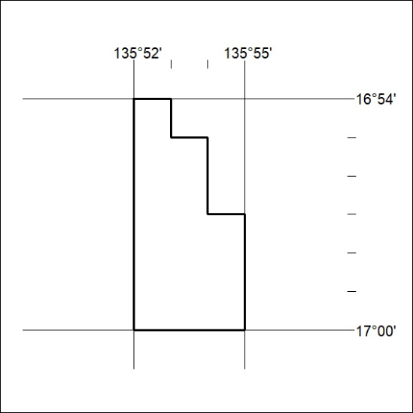
Area granted is indicated above. The titleholder is not permitted to exercise occupational rights on any land that is subject to a development title, or an application for a development title. Any land the subject of a Reserved Land gazettal under the Mineral Titles Act and all land vested in the Commonwealth of Australia is also excluded by description but not excised from the grant area.

303/23

