Mineral Titles Act 2010
NOTICE OF LAND CEASING TO BE A MINERAL TITLE AREA
Title Type and Number: | Exploration Licence 30657
Area Ceased on: | 08 September 2021
Area: | 12 Blocks, 39.18 km²
Locality: | BIRRINDUDU
Name of Applicant(s)/Holder(s): | 100% MARTIN Anthony Ernest
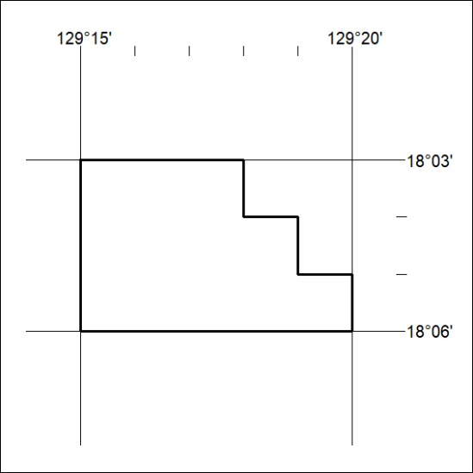

347/21

Mineral Titles Act 2010
NOTICE OF LAND CEASING TO BE A MINERAL TITLE AREA
Title Type and Number: | Mineral Authority 29974
Area ceased on: | 09 September 2021
Area: | 10.00 Hectare
Locality: | ALICE SPRINGS
Name of Applicants(s)Holder(s): | 100% NORTH CONCRETE (NT) PTY LTD [ACN. 128 802 997]
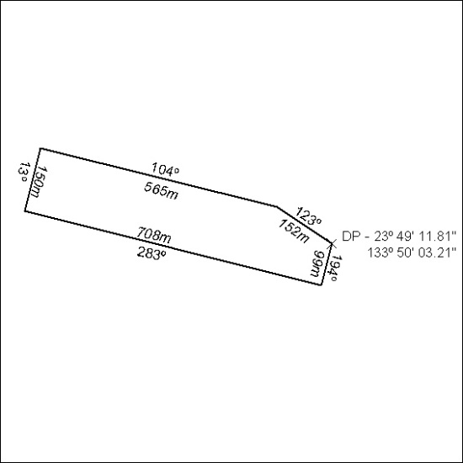

348/21

