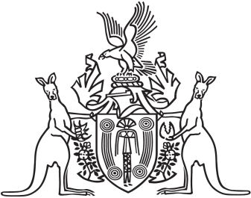
Northern Territory of Australia

Government Gazette
ISSN-0157-833X
No. S104 14 December 2018
Northern Territory of Australia

Fisheries Regulations
Off-shore Net and Line Fishery Licence Levy
I, Glenn Raymond Schipp, Director of Fisheries and Aquaculture, as the delegate of the Northern Territory Fisheries Joint Authority, under regulation 208CA(1) of the Fisheries Regulations and with reference to section 8 of the Interpretation Act, prescribe a levy of each amount specified in the Schedule for the species group specified opposite the amount, with effect from 17 December 2018 to 30 June 2019.
Dated 13 December 2018
G. R. Schipp
Director of Fisheries and Aquaculture
Schedule
Levy ($) per fishery unit | Species group
0.0405 | Grey mackerel species from the Western Grey Mackerel Management Zone
0.0405 | Grey mackerel species from the Eastern Grey Mackerel Management Zone
0.002 | Combined Blacktip Shark
0.0005 | Spot-tail Shark
0.0079 | Combined Shark group
0.0009 | Combined other shark group species
0.0388 | Combined fin fish group (by-product) species

