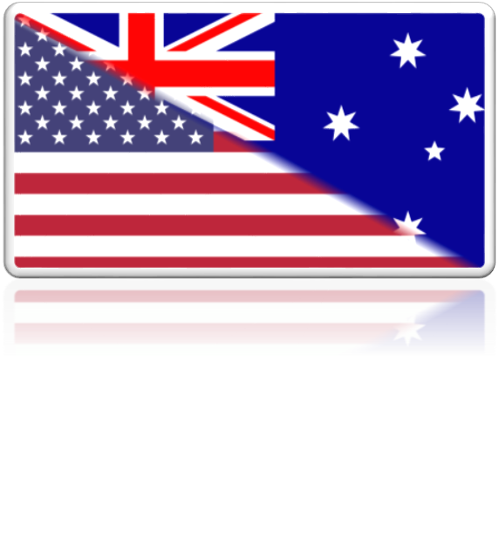
“It’s very hard to explain what mateship is. You just know when someone is going through good times or bad times. When they need your courage, when you need their courage. That’s what mateship is.”
STUDY TOUR
Peace in the Pacific
CHIEF MINISTER’S

By Shawn Bett
Our Lady of the Sacred Heart Catholic College

“Old Mate! In the gusty old weather,
when our hopes and troubles were new,
In the years spent in wearing out leather,
I found you unselfish and true –
I have gathered these verses together,
For the sake of our friendship and you.”
To an Old Mate, by Henry Lawson

Study Question:
How did the attacks on Pearl Harbour in 1941 and on Darwin in 1942 affect the relationship between Australia and the United States of America?

Mateship
Set in World War II’s Pacific Theatre, the bombings on Pearl Harbour in 1941 then Darwin in 1942, developed a powerful and enduring relationship between Australia and the United States of America. Firstly, these two attacks contained many parallels that led the two nations to ally in pursuance of a shared enemy. Secondly, the first interactions between Australians and Americans on Australian soil, while socially dysfunctional, blossomed the relationship into a victorious alliance in Aboriginal activism. Thirdly, the relationship left a momentous and evolving legacy that can be seen today. Born in the wounds of each nation, the relationship between Australia and the United States has been extremely beneficial, bringing new cultural identity and security in the Pacific, tracing back to the memory of the attacks.
On December 7th 1941, 360 Japanese bombers attacked Pearl Harbour, a U.S. base on Oahu Island, Hawaii. In the surprise attack, 2,403 soldiers and civilians were killed, with another 1,178 Americans left wounded. 164 planes were destroyed, and six battleships and three destroyers were sunk, with a further number heavily-damaged. Following the Japanese’ swift advancements in South-East Asia by early-1942, U.S. troops had begun to arrive in Australia. On the 19th February 1942, Darwin Harbour, a vital Australian military and naval-base, was bombarded by two air-raids. The Japanese dropped 683 bombs compared to Pearl Harbour’s 271, sinking nine-ships, killing 235 people, and wounding a further 300 to 400 people. The devastation concluded on the 12th December 1942, with Japan’s 64th and final air-raid on Darwin.
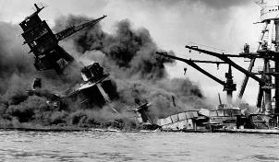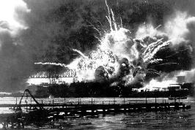
[2]
[1]
Pearl Harbour...
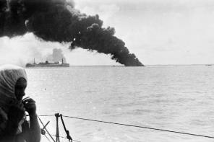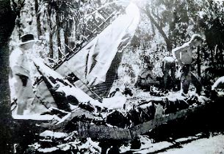
[4]
[3]
Darwin...
The two bombings had key similarities; both were surprising military-strikes by Japan that had destructive effects on human life and military property, and both crippled pivotal defence bases for the two impacted nations. However, there is one vital difference between the two bombings. Americans stationed in Darwin on the 19th gave their greatest efforts to save the lives of Australians. In the first-raid, ten American P-40 Kitty-hawks were Darwin’s only aerial-defence against 188 Japanese aircraft. Of the day’s 235 causalities, 114 were American-troops. Furthermore, eighty-eight were killed in the sinking of the harbour’s largest warship; the American USS Preary. Through the Americans’ sacrifices, the attacks on Pearl Harbour and Darwin invigorated the relationship between Australia and America.
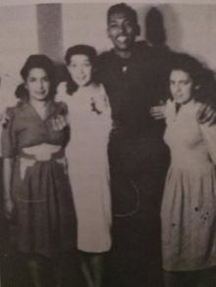
Following the Americans’ arrival on Australian-soil, the relationship rapidly expanded into an alliance of dysfunctionality and activism. By 1943, 150,000 Americans were stationed in Australia, primarily in Queensland. Around this time-period, Australia was considered an “insular” nation; many of its citizens considered themselves “British”, and many had not travelled overseas. Consequently, friction was inevitable between Australians and Americans. American-troops had attractive uniforms, charming manners, and luxury goods including Nylon stockings, chocolates and cigarettes; all of which Australian-soldiers did not have. This was due to the higher rate of pay received by American troops. Based on rank, American soldiers had almost, if not, double the pay as their Australian counterparts. All of these factors made Americans more appealing to Australian women, exemplified by the following quote: “The first time I ever saw a man carrying a bunch of flowers was the Americans.” Subsequently, violent conflicts manifested between Australian and American men, including the Battle of Brisbane on 17th November 1942, and the murders of US-Private Edward Leoniski in May 1942. From all of these factors, it is clearly irrefutable that jealousy and animosity for the American neighbours grew in some Australian men, leading to dysfunctionality in the US-Australian alliance. In a sense however, the social disputes paved the path for Aboriginal activism. While there were many incidents between Australians and Americans, it is also acknowledged that an equally-large number enjoyed friendly relations, including the African-Americans and the Indigenous population; two underprivileged groups of the time. Aborigines and White-Australians had conflicts due to the attitudes persisted by the White Australia Policy. Similarly, African-Americans still fell under Jim Crow laws in Australia and New Guinea, evident by the fact that over 8000 troops worked in segregated forces by late-1942. Inevitably, African-Americans expressed sympathy with Indigenous peoples, setting the pathway for activism. “They made us feel like we were someone....they said lovely words of endearment that the Australian man didn’t....and it was really nice.” The impact of African-American troops on Aboriginals was fully realised in the 1960s, a pivotal-era wherein Aboriginal people achieved citizenship, equal pay, defeated assimilation, and gained back their rights to their land. This directly parallels with America’s Civil Rights Movement, wherein African-Americans fought for social justice through peaceful protests and freedom rides; the latter inspiring the 1965 Aboriginal Freedom-Rides. The fact that both Aboriginals and African-Americans, while separated by thousands of kilometres of Pacific water, achieved essentially the same goals in the same era is striking. From this, it can be determined that the relationship between Australians and Americans created the opportunity for change of civil rights and multiculturalism in both nations; a legacy that lives on today.
[5]
Figure 5: Pansy Hickey (right), with friends and an American Serviceman "Slim", in Sydney

The story of the relationship between Australia and America did not end in World War II; rather, it became more fulfilling as time passed. While the presence of American-servicemen influenced the rise of Indigenous-Australian activism, they also greatly impacted Australia’s cultural scene. New ideas in Australian fashion, manufactured-goods, domestic-technology, language, music, food, and consumerism were created; all of which survive today. America has also gained remarkable benefits from its relationship with Australia. The conclusion of World War II, by the atomic bombings on Hiroshima and Nagasaki in 1945, did not diminish the threat of other global terrors. In response, America, Australia, and separately, New Zealand, formalised the ANZUS Treaty in 1951. This agreement, designed for the security of the Pacific and endures to this day, has seen Australia allied with America in every major military conflict since World War II; a title no other country can claim. The September 11th 2001 terrorist attacks, which eclipsed Pearl Harbour as America’s most traumatic event, caused Australia’s first invocation of the treaty.⁽⁾ ⁽⁾ This perfectly echoes America’s support for Australia in World War II, wherein after Darwin’s bombing, Australia was left vulnerable to the incoming Japanese forces. Similarly, the September 11 attacks shattered the myth of America’s invisibility. However, it was through the help of a mate, in the darkest times, that they were able to pull through, survive, and prosper. I believe that this is a true inspiration and a quintessential example of how two nations, while seemingly so different, can overcome the odds and stand together in the face of tragedy.
The relationship between Australia and the United States, born in the bombings of Pearl Harbour and Darwin, symbolises the ever-evolving but never-changing support the two nations provide to one another in a growing world.
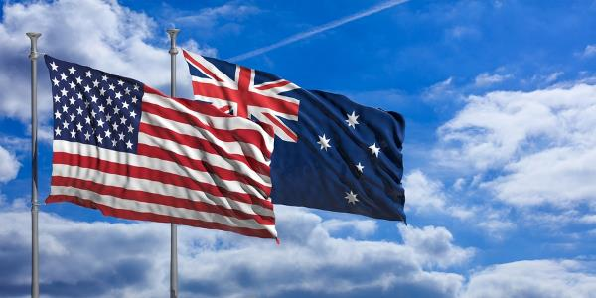
[6]

(1100 words – Without citations and picture captions)
(1099 words – Excluding title “Mateship”)
Bibliography
Opening Quotation “It’s very hard...”
- Australia in the US. Celebrating the first 100 years of Mateship. (Online video, April 18 2018). https://www.youtube.com/watch?time_continue=11&v=k9IPJ48okpI
Websites
- “Australian – American Relations.” U.S. Marines in Wartime Melbourne 1943. Accessed July 25 2018. http://history.unimelb.edu.au/overhere/australian-american-relations.html
- "Bombing of Darwin." Australian War Memorial. Accessed July 26, 2018. https://www.awm.gov.au/collection/E59
- “Bombing of Darwin.” Australian Maritime Museum. Accessed July 25, 2018, http://stories.anmm.gov.au/darwin/
- “Civil Rights Movement – Black History”. History.COM. Accessed July 25 2018. https://www.history.com/topics/black-history/civil-rights-movement
- “United States forces in Australia”. Australian War Memorial. Accessed July 22, 2018. https://www.awm.gov.au/articles/encyclopedia/homefront/us_forces
- "Roll of Honour." Northern Territory Library. Accessed July 25, 2018. http://www.ntlexhibit.nt.gov.au/exhibits/show/bod.
- "The attack on Pearl Harbour reverberates – 75 years on” SBS News. Accessed 25th July 2018. https://www.sbs.com.au/news/the-attack-on-pearl-harbour-reverberates-75-years-on
Websites (Author):
- Campion, Jessica. “How Aboriginal Activism brought about change”. Australian Geographic. July 14, 2011. Accessed July 25 2018. http://www.australiangeographic.com.au/topics/history-culture/2011/07/how-aboriginal-activism-brought-about-change
- Dunlevie, James. "Bombing of Darwin: The Story of US Kittyhawk Pilots Buel and Oestreicher." ABC News. February 19, 2016. Accessed July 25, 2018. http://www.abc.net.au/news/2016-02-19/us-kittyhawk-pilots-buel-and-oestreicher/7181406.
- Lewis, Tom “The American Alliance: founded in blood and sacrifice in Darwin.” Place Unknown. Northern Territory Government. 2017 https://researchoutput.csu.edu.au/ws/portalfiles/portal/21569906
Books:
- Dumbrell John, and Schafer Axel R. America’s Special Relationships: Foreign and Domestic aspects of the Politics of Alliance. USA and Canada: Routledge. 2009 https://books.google.com.au/books?id=pl2OAgAAQBAJ&pg=PA80&dq=america+and+australia+relationship&hl=en&sa=X&ved=0ahUKEwiF7Yz7zZrcAhUBk5QKHZIiCuAQ6AEIPTAE#v=onepage&q=america%20and%20australia%20relationship&f=false
- King C. David, McRae Norman, and Zola, Jaye, The United States and its people. Place Unknown. Addison-Wesley Publishing Company, Inc. 1995 633
- Mosler David, Catley Bob, and Catley Robert, America and Americans in Australia. West Port CT: Praeger Publishers. 1998 https://books.google.com.au/books?id=YungugjvIaQC&pg=PA33&dq=relations+between+U.S.+and+Australia+wwii&hl=en&sa=X&ved=0ahUKEwjlx8L40f3bAhWBW7wKHdqMBJE4ChDoAQgoMAA#v=onepage&q=relations%20between%20U.S.%20and%20Australia%20wwii&f=false
- Penglase, Joanna, and Horner, David. When the War Came to Australia: Memories of the Second World War. St Leonards, NSW: Allen & Unwin Pty, 1992.
- Willmott, Hedley P. Pearl Harbour. Sydney NSW: AP Publishing Pty Ltd, 2000
Pictures:
[1] – Pearl Harbour Attack | Date, History, Maps & Causalities, Britannica.com Accessed 22nd July 2018. https://www.britannica.com/event/Pearl-Harbor-attack
[2] – How Racism, Arrogance, and Incompetence led to Pearl Harbour. National Geographic, Accessed 27th July 2018, http://www.nationalgeographic.com.au/history/how-racism-arrogance-and-incompetence-led-to-pearl-harbor.aspx
[3] – “Bombing of Darwin.” Australian Maritime Museum. Accessed July 25, 2018, http://stories.anmm.gov.au/darwin/

[4] – Rayner Robert J. The Army and Defence of Darwin Fortress, Marrickville, NSW: Southwood Press Pty Limited, 1995. 179
[5] – Penglase, Joanna, and Horner, David. When the War Came to Australia: Memories of the Second World War. St Leonards, NSW: Allen & Unwin Pty, 1992. 121
[6] – “5 reasons American nurses love nursing in Australia.” Australian Nursing Agency. Accessed July 27 2018. http://us.australiannursingagency.com/blog/5-reasons-american-nurses-love-nursing-in-australia/

David C. King, Norman McRae, and Jaye Zola, The United States and its people, (Place Unknown, Addison-Wesley Pubishing Company, Inc. 1995) 633
Hedly P. Willmott. Pearl Harbour, (Sydney: AP Publishing Pty Ltd, 2000) 8
“Australian – American Relations.” U.S. Marines in Wartime Melbourne 1943. Accessed July 25 2018. http://history.unimelb.edu.au/overhere/australian-american-relations.html
Roll of Honour." Northern Territory Library. Accessed July 25, 2018. http://www.ntlexhibit.nt.gov.au/exhibits/show/bod
“Bombing of Darwin." Australian War Memorial. Accessed July 26, 2018. https://www.awm.gov.au/collection/E59
Lewis, Tom “The American Alliance: founded in blood and sacrifice in Darwin.” Place Unknown. Northern Territory Government. 2017. Page 20 https://researchoutput.csu.edu.au/ws/portalfiles/portal/21569906
Ibid, Page 19
Ibid
“United States forces in Australia”. Australian War Memorial. Accessed July 22, 2018. https://www.awm.gov.au/articles/encyclopedia/homefront/us_forces
Penglase and Horner, When the war came to Australia, 167
Ibid, 169
Penglase and Horner, When the war came to Australia, 169
Patricia Penrose (Isley’s dress designer, Z Special Unit, Melbourne) 2. World War, 1939-1945- Personal Narratives, Australia. (Sourced from When the war came to Australia)
Mosler David, Catley Bob, and Catley Robert, America and Americans in Australia. West Port CT: Praeger Publishers. 1998. 28 https://books.google.com.au/books?id=YungugjvIaQC&pg=PA33&dq=relations+between+U.S.+and+Australia+wwii&hl=en&sa=X&ved=0ahUKEwjlx8L40f3bAhWBW7wKHdqMBJE4ChDoAQgoMAA#v=onepage&q=relations%20between%20U.S.%20and%20Australia%20wwii&f=false
Penglase and Horner, When the war came to Australia, 103
Pansy Hickey ([Aboriginal] textile worker, Sydney) 2. World War, 1939-1945- Personal Narratives, Australia. (Sourced from When the war came to Australia)
Campion, Jessica. “How Aboriginal Activism brought about change”. Australian Geographic. July 14, 2011. Accessed July 25 2018. http://www.australiangeographic.com.au/topics/history-culture/2011/07/how-aboriginal-activism-brought-about-change
“Civil Rights Movement – Black History”. History.COM. Accessed July 25 2018. https://www.history.com/topics/black-history/civil-rights-movement
The Australian War Memorial, “United States forces”
Dumbrell John, and Schafer Axel R. America’s Special Relationships: Foreign and Domestic aspects of the Politics of Alliance. (USA and Canada: Routledge. 2009) 76 https://books.google.com.au/books?id=pl2OAgAAQBAJ&pg=PA80&dq=america+and+australia+relationship&hl=en&sa=X&ved=0ahUKEwiF7Yz7zZrcAhUBk5QKHZIiCuAQ6AEIPTAE#v=onepage&q=america%20and%20australia%20relationship&f=false
Ibid, 76
"The attack on Pearl Harbour reverberates – 75 years on” SBS News. Accessed July 25 2018. https://www.sbs.com.au/news/the-attack-on-pearl-harbour-reverberates-75-years-on

