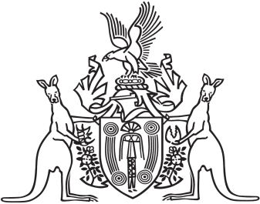
Northern Territory of Australia

Government Gazette
ISSN-0157-8324
No. G12 21 March 2018

General information
The Gazette is published by the Office of the Parliamentary Counsel.
The Gazette will be published every Wednesday, with the closing date for notices being the previous Friday at 4.00 pm.
Notices not received by the closing time will be held over until the next issue.
Notices will not be published unless a Gazette notice request form together with a copy of the signed notice and a clean copy of the notice in Word or PDF is emailed to gazettes@nt.gov.au
Notices will be published in the next issue, unless urgent publication is requested.

Availability
The Gazette will be available online at 12 Noon on the day of publication at https://nt.gov.au/about-government/gazettes
Unauthorised versions of Northern Territory Acts and Subordinate legislation are available online at https://legislation.nt.gov.au/

Northern Territory
Associations Act
Notice of Intention to Dissolve Associations
I, Malcolm John Bryant, as a delegate of the Commissioner, pursuant to section 65(4)(c) of the Associations Act, give notice that the associations specified in the Schedule will be dissolved after 3 months after the date of this notice unless cause to the contrary is shown.
Dated: 15 March 2018
M. J. Bryant
Delegate of Commissioner
Note: Enquiries should be directed to Malcolm Bryant at Licensing NT, Department of the Attorney-General and Justice, Level 3, NAB House, 71 Smith Street, Darwin. Phone: (08) 8999 1339.
____________________________
Schedule
01375c | Isolated Children’s Parents’ Association Barkly Branch Incorporated
01470c | Camel Cup Incorporated
01520c | Ngkarte Mikwekenhe Community Incorporated
02205c | Northern Territory Cardiac Support Group Incorporated
IA02454 | Human Services Training Advisory Council Incorporated
IA02930 | Piston Broke Promotions Incorporated
IA02971 | 2nd/6th Cavalry (Commando) Regiment & 2nd Cavalry Regiment Association (NT) Incorporated
IA03138 | Memo Club Alice Springs Incorporated
IA03150 | Project 127 Incorporated
IA03283 | Croc Bite Comedy Incorporated
_____________________________

