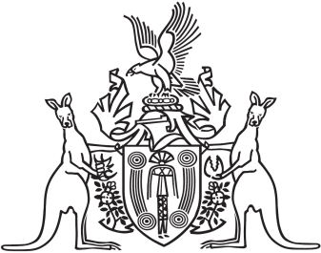
Northern Territory of Australia

Government Gazette
ISSN-0157-833X
No. S75 25 October 2017
Northern Territory of Australia
Pastoral Land Act
Pastoral Land Board
Appointment of Alternate Member
I, Lauren Jane Moss, Minister for Environment and Natural Resources, under section 15(1) of the Pastoral Land Act, appoint Tracey Louise Hayes to act as an alternate member of the Pastoral Land Board for Anne Margaret Kilgariff on and from the date of this instrument to 7 December 2017.
Dated 23 October 2017
L. J. Moss
Minister for Environment and Natural Resources

