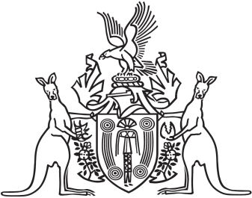
Northern Territory of Australia

Government Gazette
ISSN-0157-833X
No. S62 31 August 2017

Notification of Subordinate Legislation
Notice is given of the making of the following subordinate legislation, effective from the date specified:
Subordinate Legislation | Commencement details | Empowering Act
Education and Care Services (National Uniform Legislation) (Act Amendment) Regulations 2017  (No. 27 of 2017) | (1) These Regulations (except regulations 28, 29 and 72) commence on 1 October 2017  (2) Regulations 28, 29 and 72 commence on 1 February 2018 | Education and Care Services (National Uniform Legislation) Act
For copies of legislation please direct your request to the Print Management Unit, email pmu.ntg@nt.gov.au or phone (08) 8999 6727

