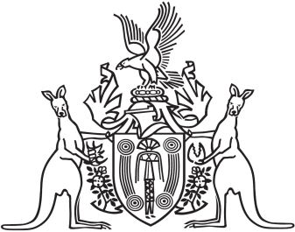
Northern Territory of Australia

Government Gazette
ISSN-0157-8324
No. G34 24 August 2016

General information
The Gazette is published by the Office of the Parliamentary Counsel.
The Gazette will be published every Wednesday, with the closing date for notices being the previous Wednesday at 4.00 pm.
Notices not received by the closing time will be held over until the next issue.
Notices will not be published unless a Gazette notice request form together with a copy of the signed notice and a clean copy of the notice in Word or PDF is emailed to gazettes@nt.gov.au
Notices will be published in the next issue, unless urgent publication is requested.

Availability
The Gazette will be available online at 12 Noon on the day of publication at http://www.nt.gov.au/ntg/gazette.shtml
Unauthorised versions of Northern Territory Acts and Subordinate legislation are available online at http://www.legislation.nt.gov.au

Northern Territory of Australia

Information Act
Appointment of Acting Commissioner
I, Johan Wessel Elferink, Attorney-General and Minister for Justice, under section 94(1)(b) of the Information Act:
(a) with effect from 1 August 2016 to 31 October 2016 and from 1 February 2017 to 30 April 2017:
(i) appoint Allan Abram Joseph Borg to act as the Information Commissioner (Commissioner) during all periods when the Commissioner is unable to perform the duties of the office; and
(ii) appoint Caroline Norrington to act as the Commissioner during all periods when the Commissioner is unable to perform the duties of the office if Allan Abram Joseph Borg is unable, for any reason, to act as the Commissioner; and
(b) with effect from 1 November 2016 to 31 January 2017 and from 1 May 2017 to 31 July 2017:
(i) appoint Caroline Norrington to act as the Commissioner during all periods when the Commissioner is unable to perform the duties of the office; and
(ii) appoint Allan Abram Joseph Borg to act as the Commissioner during all periods when the Commissioner is unable to perform the duties of the office if Caroline Norrington is unable, for any reason, to act as the Commissioner.
Dated 4 August 2016
J. W. Elferink
Attorney-General and Minister for Justice

