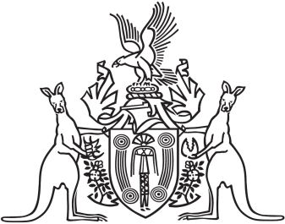
Northern Territory of Australia

Government Gazette
ISSN-0157-833X
No. S89 5 August 2016
Northern Territory of Australia

Crown Lands Act
Reserve No. 1663 (Blatherskite Park Reserve)
Appointment of Trustee
I, Bess Nungarrayi Price, Minister for Local Government and Community Services, under section 79(1) of the Crown Lands Act, appoint Joanne Mary Doyle to be a trustee of Reserve No. 1663 (Blatherskite Park Reserve).
Dated 5 August 2016
B. N. Price
Minister for Local Government and Community Services

