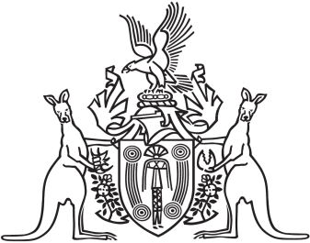
Northern Territory of Australia

Government Gazette
ISSN-0157-833X
No. S86 5 August 2016
Northern Territory of Australia

Weeds Management Act
Appointment of Member
Northern Territory Weed Advisory Committee
I, Gary John Higgins, Minister for Land Resource Management, under section 16(2) of the Weeds Management Act, appoint Garry Wayne Fischer to be a member of the Northern Territory Weed Advisory Committee on and from 1 August 2016.
Dated 4 August 2016
G. J. Higgins
Minister for Land Resource Management

