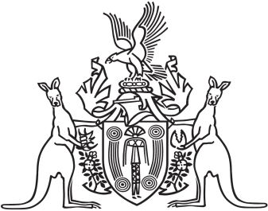
Northern Territory of Australia

Government Gazette
ISSN-0157-833X
No. S48 30 May 2016
Northern Territory of Australia

Public and Environmental Health Act
Appointment of Acting Chief Health Officer
I, Johan Wessel Elferink, Minister for Health:
- under section 67(1) of the Public and Environmental Health Act and with reference to section 43 of the Interpretation Act, revoke the instrument entitled "Appointment of Acting Chief Health Officer", dated 22 January 2015 and published in Gazette No. S5 dated 23 January 2015; and
- under section 67(1) of the Public and Environmental Health Act and with reference to sections 42(1)(b) and 44(2)(b) of the Interpretation Act, appoint each person named in the Schedule to act in the office of Chief Health Officer:
- during the periods specified opposite the person; and
- while no other person has been appointed under section 67(1) of the Public and Environmental Health Act to act in the office during a particular period.
Dated 27 May 2016
J. W. Elferink
Minister for Health
Schedule
Person appointed to act as Chief Health Officer | Period of appointment to act
Hugh Crosbie Heggie | All periods when Dinesh Kumar Arya is unable to perform duties of the office.
Steven Jaye Skov | All periods when neither of the following are able to perform the duties of the office:  - Dinesh Kumar Arya;  - Hugh Crosbie Heggie.
Christine Maree Connors | All periods when none of the following are able to perform the duties of the office:  - Dinesh Kumar Arya;  - Hugh Crosbie Heggie;  - Steven Jaye Skov.
Steven Lindsay Guthridge | All periods when none of the following are able to perform the duties of the office:  - Dinesh Kumar Arya;  - Hugh Crosbie Heggie;  - Steven Jaye Skov;  - Christine Maree Connors.
Victoria Lynn Krause | All periods when none of the following are able to perform the duties of the office:  - Dinesh Kumar Arya;  - Hugh Crosbie Heggie;  - Steven Jaye Skov;  - Christine Maree Connors;  - Steven Lindsay Guthridge.

