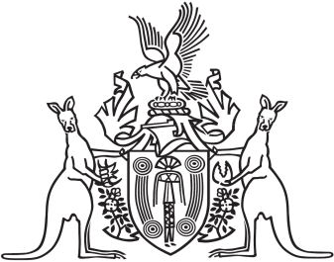
Northern Territory of Australia

Government Gazette
ISSN-0157-833X
No. S15 25 February 2016
Northern Territory of Australia

Plant Health Act
Revocation of Declarations of Quarantine Place for Control of Cucumber Green Mottle Mosaic Virus
I, Leonie Michelle Cooper, Chief Inspector of Plant Health, under section 18(1) of the Plant Health Act and with reference to section 43 of the Interpretation Act, with effect on and from 28 February 2016, revoke all instruments declaring a quarantine place for the control of the declared pest Cucumber Green Mottle Mosaic Virus in force immediately before the date of this instrument.
Dated 22 February 2016
L. M. Cooper
Chief Inspector of Plant Health

