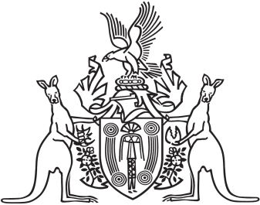
Northern Territory of Australia

Government Gazette
ISSN-0157-833X
No. S6 9 February 2016
Notification of Subordinate Legislation
Notice is given of the making of the following subordinate legislation, effective from the date specified:
Subordinate Legislation | Commencement details | Empowering Act
Work Health and Safety (National Uniform Legislation) Amendment Regulations 2016  No. 1 of 2016 | These Regulations commence on 4 April 2016 | Work Health and Safety (National Uniform Legislation) Act
For copies of legislation please direct your request to the Print Management Unit, email pmu.dcm@nt.gov.au or phone (08) 8999 6727

