Mineral Titles Act
NOTICE OF GRANT OF A MINERAL TITLE
Title Type and Number: | Mineral Lease 34134
Granted: | 31 July 2026, for a period of 25 Years
Area: | 2127.00 Hectares
Locality: | SHORT RANGE
Name of Holder/s: | 60% TENNANT CONSOLIDATED MINING GROUP PTY LTD [ACN. 645 263 547], 40% SANTEXCO PTY LTD [ACN. 002 910 296]
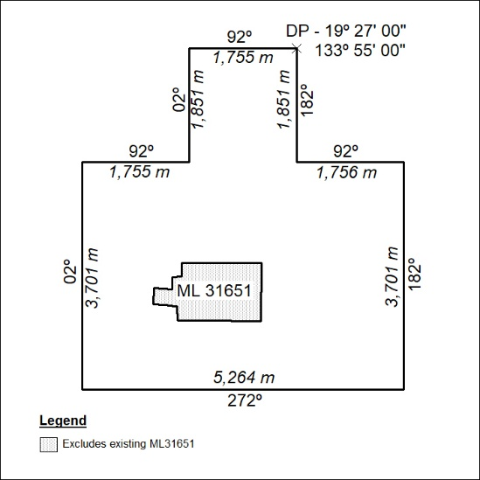

336/26

Mineral Titles Act
NOTICE OF GRANT OF A MINERAL TITLE
Title Type and Number: | Exploration Licence 34193
Granted: | 31 July 2026, for a period of 6 Years
Area: | 1 Block, 1.00 km²
Locality: | TENNANT CREEK
Name of Holder/s: | 100% TREASURE CREEK PTY LTD [ACN. 619 057 644]
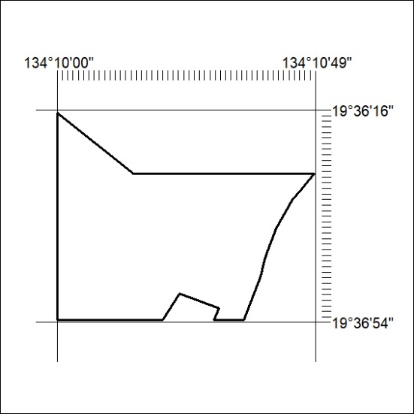
Area granted is indicated above. The titleholder is not permitted to exercise occupational rights on any land that is subject to a development title, or an application for a development title. Any land the subject of a Reserved Land gazettal under the Mineral Titles Act and all land vested in the Commonwealth of Australia is also excluded by description but not excised from the grant area.

337/26

