Mineral Titles Act
NOTICE OF GRANT OF A MINERAL TITLE
Title Type and Number: | Exploration Licence 34149
Granted: | 02 June 2026, for a period of 6 Years
Area: | 2 Blocks, 0.28 km²
Locality: | McKINLAY RIVER
Name of Holder/s: | 100% GMG MINING (NT) PTY LTD [ACN. 634 618 410]
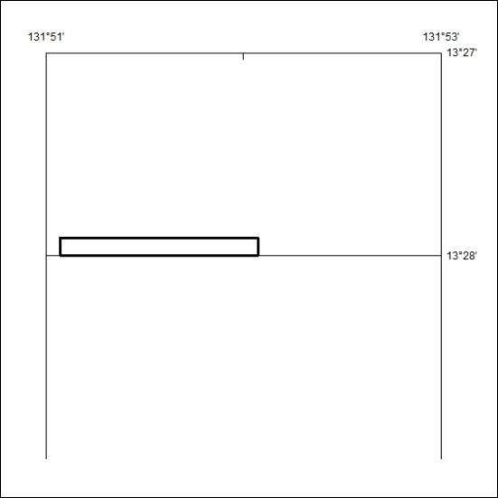
Area granted is indicated above. The titleholder is not permitted to exercise occupational rights on any land that is subject to a development title, or an application for a development title. Any land the subject of a Reserved Land gazettal under the Mineral Titles Act and all land vested in the Commonwealth of Australia is also excluded by description but not excised from the grant area.

175/26

