Mineral Titles Act 2010
NOTICE OF LAND CEASING TO BE A MINERAL TITLE APPLICATION AREA
Title Type and Number: | Exploration Licence 33468
Area Ceased on: | 13 March 2026
Area: | 185 Blocks, 607.93 km²
Locality: | OT DOWNS
Name of Applicant(s)/Holder(s): | 100% GCM CORPORATION LIMITED* [ACN. 118 788 846]
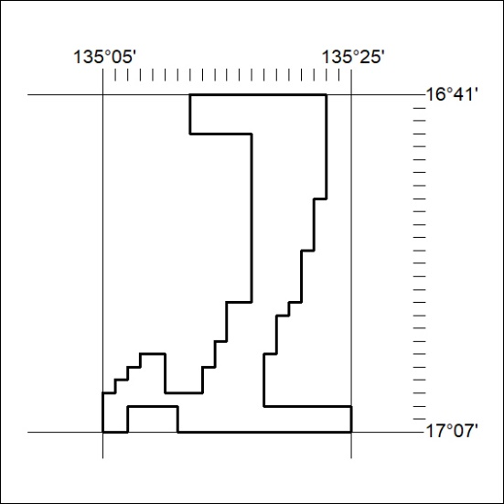

85/26

Mineral Titles Act 2010
NOTICE OF LAND CEASING TO BE A MINERAL TITLE APPLICATION AREA
Title Type and Number: | Exploration Licence 33629
Area Ceased on: | 13 March 2026
Area: | 93 Blocks, 304.81 km²
Locality: | KILGOUR
Name of Applicant(s)/Holder(s): | 100% GCM CORPORATION LIMITED* [ACN. 118 788 846]
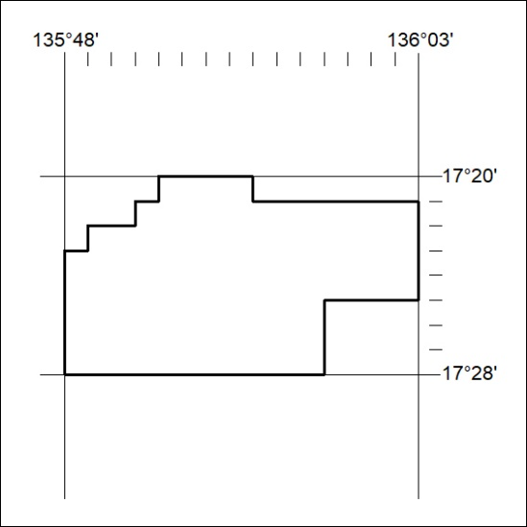

86/26

Mineral Titles Act 2010
NOTICE OF LAND CEASING TO BE A MINERAL TITLE APPLICATION AREA
Title Type and Number: | Exploration Licence 33633
Area Ceased on: | 13 March 2026
Area: | 199 Blocks, 651.88 km²
Locality: | CRESWELL DOWNS
Name of Applicant(s)/Holder(s): | 100% GCM CORPORATION LIMITED* [ACN. 118 788 846]
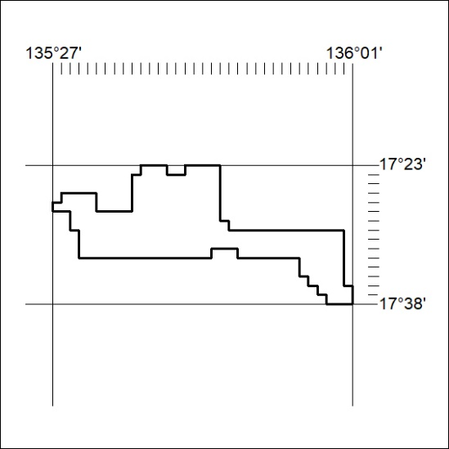

87/26

Mineral Titles Act 2010
NOTICE OF LAND CEASING TO BE A MINERAL TITLE APPLICATION AREA
Title Type and Number: | Exploration Licence 33634
Area Ceased on: | 13 March 2026
Area: | 200 Blocks, 651.28 km²
Locality: | MUNKADERRY
Name of Applicant(s)/Holder(s): | 100% GCM CORPORATION LIMITED* [ACN. 118 788 846]
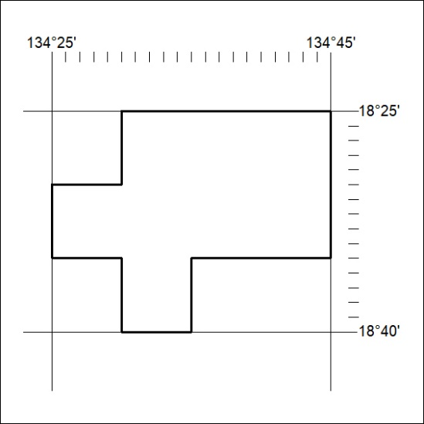

88/26

Mineral Titles Act 2010
NOTICE OF LAND CEASING TO BE A MINERAL TITLE APPLICATION AREA
Title Type and Number: | Exploration Licence 33635
Area Ceased on: | 13 March 2026
Area: | 201 Blocks, 657.62 km²
Locality: | CRESWELL DOWNS
Name of Applicant(s)/Holder(s): | 100% GCM CORPORATION LIMITED* [ACN. 118 788 846]
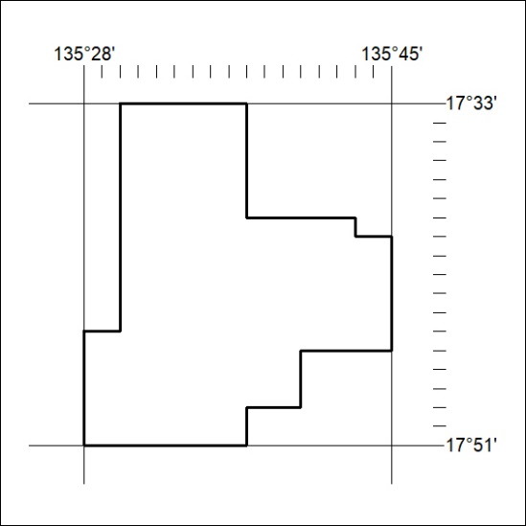

89/26

Mineral Titles Act 2010
NOTICE OF LAND CEASING TO BE A MINERAL TITLE APPLICATION AREA
Title Type and Number: | Exploration Licence 33655
Area Ceased on: | 13 March 2026
Area: | 33 Blocks, 108.27 km²
Locality: | BLOODWOOD CREEK
Name of Applicant(s)/Holder(s): | 100% GCM CORPORATION LIMITED* [ACN. 118 788 846]
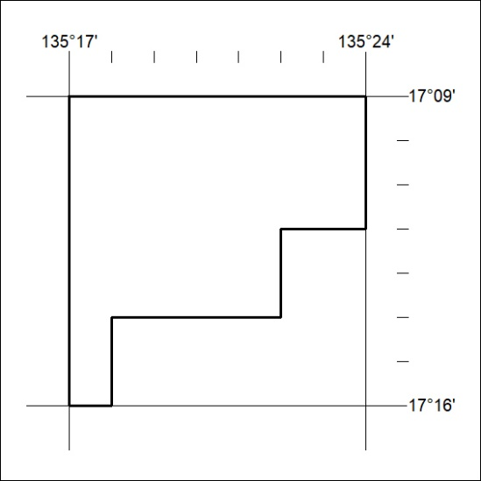

90/26

Mineral Titles Act 2010
NOTICE OF LAND CEASING TO BE A MINERAL TITLE APPLICATION AREA
Title Type and Number: | Exploration Licence 33657
Area Ceased on: | 13 March 2026
Area: | 250 Blocks, 814.66 km²
Locality: | MONMOONA
Name of Applicant(s)/Holder(s): | 100% GCM CORPORATION LIMITED* [ACN. 118 788 846]
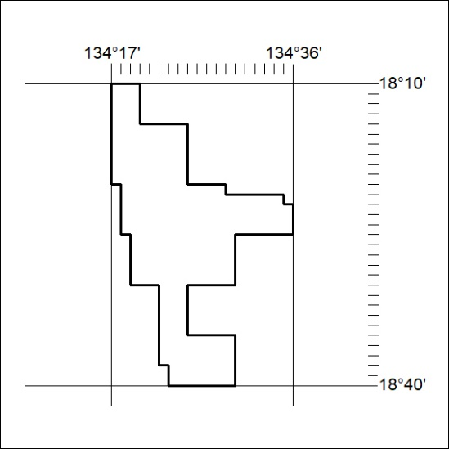

91/26

Mineral Titles Act 2010
NOTICE OF LAND CEASING TO BE A MINERAL TITLE APPLICATION AREA
Title Type and Number: | Exploration Licence 33722
Area Ceased on: | 13 March 2026
Area: | 250 Blocks, 821.93 km²
Locality: | OCTOBER
Name of Applicant(s)/Holder(s): | 100% GCM CORPORATION LIMITED* [ACN. 118 788 846]
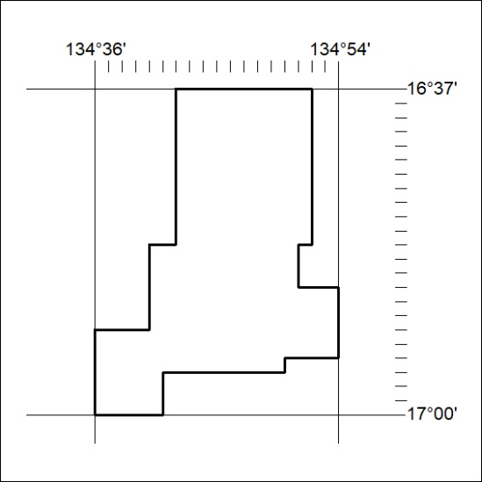

92/26

