Mineral Titles Act 2010
NOTICE OF LAND CEASING TO BE A MINERAL TITLE AREA
Title Type and Number: | Exploration Licence 32864
Area Ceased on: | 24 March 2025
Area: | 54 Blocks, 170.88 km²
Locality: | MT WEDGE
Name of Applicant(s)/Holder(s): | 100% CHALCO RESOURCES PTY LTD [ACN. 648 662 346]
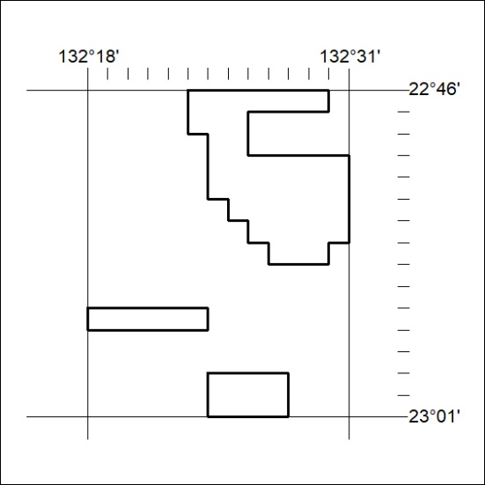

226/25

Mineral Titles Act 2010
NOTICE OF LAND CEASING TO BE A MINERAL TITLE AREA
Title Type and Number: | Exploration Licence 33189
Area Ceased on: | 21 March 2025
Area: | 42 Blocks, 140.06 km²
Locality: | PINE CREEK
Name of Applicant(s)/Holder(s): | 100% MANGUSTA MINERALS PTY LTD [ACN. 653 950 522]
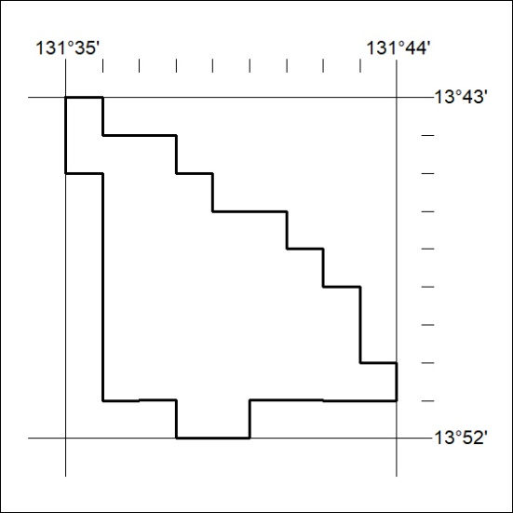

227/25

Mineral Titles Act 2010
NOTICE OF LAND CEASING TO BE A MINERAL TITLE APPLICATION AREA
Title Type and Number: | Exploration Licence 33451
Area Ceased on: | 24 March 2025
Area: | 249 Blocks, 803.98 km²
Locality: | SHORT RANGE
Name of Applicant(s)/Holder(s): | 100% LANE Michael Dominic
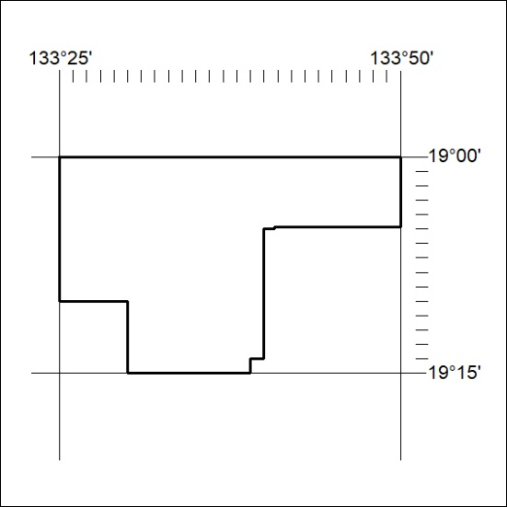

228/25

