Mineral Titles Act 2010
NOTICE OF LAND CEASING TO BE A MINERAL TITLE APPLICATION AREA
Title Type and Number: | Exploration Licence 33734
Area Ceased on: | 03 March 2025
Area: | 144 Blocks, 437.19 km²
Locality: | TODD
Name of Applicant(s)/Holder(s): | 100% SBR METALS (SA) PTY LTD [ACN. 674 331 170]
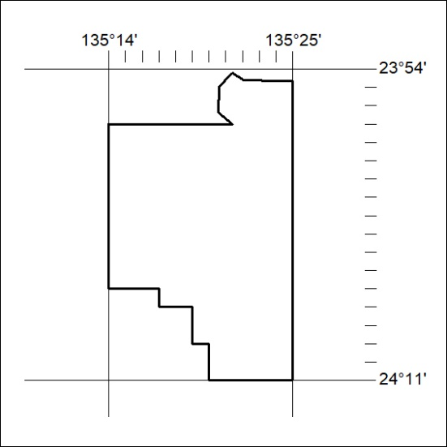

67/25

Mineral Titles Act 2010
NOTICE OF LAND CEASING TO BE A MINERAL TITLE AREA
Title Type and Number: | Exploration Licence 33375
Area Ceased on: | 21 February 2025
Area: | 73 Blocks, 227.98 km²
Locality: | DALMORE
Name of Applicant(s)/Holder(s): | 100% KNOX RESOURCES PTY LTD* [ACN. 623 480 286]
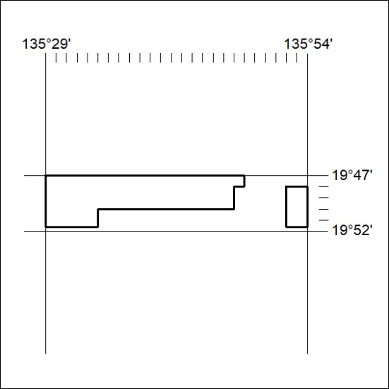

68/25

