Mineral Titles Act 2010
NOTICE OF LAND CEASING TO BE A MINERAL TITLE AREA
Title Type and Number: | Extractive Mineral Permit 29618
Area ceased on: | 22 February 2025
Locality: | FERGUSSON RIVER
Name of Applicants(s)Holder(s): | 100% NORTHERN AG & CIVIL PTY LTD [ACN. 638 956 788]
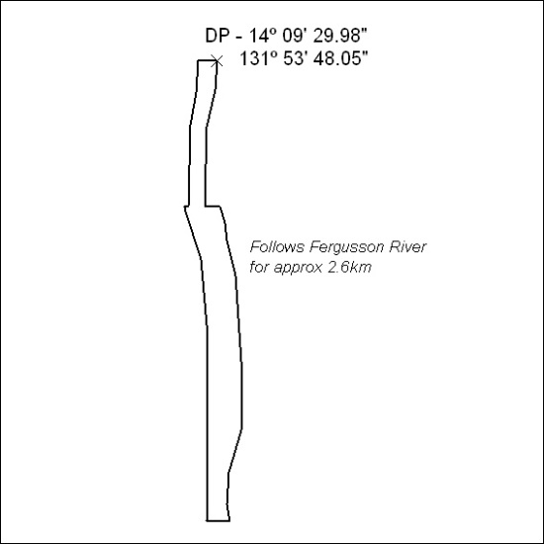

60/25

Mineral Titles Act 2010
NOTICE OF LAND CEASING TO BE A MINERAL TITLE AREA
Title Type and Number: | Exploration Licence 33262
Area Ceased on: | 26 February 2025
Area: | 242 Blocks, 769.68 km²
Locality: | MACDONALD DOWNS
Name of Applicant(s)/Holder(s): | 100% SANDFIRE RESOURCES LIMITED* [ACN. 105 154 185]
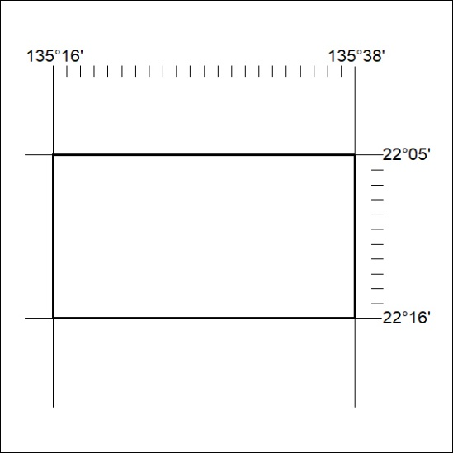

61/25

Mineral Titles Act 2010
NOTICE OF LAND CEASING TO BE A MINERAL TITLE AREA
Title Type and Number: | Exploration Licence 33463
Area Ceased on: | 28 February 2025
Area: | 15 Blocks, 47.52 km²
Locality: | DNEIPER
Name of Applicant(s)/Holder(s): | 100% IGO NEWSEARCH PTY LTD [ACN. 142 192 701]
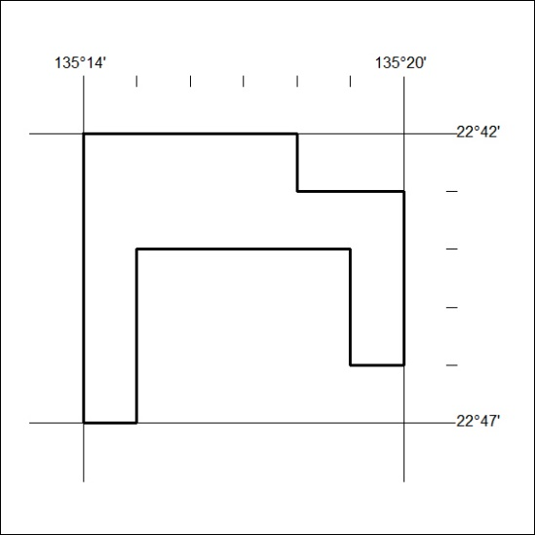

62/25

Mineral Titles Act 2010
NOTICE OF LAND CEASING TO BE A MINERAL TITLE AREA
Title Type and Number: | Exploration Licence 33265
Area Ceased on: | 26 February 2025
Area: | 206 Blocks, 655.11 km²
Locality: | LUCY
Name of Applicant(s)/Holder(s): | 100% SANDFIRE RESOURCES LIMITED* [ACN. 105 154 185]
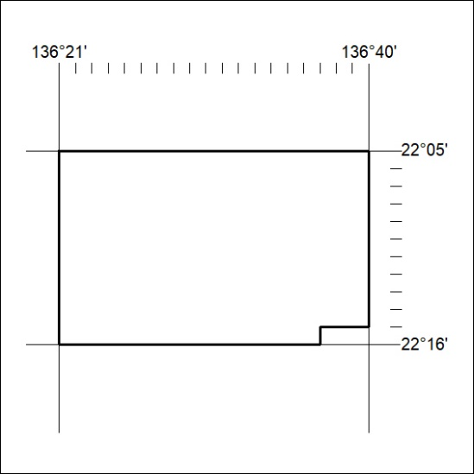

63/25

Mineral Titles Act 2010
NOTICE OF LAND CEASING TO BE A MINERAL TITLE AREA
Title Type and Number: | Exploration Licence 33266
Area Ceased on: | 26 February 2025
Area: | 181 Blocks, 559.00 km²
Locality: | MACDONALD DOWNS
Name of Applicant(s)/Holder(s): | 100% SANDFIRE RESOURCES LIMITED* [ACN. 105 154 185]
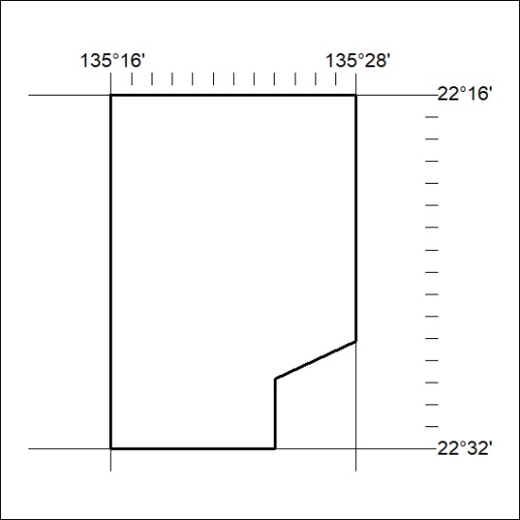

64/25

Mineral Titles Act 2010
NOTICE OF LAND CEASING TO BE A MINERAL TITLE AREA
Title Type and Number: | Exploration Licence 33270
Area Ceased on: | 26 February 2025
Area: | 224 Blocks, 711.37 km²
Locality: | LUCY
Name of Applicant(s)/Holder(s): | 100% SANDFIRE RESOURCES LIMITED* [ACN. 105 154 185]
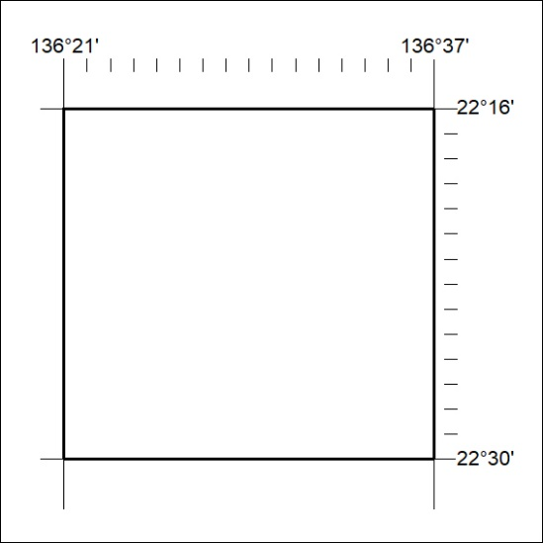

65/25

Mineral Titles Act 2010
NOTICE OF LAND CEASING TO BE A MINERAL TITLE AREA
Title Type and Number: | Exploration Licence 33275
Area Ceased on: | 26 February 2025
Area: | 52 Blocks, 164.80 km²
Locality: | JERVOIS RANGE
Name of Applicant(s)/Holder(s): | 100% SANDFIRE RESOURCES LIMITED* [ACN. 105 154 185]
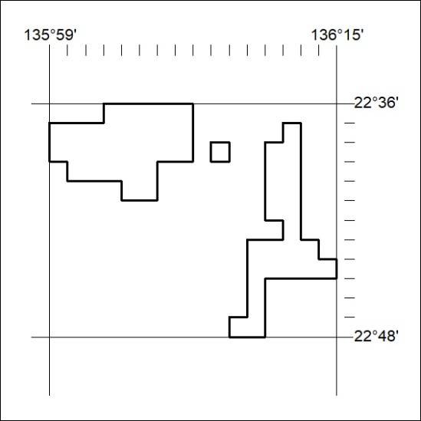

66/25

