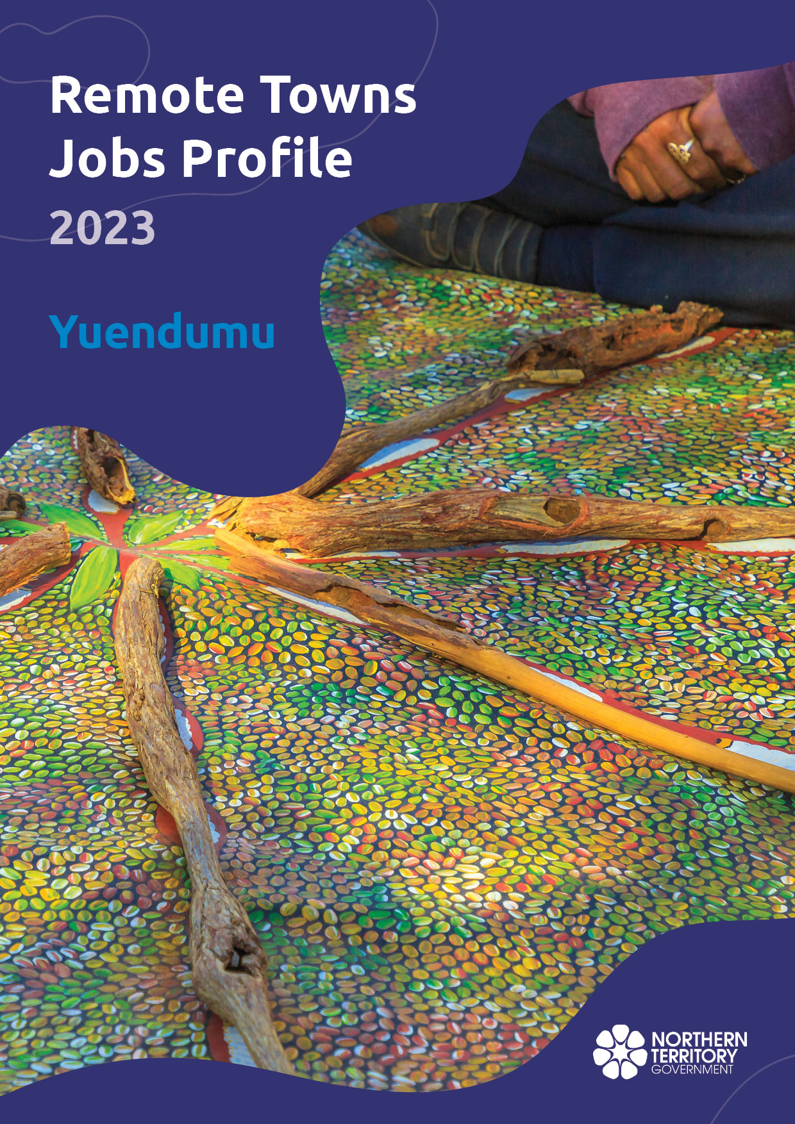

**© Northern Territory of Australia 2025**

**Preferred Reference:** Department of Trade, Business and Asian Relations, 2023 Remote Towns Jobs Profiles, Northern Territory Government, January 2025, Darwin.

**Front cover image**: Aboriginal bush painting at Karrke Aboriginal Cultural Experience.

**Disclaimer**

The data in this publication was collected by conducting a survey of businesses located in the 28 remote town boundaries. This body of work was completed in 2023 by the former Northern Territory Department of Industry, Tourism and Trade.

The collection methodology was created in accordance with Australian Bureau of Statistics data quality framework principles. Data in this publication is only reflective of those businesses reported on as operating in the town at the time of data collection (see table at the end of publication for list of businesses reported on). To comply with privacy legislation or where appropriate, some data in this publication may have been adjusted and will not reflect the actual data reported by businesses. As a result of this, combined with certain data not being reported by some businesses, some components may not add to totals. Changes over time may also reflect change in business propensity to report on certain data items rather than actual changes over time. Total figures have generally not been adjusted. Caution is advised when interpreting the comparisons made to the earlier 2011, 2014 and 2017 publications as the businesses identified and reported on and the corresponding jobs may differ between publications. The surveys have not always gathered data on training and jobs in the same years.

**Notes for each table and chart are ordered alphabetically and listed at the end of the publication.**

The Northern Territory of Australia exercised due care and skill to ensure that at the time of publication the information contained in this publication is true and correct. However, it is not intended to be relied on as professional advice or used for commercial purposes. The Territory gives no warranty or assurances as to the accuracy of the information contained in the publication and to the maximum extent permitted by law accepts no direct or indirect liability for reliance on its content.

Any use of this report for commercial purposes is not endorsed by the Department of Trade, Business and Asian Relations.

Contents

Yuendumu 4

Introduction 5

Summary 6

Jobs overview 7

Jobs filled by Aboriginality 8

Jobs by sector: Private and public 11

Job status: Permanent and temporary 17

Job vacancies 21

Jobs by industry 24

Jobs by occupation 30

Jobs by industry by occupation 34

Jobs by gender 37

Jobs by age 43

Vocational Education and Training 49

Population 56

Community Development Program 58

Businesses 59

Notes 61

Abbreviations and Acronyms 62

# Yuendumu

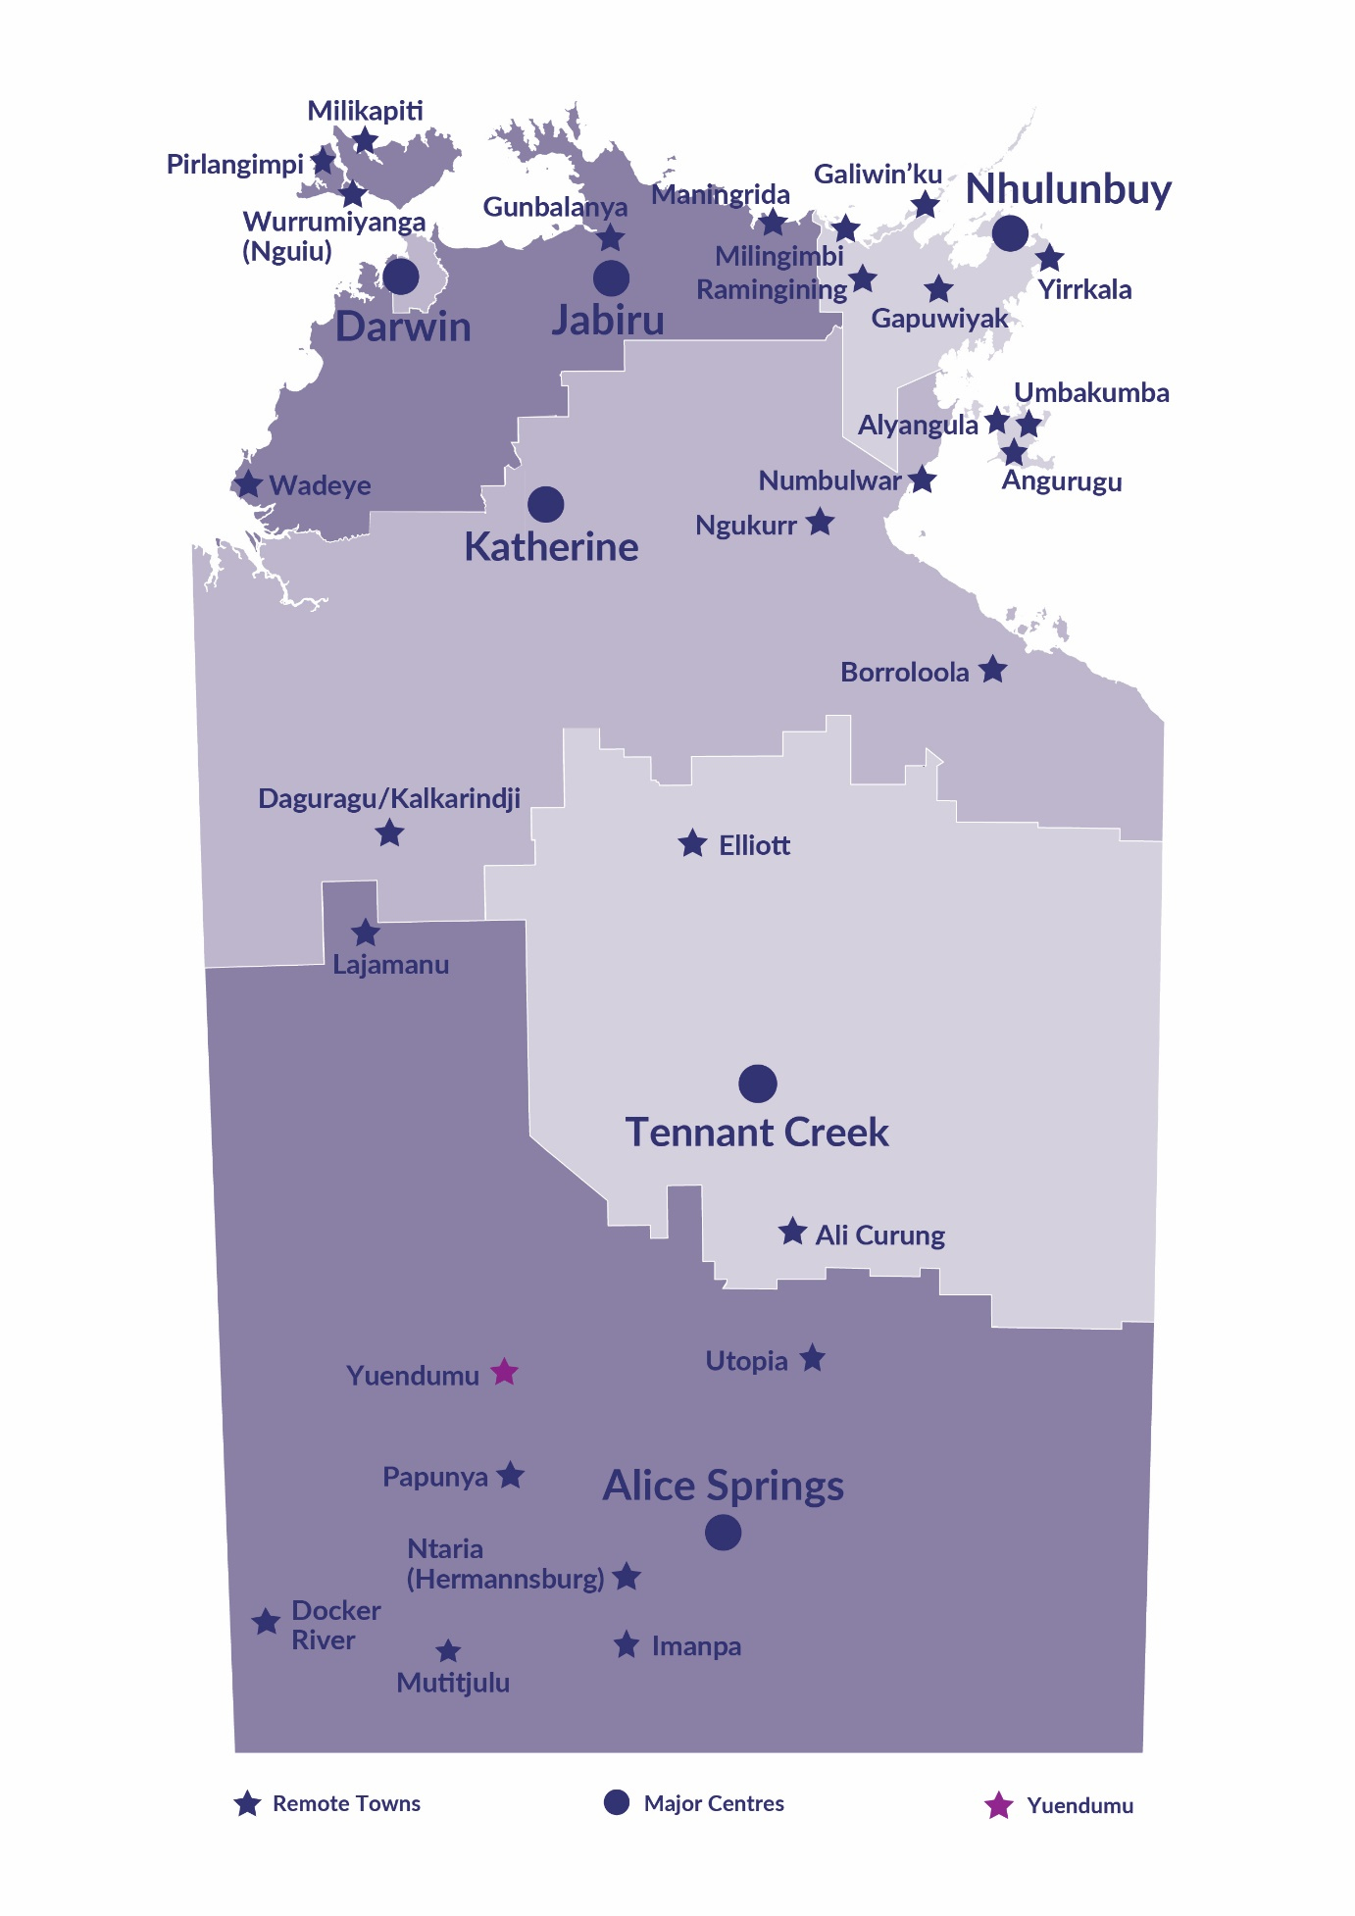Yuendumu is located 290 kilometres north-west of Alice Springs on the Tanami Highway, with a population of 738 residents.

*Source: Northern Territory Department of Industry, Tourism and Trade*

# Introduction

This jobs profile provides a snapshot of jobs and the characteristics of job holders in Yuendumu as of September 2023. Trends from the surveys conducted in 2011, 2014, and 2017 are also described. Additionally, it presents data on Community Development Program activity, Population, and Vocational Education and Training.

This job profile is one of 28 profiles developed for remote towns in the Northern Territory. It is anticipated these, and subsequent profiles will contribute to a robust evidence base to inform decision making in and relating to these remote Territory towns.

This profile contains information collected by the Northern Territory Department of Industry, Tourism and Trade from businesses operating within the town and is supplemented by other administrative data sets and information.

Each profile provides up-to-date information that is intended to inform the planning and design of current and future government programs and as an evidence base to inform decision making relating to workforce development, enterprise and job opportunities.

The profile may best be understood as a point-in-time tool. The number of business surveys from which the data was drawn is significantly less than in earlier surveys, and business participation has decreased with each survey. For Yuendumu, 26% fewer businesses than in 2017 are reported here.

The data collection methodology and corresponding questionnaire were created in partnership with the Australian Bureau of Statistics (ABS) and in accordance with ABS data quality framework and survey principles.

The Department of Industry, Tourism and Trades’ Territory Engagement and Delivery, Skills Initiative and VET data teams collaborated with the Northern Institute at Charles Darwin University to facilitate the surveys and reports.

The information collected and reported on represents a significant goodwill investment by those businesses and organisations that participated. Each business is listed at the end of this publication.

# Summary

The 2023 jobs profile was developed based on responses from 14 businesses operating within the Yuendumu town boundary, 5 less than in the 2017 survey. Of these, there were:

* 8 businesses from the Private Sector, accounting for 137 jobs filled or 70% of total jobs filled
* 6 businesses from the Public Sector, accounting for 59 jobs filled or 30% of total jobs filled
* 8 businesses participated in all four surveys (completed in 2011, 2014, 2017 and 2023)

A total of 267 jobs in Yuendumu were reported, an increase of 19 jobs from 2017.[1]

The 2023 profile highlights:

* there were 196 jobs filled of which:
* 131 jobs (67%) were filled by Aboriginal people, an increase of 19 jobs from 2017
* 65 jobs (33%) were filled by non-Aboriginal people, a decrease of 27 jobs from 2017
* 52% of employed Aboriginal people are working in the Private Sector
* Aboriginal people accounted for 67% of job holders in the town compared to 55% in 2017
* 53% of total Aboriginal filled jobs are filled by Aboriginal females, compared to 41% in 2017
* there were 71 jobs vacancies, of which:
* job vacancies as a percentage of jobs increased to 27% in 2023 from 18% in 2017
* 1 in 4 jobs were vacant
* 28 of the vacancies were in Professional areas
* Public Administration and Safety was the largest industry employer in 2023
* Public Administration and Safety had the highest increase in jobs filled between 2017 and 2023 of 64 jobs
* Health Care and Social Assistance, and Arts and Recreation Services had the highest decrease in jobs filled between 2017 and 2023 of 50 and 21 respectively
* training had a significant decrease in student numbers between 2016 and 2023
* Building and Construction had the highest student numbers in 2023 of 21 students
* Building and Construction had the highest increase in student numbers between 2016 and 2023 of 8 students
* Community Services, Health and Education had the highest decrease in student numbers between 2023 and 2016 of 73 students

The overall population in Yuendumu increased by 49 people (7%) between 2011 and 2021 to 738 people.

In comparison, the overall Northern Territory population increased by 9.7% between 2011 and 2021.

In 2021, the working age population (15 years and over) in Yuendumu was an estimated 533 people compared to 488 in 2011 an increase of 9%.

There were 0.5 jobs in Yuendumu per working age person compared to 0.3 jobs per working age person across the 28 remote towns in the Northern Territory.

# Jobs overview

Table 1: Count of jobs filled and vacancies, 2011, 2014, 2017 & 2023 (a)(b)

|  |  |  |  |  |  |  |  |
| --- | --- | --- | --- | --- | --- | --- | --- |
|  | **2011** | **2014** | **2017** | **2023** | **Change 2011-2014** | **Change 2014-2017** | **Change 2017-2023** |
| **Total All Jobs** | **232** | **255** | **248** | **267** | **23** | **-7** | **19** |
| **Vacancies** | **23** | **26** | **44** | **71** | **3** | **18** | **27** |
| Vacancies as % of Total All Jobs | 9.9% | 10.2% | 17.7% | 26.6% | 0.3 ppt | 7.5 ppt | 8.9ppt |
| **Jobs filled** | **209** | **229** | **204** | **196** | **20** | **-25** | **-8** |
| Full-time | 138 | 145 | 138 | 164 | 7 | -7 | 26 |
| Part-time | 71 | 84 | 66 | 32 | 13 | -18 | -34 |

Source: Northern Territory Department of Industry, Tourism and Trade

Chart 1: Count of jobs vacant and jobs filled by full-time/part-time status, 2011, 2014, 2017 & 2023 (a)(b)

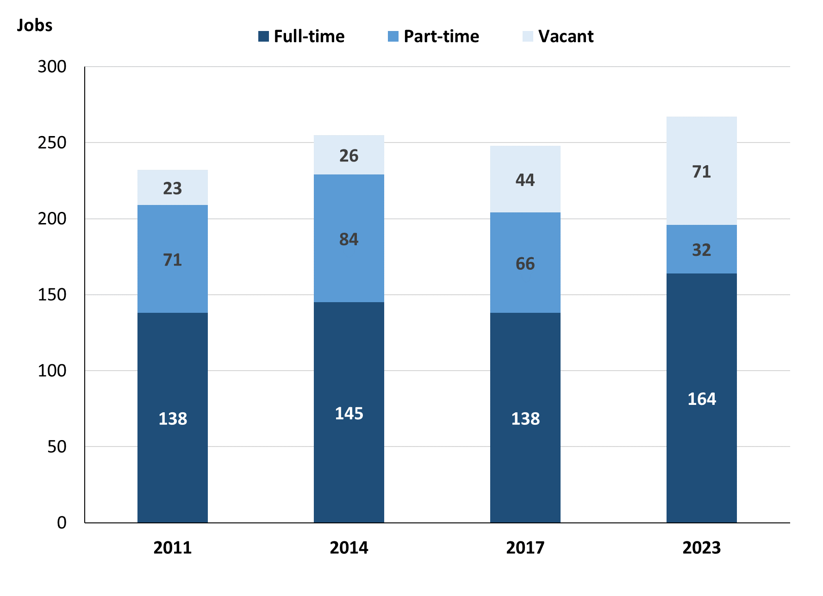

Source: Northern Territory Department of Industry, Tourism and Trade

In 2023 in Yuendumu:

* there was a total of 196 **jobs filled**, a decrease of 8 jobs from 2017 and a decrease of 33 jobs from 2014
* of the 196 **jobs filled** in 2023:
* 164 were **full-time** jobs, an increase of 26 jobs from 2017 and an increase of 19 jobs from 2014
* 32 were **part-time** jobs, a decrease of 34 jobs from 2017 and a decrease of 52 jobs from 2014
* there were 71 total **jobs vacant** in 2023, an increase of 27 vacancies from 2017 and an increase of 45 vacancies from 2014.

# Jobs filled by Aboriginality

Chart 2: Count of jobs filled by Aboriginality, 2011, 2014, 2017 & 2023 (a)(c)

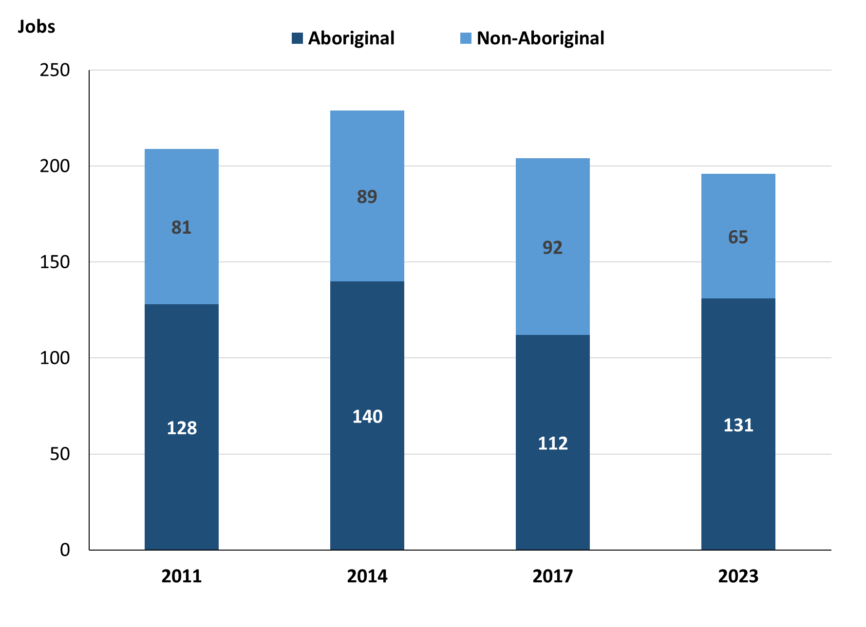

Source: Northern Territory - Department of Industry, Tourism and Trade

In 2023 in Yuendumu:

* of the 196 jobs filled:
* **Aboriginal** people filled 131 jobs, an increase of 19 jobs from 2017 and a decrease of 9 jobs from 2014
* **non-Aboriginal** people filled 65 jobs, a decrease of 27 jobs from 2017 and a decrease of 24 jobs from 2014
* **Aboriginal** people accounted for 67% of job holders compared to 55% in 2017 and 61% in 2014.

Table 2a: Count of jobs filled by full-time/part-time status, 2011, 2014, 2017 & 2023 (a)(b)(c)

|  |  |  |  |  |  |  |  |  |  |  |  |  |  |
| --- | --- | --- | --- | --- | --- | --- | --- | --- | --- | --- | --- | --- | --- |
| **Indicator** | **2011** | | | **2014** | | | **2017** | | | **2023** | | | |
| **Aboriginal** | **Non-Aboriginal** | **Total** | **Aboriginal** | **Non-Aboriginal** | **Total** | **Aboriginal** | **Non-Aboriginal** | **Total** | **Aboriginal** | **Non-Aboriginal** | **Total** |
| Full-time | 64 | 74 | **138** | 66 | 79 | **145** | 51 | 87 | **138** | 101 | 63 | **164** |
| Part-time | 64 | 7 | **71** | 74 | 10 | **84** | 61 | 5 | **66** | 30 | 2 | **32** |
| **Total** | **128** | **81** | **209** | **140** | **89** | **229** | **112** | **92** | **204** | **131** | **65** | **196** |

Source: Northern Territory - Department of Industry, Tourism and Trade

Table 2b: Count of jobs filled by full-time/part-time status, 2011-2014, 2014-2017 & 2017-2023 (a)(b)(c)

|  |  |  |  |  |  |  |  |  |  |
| --- | --- | --- | --- | --- | --- | --- | --- | --- | --- |
| **Indicator** | **Change 2011-2014** | | | **Change 2014-2017** | | | **Change 2017-2023** | | |
| **Aboriginal** | **Non-Aboriginal** | **Total** | **Aboriginal** | **Non-Aboriginal** | **Total** | **Aboriginal** | **Non-Aboriginal** | **Total** |
| Full-time | 2 | 5 | **7** | -15 | 8 | **-7** | 50 | -24 | **26** |
| Part-time | 10 | 3 | **13** | -13 | -5 | **-18** | -31 | -3 | **-34** |
| **Total** | **12** | **8** | **20** | **-28** | **3** | **-25** | **19** | **-27** | **-8** |

Source: Northern Territory - Department of Industry, Tourism and Trade

Chart 3: Count of jobs filled by full-time/part-time, 2011, 2014, 2017 & 2023 (a)(b)(c)

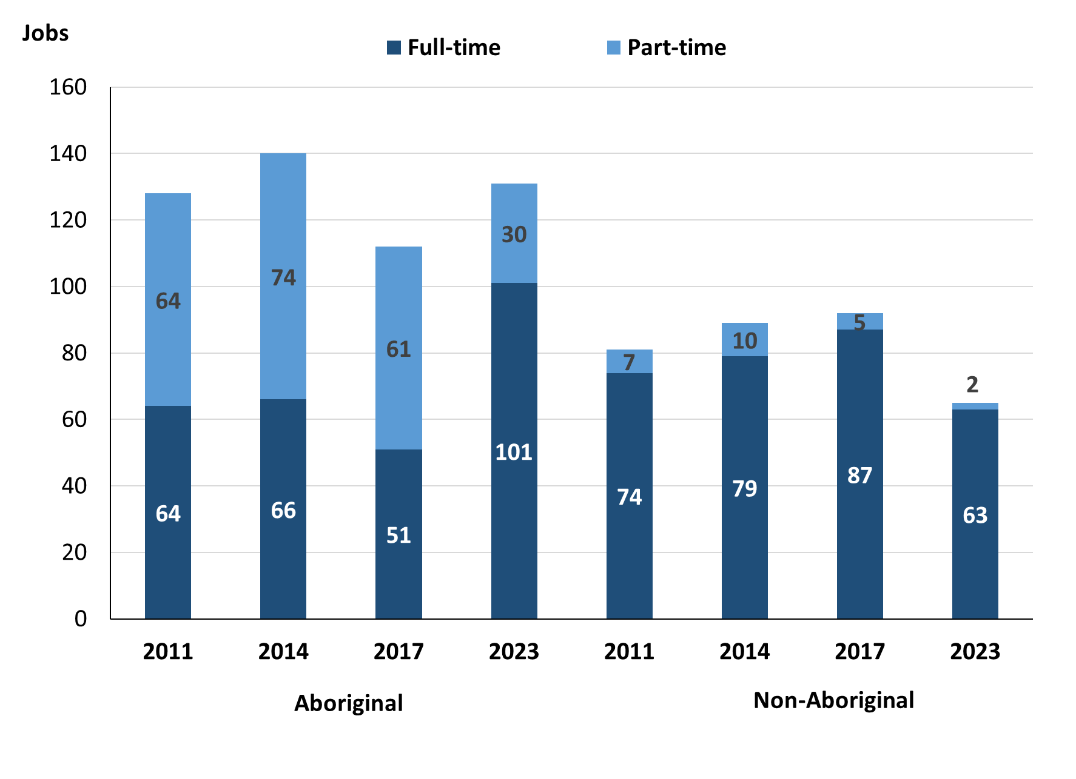

Source: Northern Territory - Department of Industry, Tourism and Trade

In 2023 in Yuendumu:

* of the 196 **jobs filled:**
* 101 were full-time jobs filled by **Aboriginal** people, an increase of 50 jobs from 2017 and an increase of 35 jobs from 2014
* 30 were part-time jobs filled by **Aboriginal** people, a decrease of 31 jobs from 2017 and a decrease of 44 jobs from 2014
* 63 were full-time jobs filled by **non-Aboriginal** people, a decrease of 24 jobs from 2017 and a decrease of 16 jobs from 2014
* 2 were part-time jobs filled by **non-Aboriginal** people, a decrease of 3 jobs from 2017 and a decrease of 8 jobs from 2014.

# Jobs by sector: Private and public

Table 3a: Count of jobs filled by business sector, 2011, 2014, 2017 & 2023 (a)(b)(c)

|  |  |  |  |  |  |  |  |  |  |  |  |  |
| --- | --- | --- | --- | --- | --- | --- | --- | --- | --- | --- | --- | --- |
| **Indicator** | **2011** | | | **2014** | | | **2017** | | | **2023** | | |
| **Aboriginal** | **Non-Aboriginal** | **Total** | **Aboriginal** | **Non-Aboriginal** | **Total** | **Aboriginal** | **Non-Aboriginal** | **Total** | **Aboriginal** | **Non-Aboriginal** | **Total** |
| **Public Sector** | 73 | 40 | **113** | 65 | 34 | **99** | 41 | 41 | **82** | 29 | 30 | **59** |
| Australian Government | 3 | 2 | **5** | 8 | 2 | **10** | 4 | 2 | **6** | 1 | 1 | **2** |
| Territory Government | 19 | 28 | **47** | 28 | 27 | **55** | 30 | 37 | **67** | 27 | 25 | **52** |
| Local Government | 51 | 10 | **61** | 29 | 5 | **34** | 7 | 2 | **9** | 1 | 4 | **5** |
| **Private Sector** | 55 | 41 | **96** | 75 | 55 | **130** | 71 | 51 | **122** | 102 | 35 | **137** |
| **Total** | **128** | **81** | **209** | **140** | **89** | **229** | **112** | **92** | **204** | **131** | **65** | **196** |

Source: Northern Territory - Department of Industry, Tourism and Trade

Table 3b: Count of jobs filled by business sector, 2011-2014, 2014-2017 & 2017-2023 (a)(b)(c)

|  |  |  |  |  |  |  |  |  |  |
| --- | --- | --- | --- | --- | --- | --- | --- | --- | --- |
| **Indicator** | **Change 2011-2014** | | | **Change 2014-2017** | | | **Change 2017-2023** | | |
| **Aboriginal** | **Non-Aboriginal** | **Total** | **Aboriginal** | **Non-Aboriginal** | **Total** | **Aboriginal** | **Non-Aboriginal** | **Total** |
| **Public Sector** | -8 | -6 | **-14** | -24 | 7 | **-17** | -12 | -11 | **-23** |
| Australian Government | 5 | 0 | **5** | -4 | 0 | **-4** | -3 | -1 | **-4** |
| Territory Government | 9 | -1 | **8** | 2 | 10 | **12** | -3 | -12 | **-15** |
| Local Government | -22 | -5 | **-27** | -22 | -3 | **-25** | -6 | 2 | **-4** |
| **Private Sector** | 20 | 14 | **34** | -4 | -4 | **-8** | 31 | -16 | **15** |
| **Total** | **12** | **8** | **20** | **-28** | **3** | **-25** | **19** | **-27** | **-8** |

Source: Northern Territory - Department of Industry, Tourism and Trade

Chart 4: Count of jobs filled by sector of business, 2011, 2014, 2017 & 2023 (a)(d)

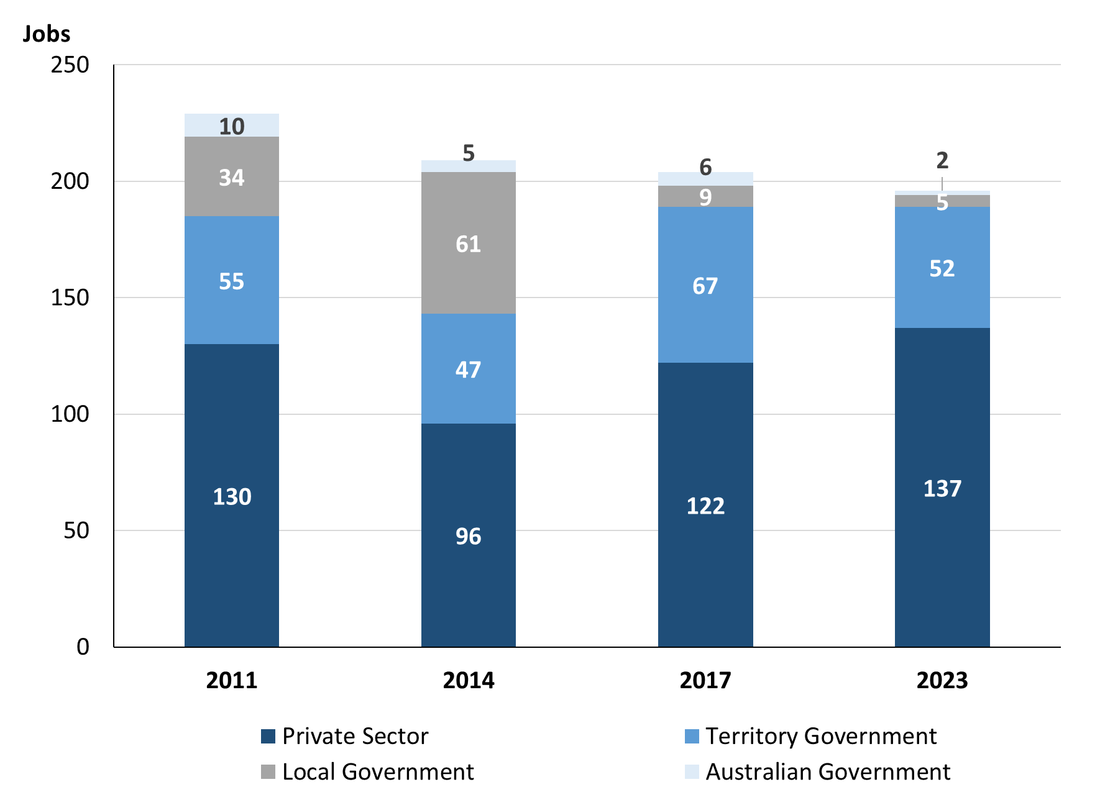

Source: Northern Territory - Department of Industry, Tourism and Trade

Chart 5: Percentage of jobs filled by sector of business in 2023 (a)(d)

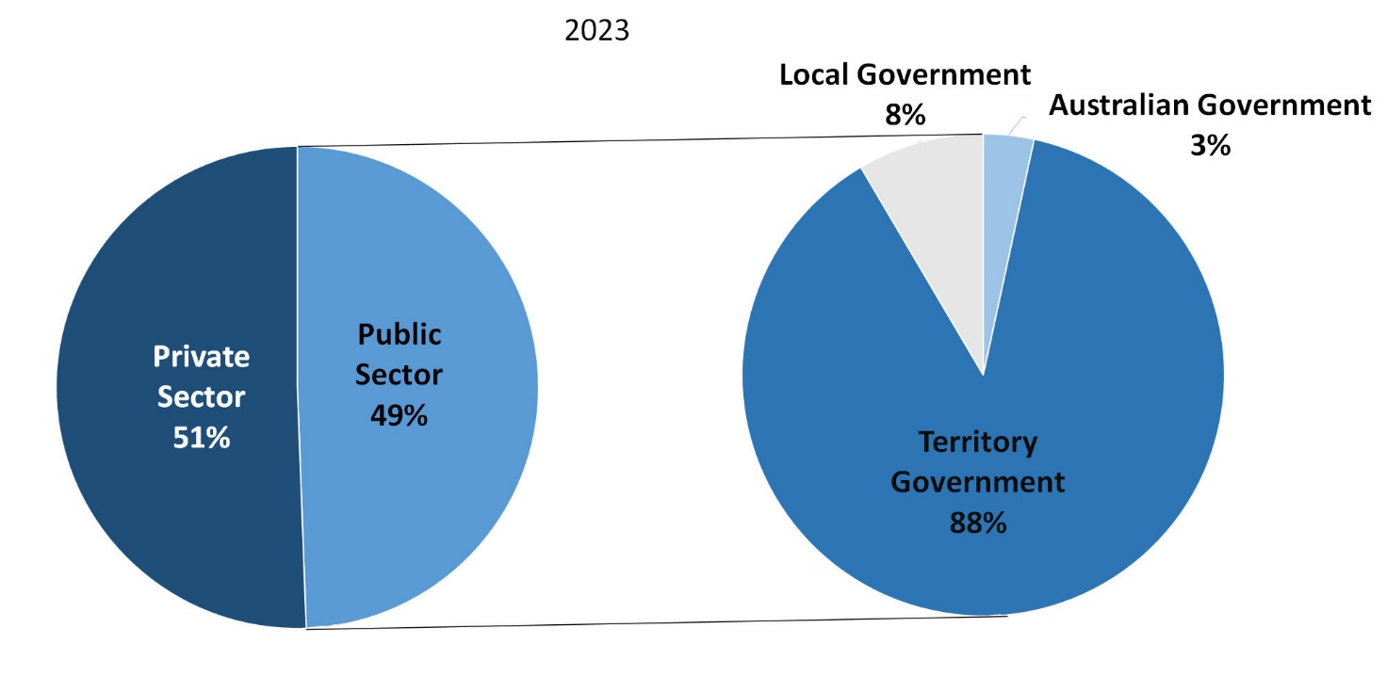Source: Northern Territory - Department of Industry, Tourism and Trade

In 2023 in Yuendumu:

* there were 59 jobs in the **Public Sector**, a decrease of 23 jobs from 2017 and a decrease of 40 jobs from 2014
* of the 59 jobs in the **Public Sector**:
* 2 jobs were in the Australian Government, a decrease of 4 jobs from 2017 and a decrease of 8 jobs from 2014
* 52 jobs were in the Territory Government, a decrease of 15 jobs from 2017 and a decrease of 3 jobs from 2014
* 5 jobs were in the Local Government, a decrease of 4 jobs from 2017 and a decrease of 29 jobs from 2014
* there were 137 jobs in the **Private Sector**, an increase of 15 jobs from 2017 and an increase of 7 jobs from 2014.

Chart 6: Count of jobs filled by sector, 2011, 2014, 2017 & 2023 (a)(c)(d)

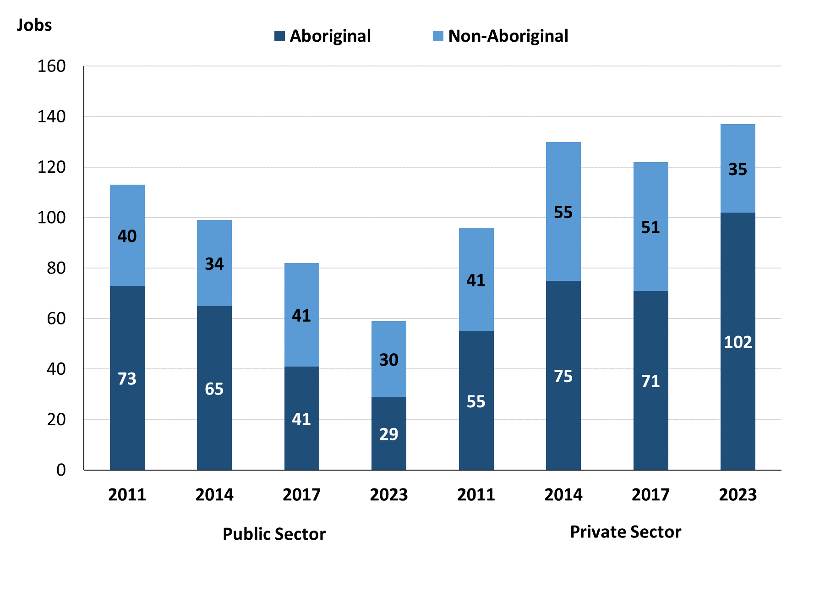

Source: Northern Territory - Department of Industry, Tourism and Trade

In 2023 in Yuendumu:

* of the 59 jobs in the **Public Sector**:
* **Aboriginal** people filled 29 jobs, a decrease of 12 jobs from 2017 and a decrease of 36 jobs from 2014
* **non-Aboriginal** people filled 30 jobs, a decrease of 11 jobs from 2017 and a decrease of 4 jobs from 2014
* of the 137 jobs in the **Private Sector**:
* **Aboriginal** people filled 102 jobs, an increase of 31 jobs from 2017 and an increase of 27 jobs from 2014
* **non-Aboriginal** people filled 35 jobs, a decrease of 16 jobs from 2017 and a decrease of 20 jobs from 2014.

Chart 7: Count of jobs filled by sector and full-time/part-time status, 2011, 2014, 2017 & 2023 (a)(b)(d)

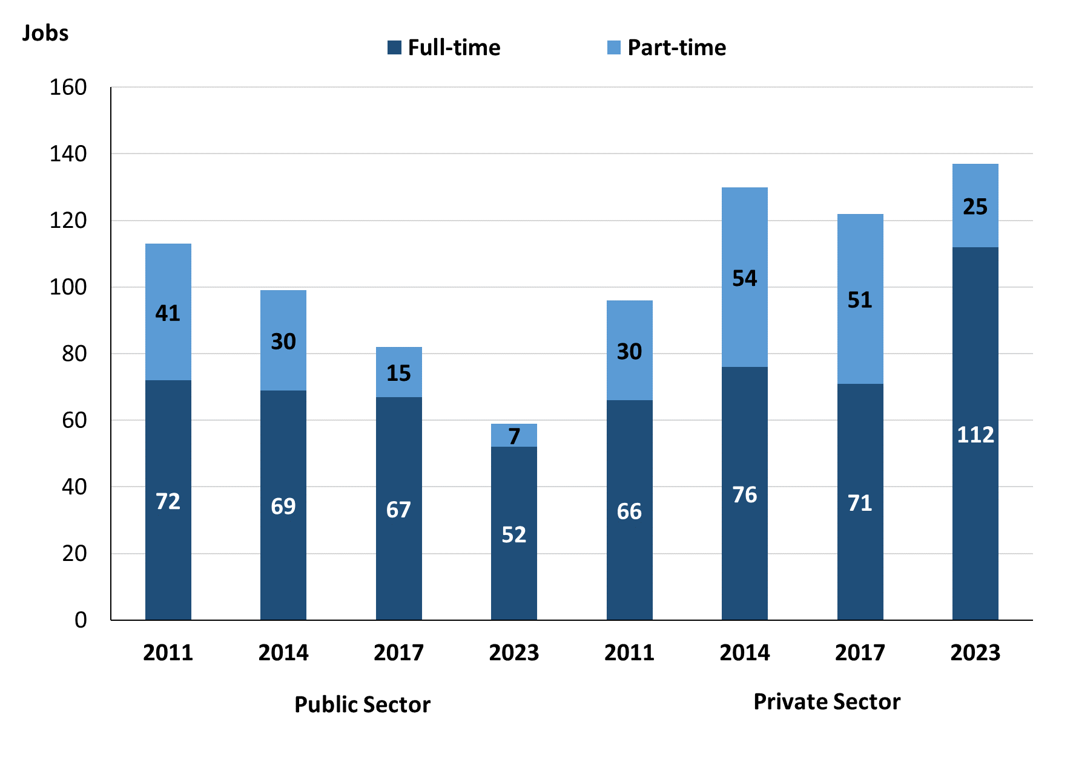

Source: Northern Territory - Department of Industry, Tourism and Trade

In 2023 in Yuendumu:

* of the 59 jobs in the **Public Sector,** there were:
* 52 were **full-time** jobs, a decrease of 15 jobs from 2017 and a decrease of 24 jobs from 2014
* 7 were **part-time** jobs, a decrease of 8 jobs from 2017 and a decrease of 23 jobs from 2014
* of the 137 jobs in the **Private Sector,** there were:
* 112 were **full-time** jobs, an increase of 41 jobs from 2017 and an increase of 43 jobs from 2014
* 25 were **part-time** jobs, a decrease of 26 jobs from 2017 and a decrease of 29 jobs from 2014.

Table 4: Count of jobs filled by full-time/part-time status by sector, 2011, 2014, 2017 & 2023 (a)(b)(c)(d)

|  |  |  |  |  |  |  |  |  |  |  |
| --- | --- | --- | --- | --- | --- | --- | --- | --- | --- | --- |
| **Indicator** | **2011** | | | | | | | | | |
| **Aboriginal** | | | **Non-Aboriginal** | | | **Total** | | | |
| **Full-time** | **Part-time** | **Total** | **Full-time** | **Part-time** | **Total** | **Full-time** | **Part-time** | **Total** |
| Public Sector | 35 | 38 | **73** | 37 | 3 | **40** | 72 | 41 | **113** |
| Private Sector | 29 | 26 | **55** | 37 | 4 | **41** | 66 | 30 | **96** |
| **Total** | **64** | **64** | **128** | **74** | **7** | **81** | **138** | **71** | **209** |

|  |  |  |  |  |  |  |  |  |  |
| --- | --- | --- | --- | --- | --- | --- | --- | --- | --- |
| **Indicator** | **2014** | | | | | | | | |
| **Aboriginal** | | | **Non-Aboriginal** | | | **Total** | | |
| **Full-time** | **Part-time** | **Total** | **Full-time** | **Part-time** | **Total** | **Full-time** | **Part-time** | **Total** |
| Public Sector | 42 | 29 | **71** | 34 | 1 | **35** | 76 | 30 | **106** |
| Private Sector | 24 | 45 | **69** | 45 | 9 | **54** | 69 | 54 | **123** |
| **Total** | **66** | **74** | **140** | **79** | **10** | **89** | **145** | **84** | **229** |

|  |  |  |  |  |  |  |  |  |  |
| --- | --- | --- | --- | --- | --- | --- | --- | --- | --- |
| **Indicator** | **2017** | | | | | | | | |
| **Aboriginal** | | | **Non-Aboriginal** | | | **Total** | | |
| **Full-time** | **Part-time** | **Total** | **Full-time** | **Part-time** | **Total** | **Full-time** | **Part-time** | **Total** |
| Public Sector | 27 | 14 | **41** | 40 | 1 | **41** | 67 | 15 | **82** |
| Private Sector | 24 | 47 | **71** | 47 | 4 | **51** | 71 | 51 | **122** |
| **Total** | **66** | **74** | **112** | **87** | **5** | **92** | **138** | **66** | **204** |

|  |  |  |  |  |  |  |  |  |  |
| --- | --- | --- | --- | --- | --- | --- | --- | --- | --- |
| **Indicator** | **2023** | | | | | | | | |
| **Aboriginal** | | | **Non-Aboriginal** | | | **Total** | | |
| **Full-time** | **Part-time** | **Total** | **Full-time** | **Part-time** | **Total** | **Full-time** | **Part-time** | **Total** |
| Public Sector | 23 | 6 | **29** | 29 | 1 | **30** | 52 | 7 | **59** |
| Private Sector | 78 | 24 | **102** | 34 | 1 | **35** | 112 | 25 | **137** |
| **Total** | **101** | **30** | **131** | **63** | **2** | **65** | **164** | **32** | **196** |

Source: Northern Territory - Department of Industry, Tourism and Trade

In 2023 in Yuendumu there were:

* 29 jobs in the **Public Sector** filled by **Aboriginal** people, a decrease of 12 jobs from 2017 and a decrease of 42 jobs from 2014, of which:
* 23 were **full-time** jobs, a decrease of 4 jobs from 2017 and a decrease of 19 jobs from 2014
* 6 were **part-time** jobs, a decrease of 8 jobs from 2017 and a decrease of 23 jobs from 2014
* 102 jobs in the **Private Sector** filled by **Aboriginal** people, an increase of 31 jobs from 2017 and an increase of 33 jobs from 2014, of which:
* 78 were **full-time** jobs, an increase of 54 jobs from 2017 and an increase of 54 jobs from 2014
* 24 were **part-time** jobs, a decrease of 23 jobs from 2017 and a decrease of 21 jobs from 2014
* 30 jobs in the **Public Sector** filled by **non-Aboriginal** people, a decrease of 11 jobs from 2017 and a decrease of 5 jobs from 2014, of which:
* 29 were **full-time** jobs, a decrease of 11 jobs from 2017 and a decrease of 5 jobs from 2014
* 1 was a **part-time** job, unchanged from 2017 and unchanged from 2014
* 35 jobs in the **Private Sector** filled by **non-Aboriginal** people, a decrease of 16 jobs from 2017 and a decrease of 19 jobs from 2014, of which:
* 34 were **full-time** jobs, a decrease of 13 jobs from 2017 and a decrease of 11 jobs from 2014
* 1 was **part-time** jobs, a decrease of 3 jobs from 2017 and a decrease of 8 jobs from 2014.

# Job status: Permanent and temporary

Table 5a: Count of jobs filled by employment status, 2011, 2014, 2017 & 2023 (a)(c)(e)

|  |  |  |  |  |  |  |  |  |  |  |  |  |
| --- | --- | --- | --- | --- | --- | --- | --- | --- | --- | --- | --- | --- |
| **Indicator** | **2011** | | | **2014** | | | **2017** | | | **2023** | | |
| **Aboriginal** | **Non-Aboriginal** | **Total** | **Aboriginal** | **Non-Aboriginal** | **Total** | **Aboriginal** | **Non-Aboriginal** | **Total** | **Aboriginal** | **Non-Aboriginal** | **Total** |
| Permanent | 41 | 34 | **75** | 65 | 59 | **124** | 48 | 49 | **97** | 33 | 30 | **63** |
| Temporary | 87 | 47 | **134** | 75 | 30 | **105** | 64 | 43 | **107** | 98 | 35 | **133** |
| **Total** | **128** | **81** | **209** | **140** | **89** | **229** | **112** | **92** | **204** | **131** | **65** | **196** |

Source: Northern Territory - Department of Industry, Tourism and Trade

Table 5b: Count of jobs filled by employment status, 2011-2014, 2014-2017, 2017-2023 (a)(c)(e)

|  |  |  |  |  |  |  |  |  |  |
| --- | --- | --- | --- | --- | --- | --- | --- | --- | --- |
| **Indicator** | **Change 2011-2014** | | | **Change 2014-2017** | | | **Change**  **2017-2023** | | |
| **Aboriginal** | **Non-Aboriginal** | **Total** | **Aboriginal** | **Non-Aboriginal** | **Total** | **Aboriginal** | **Non-Aboriginal** | **Total** |
| Permanent | 24 | 25 | **49** | -17 | -10 | **-27** | -15 | -19 | **-34** |
| Temporary | -12 | -17 | **-29** | -11 | 13 | **2** | 34 | -8 | **26** |
| **Total** | **12** | **8** | **20** | **-28** | **3** | **-25** | **19** | **-27** | **-8** |

Source: Northern Territory - Department of Industry, Tourism and Trade

Chart 8: Count of jobs filled by employment status, 2011, 2014, 2017 & 2023 (a)(c)(e)

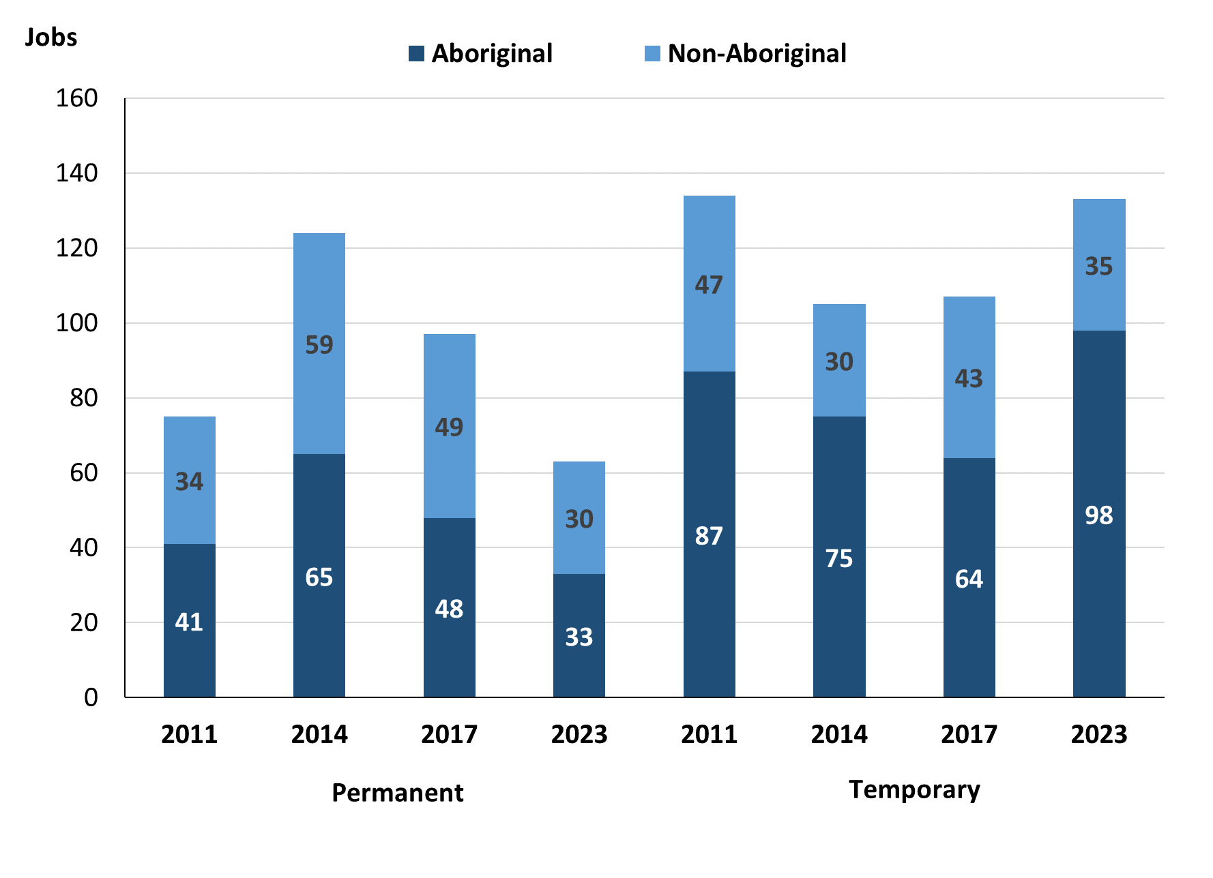

Source: Northern Territory - Department of Industry, Tourism and Trade

In 2023 in Yuendumu:

* there were 63 **permanent jobs**, a decrease of 34 jobs from 2017, and a decrease of 61 jobs from 2014, of which:
* **Aboriginal** people filled 33 jobs, a decrease of 15 jobs from 2017 and a decrease of 32 jobs from 2014
* **non-Aboriginal** people filled 30 jobs, a decrease of 19 jobs from 2017 and a decrease of 29 jobs from 2014
* there were 133 **temporary** **jobs**, an increase of 26 jobs from 2017 and an increase of 28 jobs from 2014, of which:
* **Aboriginal** people filled 98 jobs, an increase of 34 jobs from 2017 and an increase of 23 jobs from 2014
* **non-Aboriginal** people filled 35 jobs, a decrease of 8 jobs from 2017 and an increase of 5 jobs from 2014.

Table 6: Count of jobs filled by sector and employment status, 2011, 2014, 2017 & 2023 (a)(c)(d)(e)

|  |  |  |  |  |  |  |  |  |  |
| --- | --- | --- | --- | --- | --- | --- | --- | --- | --- |
| **Indicator** | **2011** | | | | | | | | |
| **Aboriginal** | | | **Non-Aboriginal** | | | **Total** | | |
| **Perm** | **Temp** | **Total** | **Perm** | **Temp** | **Total** | **Perm** | **Temp** | **Total** |
| Public Sector | 18 | 55 | **73** | 16 | 24 | **40** | 34 | 79 | **113** |
| Private Sector | 23 | 32 | **55** | 18 | 23 | **41** | 41 | 55 | **96** |
| **Total** | **41** | **87** | **128** | **34** | **47** | **81** | **75** | **134** | **209** |

|  |  |  |  |  |  |  |  |  |  |
| --- | --- | --- | --- | --- | --- | --- | --- | --- | --- |
| **Indicator** | **2014** | | | | | | | | |
| **Aboriginal** | | | **Non-Aboriginal** | | | **Total** | | |
| **Perm** | **Temp** | **Total** | **Perm** | **Temp** | **Total** | **Perm** | **Temp** | **Total** |
| Public Sector | 32 | 33 | **65** | 29 | 5 | **34** | 61 | 38 | **99** |
| Private Sector | 33 | 42 | **75** | 30 | 25 | **55** | 63 | 67 | **130** |
| **Total** | **65** | **75** | **140** | **59** | **30** | **89** | **124** | **105** | **229** |

|  |  |  |  |  |  |  |  |  |  |  |
| --- | --- | --- | --- | --- | --- | --- | --- | --- | --- | --- |
| **Indicator** | **2017** | | | | | | | | | |
| **Aboriginal** | | | **Non-Aboriginal** | | | **Total** | | | |
| **Perm** | **Temp** | **Total** | **Perm** | **Temp** | **Total** | **Perm** | **Temp** | **Total** |
| Public Sector | 24 | 17 | **41** | 19 | 22 | **41** | 43 | 39 | **82** |
| Private Sector | 24 | 47 | **71** | 30 | 21 | **51** | 54 | 68 | **122** |
| **Total** | **48** | **64** | **112** | **49** | **43** | **92** | **97** | **107** | **204** |

|  |  |  |  |  |  |  |  |  |  |  |
| --- | --- | --- | --- | --- | --- | --- | --- | --- | --- | --- |
| **Indicator** | **2023** | | | | | | | | | |
| **Aboriginal** | | | **Non-Aboriginal** | | | **Total** | | | |
| **Perm** | **Temp** | **Total** | **Perm** | **Temp** | **Total** | **Perm** | **Temp** | **Total** |
| Public Sector | 11 | 18 | **29** | 13 | 17 | **30** | 24 | 35 | **59** |
| Private Sector | 22 | 80 | **102** | 17 | 18 | **35** | 39 | 98 | **137** |
| **Total** | **33** | **98** | **131** | **30** | **35** | **65** | **63** | **133** | **196** |

Source: Northern Territory - Department of Industry, Tourism and Trade

In 2023 in Yuendumu there were:

* 59 jobs in the **Public Sector**, a decrease of 23 jobs from 2017 and a decrease of 40 jobs from 2014, of which:
* 24 jobs were **permanent**, a decrease of 19 jobs from 2017 and a decrease of 37 jobs from 2014, of which:
* **Aboriginal** people filled 11 jobs, a decrease of 13 jobs from 2017 and a decrease of 21 jobs from 2014
* **non-Aboriginal** people filled 13 jobs, a decrease of 6 jobs from 2017 and a decrease of 16 jobs from 2014
* 35 jobs were **temporary**, a decrease of 4 jobs from 2017 and a decrease of 3 jobs from 2014, of which:
* **Aboriginal** people filled 18 jobs, an increase of 1 job from 2017 and a decrease of 15 jobs from 2014
* **non-Aboriginal** people filled 17 jobs, a decrease of 5 jobs from 2017 and an increase of 12 jobs from 2014
* 137 jobs in the **Private Sector**, an increase of 15 jobs from 2017 and an increase of 7 jobs from 2014, of which:
* 39 jobs were **permanent**, a decrease of 15 jobs from 2017 and a decrease of 24 jobs from 2014, of which:
* **Aboriginal** people filled 22 jobs, a decrease of 2 jobs from 2017 and a decrease of 11 jobs from 2014
* **non-Aboriginal** people filled 17 jobs, a decrease of 13 jobs from 2017 and a decrease of 13 jobs from 2014
* 98 jobs were **temporary**, an increase of 30 jobs from 2017 and an increase of 31 jobs from 2014, of which:
* **Aboriginal** people filled 80 jobs, an increase of 33 jobs from 2017 and an increase of 38 jobs from 2014
* **non-Aboriginal** people filled 18 jobs, a decrease of 3 jobs from 2017 and a decrease of 7 jobs from 2014.

# Job vacancies

Table 7: Job vacancies, 2011, 2014, 2017 & 2023

|  |  |  |  |  |  |  |  |
| --- | --- | --- | --- | --- | --- | --- | --- |
| **Indicator** | **2011** | **2014** | **2017** | **2023** | **Change 2011-2014** | **Change 2014-2017** | **Change 2017-2023** |
| **Job vacancies** | **23** | **26** | **44** | **71** | **3** | **18** | **27** |

Source: Northern Territory - Department of Industry, Tourism and Trade

Table 8a: Job vacancies by occupation, 2011, 2014, 2017 & 2023 (f)(g)

|  |  |  |  |  |
| --- | --- | --- | --- | --- |
| **Occupation (ANZSCO major group)** | **2011** | **2014** | **2017** | **2023** |
| Clerical and Administrative Workers | 1 | 3 | 3 | 11 |
| Community and Personal Service Workers | 6 | 17 | 19 | 22 |
| Labourers | 9 | 1 | 2 | 2 |
| Machinery Operators and Drivers | 0 | 0 | 0 | 1 |
| Managers | 0 | 1 | 5 | 5 |
| Professionals | 3 | 4 | 7 | 28 |
| Sales Workers | 1 | 0 | 4 | 0 |
| Technicians and Trades Workers | 3 | 0 | 4 | 2 |
| **Total** | **23** | **26** | **44** | **71** |

Source: Northern Territory - Department of Industry, Tourism and Trade

Table 8b: Job vacancies by occupation, 2011-2014, 2014-2017 & 2017-2023 (f)(g)

|  |  |  |  |
| --- | --- | --- | --- |
| **Occupation (ANZSCO major group)** | **Change 2011-2014** | **Change 2014-2017** | **Change 2017-2023** |
| Clerical and Administrative Workers | 2 | 0 | 8 |
| Community and Personal Service Workers | 11 | 2 | 3 |
| Labourers | -8 | 1 | 0 |
| Machinery Operators and Drivers | 0 | 0 | 1 |
| Managers | 1 | 4 | 0 |
| Professionals | 1 | 3 | 21 |
| Sales Workers | -1 | 4 | -4 |
| Technicians and Trades Workers | -3 | 4 | -2 |
| **Total** | **3** | **18** | **27** |

Source: Northern Territory - Department of Industry, Tourism and Trade

Table 9: Job vacancies by job title, 2023 profile (f)

|  |  |
| --- | --- |
| **Job Vacancy** | **No.** |
| Aboriginal and Torres Strait Islander Education Worker | 9 |
| Aboriginal and Torres Strait Islander Health Worker | 6 |
| Aboriginal and Torres Strait Islander Land and Sea Ranger | 7 |
| Assistant Principal | 1 |
| Bus Driver | 1 |
| Child Care Centre Manager | 1 |
| Child Care Worker | 1 |
| Classroom Teacher | 11 |
| Corporate General Manager | 1 |
| Education Aide | 1 |
| Gardener (General) | 1 |
| General Clerk | 4 |
| Handyperson | 2 |
| ICT Support Technician | 1 |
| Liaison Officer | 3 |
| Medical Administrator | 3 |
| Medical Practitioner | 2 |
| Occupational Therapist | 1 |
| Police Officer | 2 |
| Primary Health Organisation Manager | 3 |
| Program or Project Administrator | 4 |
| Protective Services Officer | 1 |
| Registered Nurses nec | 2 |
| Senior Teacher | 1 |
| Special Education Teacher | 1 |
| Vocational Education Teacher | 1 |
| **Total** | **71** |

Source: Northern Territory - Department of Industry, Tourism and Trade

In 2023 in Yuendumu:

* there were 71 **vacancies** reported, an increase of 27 vacancies from 2017 and an increase of 45 vacancies from 2014
* Of the 71 reported **vacancies,** the greatest demand was for:
* 28 Professionals, the majority in the following jobs:
* Aboriginal and Torres Strait Islander Land and Sea Ranger
* Classroom Teacher
* Teachers' Aide
* 23 Community and Personal Service Workers, the majority in the following jobs:
* Aboriginal and Torres Strait Islander Education Worker
* Aboriginal and Torres Strait Islander Health Worker
* Liaison Officer
* 10 Clerical and Administrative Workers, the majority in the following jobs:
* General Clerk
* Program or Project Administrator

# Jobs by industry

Table 10: Count of jobs filled by industry of business, 2011, 2014, 2017, 2023 and change in count of jobs filled by industry 2011-2014, 2014-2017 & 2017-2023 (a)(h)

|  |  |  |  |  |  |  |  |  |  |  |  |
| --- | --- | --- | --- | --- | --- | --- | --- | --- | --- | --- | --- |
| **Industry (ANZSIC Division)** | **2011** | | **2014** | | **2017** | | **2023** | | **Change 2011-2014** | **Change 2014-2017** | **Change 2017-2023** |
| **Total** | **% of Total** | **Total** | **% of Total** | **Total** | **% of Total** | **Total** | **% of Total** | **Total** | **Total** | **Total** |
| Arts and Recreation Services | 6 | 2.9% | 13 | 5.7% | 40 | 19.6% | 19 | 9.7% | 7 | 27 | -21 |
| Construction | 10 | 4.8% | 1 | 0.4% | 21 | 10.3% | 17 | 8.7% | -9 | 20 | -4 |
| Education and Training | 41 | 19.6% | 37 | 16.2% | 43 | 21.1% | 38 | 19.4% | -4 | 6 | -5 |
| Electricity, Gas, Water and Waste Services | 0 | 0.0% | 0 | 0.0% | 0 | 0.0% | 10 | 5.1% | 0 | 0 | 10 |
| Health Care and Social Assistance | 43 | 20.6% | 88 | 38.4% | 56 | 27.5% | 6 | 3.1% | 45 | -32 | -50 |
| Other Services | 0 | 0.0% | 14 | 6.1% | 0 | 0.0% | 0 | 0.0% | 14 | -14 | 0 |
| Professional, Scientific and Technical Services | 22 | 10.5% | 0 | 0.0% | 0 | 0.0% | 0 | 0.0% | -22 | 0 | 0 |
| Public Administration and Safety | 70 | 33.5% | 57 | 24.9% | 26 | 12.7% | 90 | 45.9% | -13 | -31 | 64 |
| Retail Trade | 15 | 7.2% | 19 | 8.3% | 18 | 8.8% | 16 | 8.2% | 4 | -1 | -2 |
| **Total** | **209** | **100.0%** | **229** | **100.0%** | **204** | **100.0%** | **196** | 100.0% | **20** | **-25** | **-8** |

Source: Northern Territory - Department of Industry, Tourism and Trade

**In 2023 in Yuendumu**:

* Community and Personal Service Workers was the **largest occupation classification** in terms of jobs filled, accounting for 73 jobs (37.2% of total jobs filled), an increase of 15 jobs from 2017 and an increase of 6 jobs from 2014
* **other** **significant** occupation classifications were:
* Professionals, accounting for 53 jobs or 27.0% of total jobs a decrease of 6 jobs from 2017 and a decrease of 5 jobs from 2014
* Clerical and Administrative Workers, accounting for 19 jobs or 9.7% of total jobs a decrease of 12 jobs from 2017 and a decrease of 11 jobs from 2014
* Technicians and Trades Workers, accounting for 17 jobs or 8.7% of total jobs an increase of 12 jobs from 2017 and an increase of 4 jobs from 2014.

Table 11a: Count of jobs filled by industry of business, 2011, 2014, 2017 & 2023 (a)(c)(h)

|  |  |  |  |  |  |  |  |  |  |  |  |  |
| --- | --- | --- | --- | --- | --- | --- | --- | --- | --- | --- | --- | --- |
| **Industry (ANZSIC division)** | **2011** | | | **2014** | | | **2017** | | | **2023** | | |
| **Aboriginal** | **Non-Aboriginal** | **Total** | **Aboriginal** | **Non-Aboriginal** | **Total** | **Aboriginal** | **Non-Aboriginal** | **Total** | **Aboriginal** | **Non-Aboriginal** | **Total** |
| Arts and Recreation Services | 1 | 5 | **6** | 7 | 6 | **13** | 28 | 12 | **40** | 14 | 5 | **19** |
| Construction | 7 | 3 | **10** | 0 | 1 | **1** | 14 | 7 | **21** | 6 | 11 | **17** |
| Education and Training | 19 | 22 | **41** | 19 | 18 | **37** | 20 | 23 | **43** | 21 | 17 | **38** |
| Electricity, Gas, Water and Waste Services | 0 | 0 | **0** | 0 | 0 | **0** | 0 | 0 | **0** | 5 | 5 | **10** |
| Health Care and Social Assistance | 16 | 27 | **43** | 49 | 39 | **88** | 23 | 33 | **56** | 2 | 4 | **6** |
| Other Services | 0 | 0 | **0** | 10 | 4 | **14** | 0 | 0 | **0** | 0 | 0 | **0** |
| Professional, Scientific and Technical Services | 18 | 4 | **22** | 0 | 0 | **0** | 0 | 0 | **0** | 0 | 0 | **0** |
| Public Administration and Safety | 57 | 13 | **70** | 47 | 10 | **57** | 17 | 9 | **26** | 79 | 11 | **90** |
| Retail Trade | 8 | 7 | **15** | 8 | 11 | **19** | 10 | 8 | **18** | 4 | 12 | **16** |
| **Total** | **128** | **81** | **209** | **140** | **89** | **229** | **112** | **92** | **204** | **131** | **65** | **196** |

Source: Northern Territory - Department of Industry, Tourism and Trade

Table 11b: Count of jobs filled by industry of business, 2011-2014, 2014-2017 & 2017-2023 (a)(c)(h)

|  |  |  |  |  |  |  |  |  |  |  |
| --- | --- | --- | --- | --- | --- | --- | --- | --- | --- | --- |
| **Industry (ANZSIC division)** | **Change 2011-2014** | | | | **Change  2014-2017** | | | **Change 2017-2023** | | |
| **Aboriginal** | **Non-Aboriginal** | **Total** | **Aboriginal** | | **Non-Aboriginal** | **Total** | **Aboriginal** | **Non-Aboriginal** | **Total** |
| Arts and Recreation Services | 6 | 1 | **7** | 21 | | 6 | **27** | -14 | -7 | **-21** |
| Construction | -7 | -2 | **-9** | 14 | | 6 | **20** | -8 | 4 | **-4** |
| Education and Training | 0 | -4 | **-4** | 1 | | 5 | **6** | 1 | -6 | **-5** |
| Electricity, Gas, Water and Waste Services | 0 | 0 | **0** | 0 | | 0 | **0** | 5 | 5 | **10** |
| Health Care and Social Assistance | 33 | 12 | **45** | -26 | | -6 | **-32** | -21 | -29 | **-50** |
| Other Services | 10 | 4 | **14** | -10 | | -4 | **-14** | 0 | 0 | **0** |
| Professional, Scientific and Technical Services | -18 | -4 | **-22** | 0 | | 0 | **0** | 0 | 0 | **0** |
| Public Administration and Safety | -10 | -3 | **-13** | -30 | | -1 | **-31** | 62 | 2 | **64** |
| Retail Trade | 0 | 4 | **4** | 2 | | -3 | **-1** | -6 | 4 | **-2** |
| **Total** | **12** | **8** | **20** | **-28** | | **3** | **-25** | **19** | **-27** | **-8** |

Source: Northern Territory - Department of Industry, Tourism and Trade

Chart 9: Count of jobs filled by top 5 industries, 2023 (a)(c)(h)

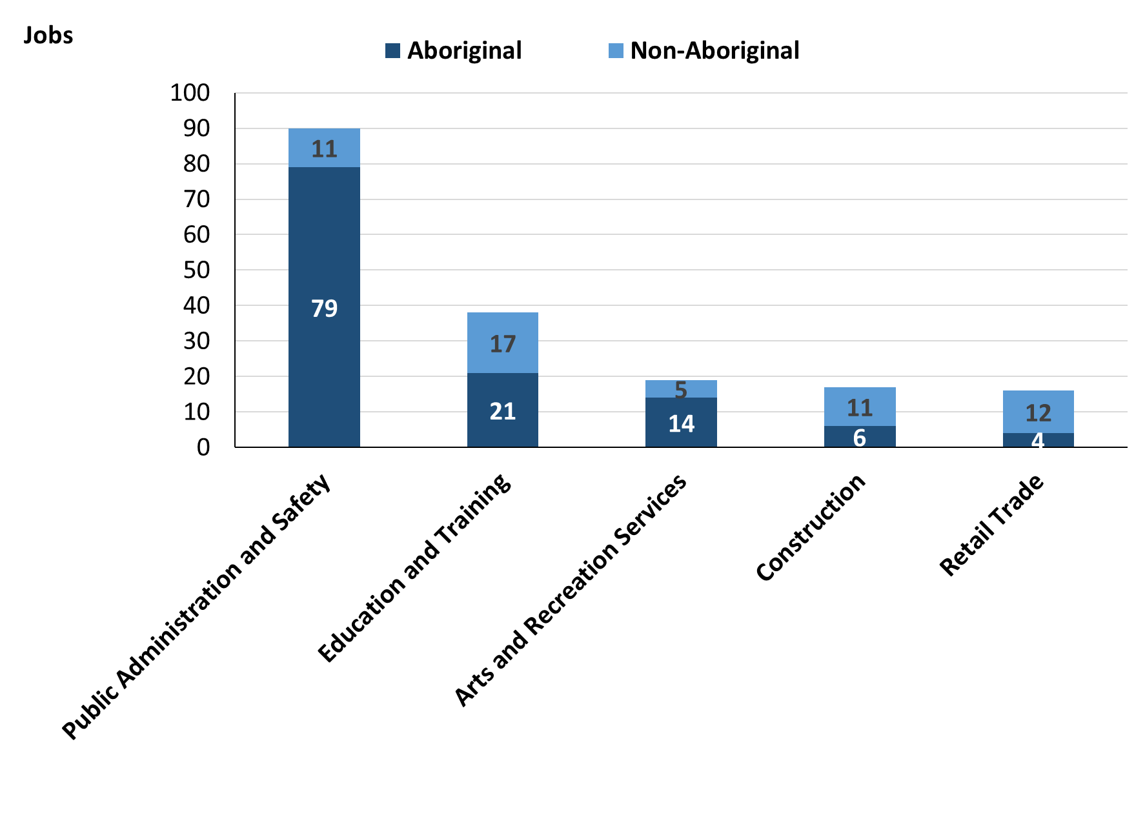

Source: Northern Territory - Department of Industry, Tourism and Trade

In 2023 in Yuendumu:

* of the 131 **jobs filled** by **Aboriginal** people, there were:
* 79 jobs in Public Administration and Safety, an increase of 62 jobs from 2017 and an increase of 32 jobs from 2014
* 21 jobs in Education and Training, an increase of 1 job from 2017 and an increase of 2 jobs from 2014
* 14 jobs in Arts and Recreation Services, a decrease of 14 jobs from 2017 and an increase of 7 jobs from 2014
* of the 65 **jobs filled** by **non-Aboriginal** people, there were:
* 17 jobs in Education and Training, a decrease of 6 jobs from 2017 and a decrease of 1 job from 2014
* 12 jobs in Retail Trade, an increase of 4 jobs from 2017 and an increase of 1 job from 2014
* 11 jobs in Public Administration and Safety, an increase of 2 jobs from 2017 and an increase of 1 job from 2014.

Table 12: Count of jobs filled by industry and employment status, 2011 (a)(c)(e)(h)

|  |  |  |  |  |  |  |  |  |  |
| --- | --- | --- | --- | --- | --- | --- | --- | --- | --- |
| **Industry (ANZSIC division)** | **2011** | | | | | | | | |
| **Aboriginal** | | | **Non-Aboriginal** | | | **Total** | | |
| **Perm** | **Temp** | **Total** | **Perm** | **Temp** | **Total** | **Perm** | **Temp** | **Total** |
| Arts and Recreation Services | 0 | 1 | **1** | 1 | 4 | **5** | 1 | 5 | **6** |
| Construction | 3 | 4 | **7** | 3 | 0 | **3** | 6 | 4 | **10** |
| Education and Training | 6 | 13 | **19** | 8 | 14 | **22** | 14 | 27 | **41** |
| Health Care and Social Assistance | 9 | 7 | **16** | 7 | 20 | **27** | 16 | 27 | **43** |
| Professional, Scientific and Technical Services | 8 | 10 | **18** | 4 | 0 | **4** | 12 | 10 | **22** |
| Public Administration and Safety | 14 | 43 | **57** | 6 | 7 | **13** | 20 | 50 | **70** |
| Retail Trade | 1 | 7 | **8** | 5 | 2 | **7** | 6 | 9 | **15** |
| **Total** | **41** | **87** | **128** | **34** | **47** | **81** | **75** | **134** | **209** |

Source: Northern Territory - Department of Industry, Tourism and Trade

Table 13: Count of jobs filled by industry and employment status, 2014 (a)(c)(e)(h)

|  |  |  |  |  |  |  |  |  |  |
| --- | --- | --- | --- | --- | --- | --- | --- | --- | --- |
| **Industry (ANZSIC division)** | **2014** | | | | | | | | |
| **Aboriginal** | | | **Non-Aboriginal** | | | **Total** | | |
| **Perm** | **Temp** | **Total** | **Perm** | **Temp** | **Total** | **Perm** | **Temp** | **Total** |
| Arts and Recreation Services | 1 | 6 | **7** | 3 | 3 | **6** | 4 | 9 | **13** |
| Construction | 0 | 0 | **0** | 0 | 1 | **1** | 0 | 1 | **1** |
| Education and Training | 7 | 12 | **19** | 12 | 6 | **18** | 19 | 18 | **37** |
| Health Care and Social Assistance | 41 | 8 | **49** | 32 | 7 | **39** | 73 | 15 | **88** |
| Other Services | 0 | 10 | **10** | 0 | 4 | **4** | 0 | 14 | **14** |
| Public Administration and Safety | 13 | 34 | **47** | 7 | 3 | **10** | 20 | 37 | **57** |
| Retail Trade | 3 | 5 | **8** | 5 | 6 | **11** | 8 | 11 | **19** |
| **Total** | **65** | **75** | **140** | **59** | **30** | **89** | **124** | **105** | **229** |

Source: Northern Territory - Department of Industry, Tourism and Trade

Table 14: Count of jobs filled by industry and employment status, 2017 (a)(c)(e)(h)

|  |  |  |  |  |  |  |  |  |  |
| --- | --- | --- | --- | --- | --- | --- | --- | --- | --- |
| **Industry (ANZSIC division)** | **2017** | | | | | | | | |
| **Aboriginal** | | | **Non-Aboriginal** | | | **Total** | | |
| **Perm** | **Temp** | **Total** | **Perm** | **Temp** | **Total** | **Perm** | **Temp** | **Total** |
| Arts and Recreation Services | 2 | 26 | **28** | 4 | 8 | **12** | 6 | 34 | **40** |
| Construction | 0 | 14 | **14** | 1 | 6 | **7** | 1 | 20 | **21** |
| Education and Training | 17 | 3 | **20** | 10 | 13 | **23** | 27 | 16 | **43** |
| Health Care and Social Assistance | 21 | 2 | **23** | 25 | 8 | **33** | 46 | 10 | **56** |
| Public Administration and Safety | 5 | 12 | **17** | 7 | 2 | **9** | 12 | 14 | **26** |
| Retail Trade | 3 | 7 | **10** | 2 | 6 | **8** | 5 | 13 | **18** |
| **Total** | **48** | **64** | **112** | **49** | **43** | **92** | **97** | **107** | **204** |

Source: Northern Territory - Department of Industry, Tourism and Trade

Table 15: Count of jobs filled by industry and employment status, 2023 (a)(c)(e)(h)

|  |  |  |  |  |  |  |  |  |  |
| --- | --- | --- | --- | --- | --- | --- | --- | --- | --- |
| **Industry (ANZSIC division)** | **2023** | | | | | | | | |
| **Aboriginal** | | | **Non-Aboriginal** | | | **Total** | | |
| **Perm** | **Temp** | **Total** | **Perm** | **Temp** | **Total** | **Perm** | **Temp** | **Total** |
| Arts and Recreation Services | 7 | 7 | **14** | 4 | 1 | **5** | 11 | 8 | **19** |
| Construction | 2 | 4 | **6** | 10 | 1 | **11** | 12 | 5 | **17** |
| Education and Training | 6 | 15 | **21** | 4 | 13 | **17** | 10 | 28 | **38** |
| Electricity, Gas, Water and Waste Services | 0 | 5 | **5** | 0 | 5 | **5** | 0 | 10 | **10** |
| Health Care and Social Assistance | 2 | 0 | **2** | 1 | 3 | **4** | 3 | 3 | **6** |
| Public Administration and Safety | 12 | 67 | **79** | 10 | 1 | **11** | 22 | 68 | **90** |
| Retail Trade | 4 | 0 | **4** | 1 | 11 | **12** | 5 | 11 | **16** |
| **Total** | **33** | **98** | **131** | **30** | **35** | **65** | **63** | **133** | **196** |

Source: Northern Territory - Department of Industry, Tourism and Trade

In 2023 in Yuendumu:

* of the 63 **permanent** **jobs,** there were:
* 22 jobs in Public Administration and Safety, an increase of 10 jobs from 2017 and an increase of 2 jobs from 2014, including:
* **Aboriginal** people filled 12 jobs, an increase of 7 jobs from 2017 and a decrease of 1 job from 2014
* **non-Aboriginal** people filled 10 jobs, an increase of 3 jobs from 2017 and an increase of 3 jobs from 2014
* 12 jobs in Construction, an increase of 11 jobs from 2017 and an increase of 12 jobs from 2014, including:
* **Aboriginal** people filled 2 jobs, an increase of 2 jobs from 2017 and an increase of 2 jobs from 2014
* **non-Aboriginal** people filled 10 jobs, an increase of 9 jobs from 2017 and an increase of 10 jobs from 2014
* 11 jobs in Arts and Recreation Services, an increase of 5 jobs from 2017 and an increase of 7 jobs from 2014, including:
* **Aboriginal** people filled 7 jobs, an increase of 5 jobs from 2017 and an increase of 6 jobs from 2014
* **non-Aboriginal** people filled 4 jobs, unchanged from 2017 and an increase of 1 job from 2014
* of the 133 **temporary jobs**, there were:
* 68 jobs in Public Administration and Safety, an increase of 54 jobs from 2017 and an increase of 31 jobs from 2014, including:
* **Aboriginal** people filled 67 jobs, an increase of 55 jobs from 2017 and an increase of 33 jobs from 2014
* **non-Aboriginal** people filled 1 job, a decrease of 1 job from 2017 and a decrease of 2 jobs from 2014
* 28 jobs in Education and Training, an increase of 12 jobs from 2017 and an increase of 10 jobs from 2014, including:
* **Aboriginal** people filled 15 jobs, an increase of 12 jobs from 2017 and an increase of 3 jobs from 2014
* **non-Aboriginal** people filled 13 jobs, unchanged from 2017 and an increase of 7 jobs from 2014
* 11 jobs in Retail Trade, a decrease of 2 jobs from 2017 and unchanged from 2014, including
* **Aboriginal** people filled 0 jobs, a decrease of 7 jobs from 2017 and a decrease of 5 jobs from 2014
* **Non-Aboriginal** people filled 11 jobs, an increase of 5 jobs from 2017 and an increase of 5 jobs from 2014.

# Jobs by occupation

Table 16a: Count of jobs filled by occupation, 2011, 2014, 2017 & 2023 (a)(f)(g)

|  |  |  |  |  |  |  |  |  |
| --- | --- | --- | --- | --- | --- | --- | --- | --- |
| **Occupation (ANZSCO major group)** | **2011** | | **2014** | | **2017** | | **2023** | |
| **Total** | **% of Total** | **Total** | **% of Total** | **Total** | **% of Total** | **Total** | **% of Total** |
| Clerical and Administrative Workers | 27 | 12.9% | 30 | 13.1% | 31 | 15.2% | 19 | 9.7% |
| Community and Personal Service Workers | 80 | 38.3% | 67 | 29.3% | 58 | 28.4% | 73 | 37.2% |
| Labourers | 17 | 8.1% | 31 | 13.5% | 14 | 6.9% | 7 | 3.6% |
| Machinery Operators and Drivers | 2 | 1.0% | 1 | 0.4% | 13 | 6.4% | 4 | 2.0% |
| Managers | 14 | 6.7% | 20 | 8.7% | 18 | 8.8% | 14 | 7.1% |
| Professionals | 58 | 27.8% | 58 | 25.3% | 59 | 28.9% | 53 | 27.0% |
| Sales Workers | 3 | 1.4% | 9 | 3.9% | 6 | 2.9% | 7 | 3.6% |
| Technicians and Trades Workers | 7 | 3.3% | 13 | 5.7% | 5 | 2.5% | 17 | 8.7% |
| Other Occupations | 1 | 0.5% | 0 | 0.0% | 0 | 0.0% | 2 | 1.0% |
| **Total** | **209** | **100.0%** | **229** | **100.0%** | **204** | **100.0%** | **196** | **100.0%** |

Source: Northern Territory - Department of Industry, Tourism and Trade

Table 16b: Count of jobs filled by occupation, 2011-2014, 2014-2017, 2017-2023 (a)(f)(g)

|  |  |  |  |
| --- | --- | --- | --- |
| **Occupation (ANZSCO major group)** | **Change 2011-2014** | **Change 2014-2017** | **Change 2017-2023** |
| **Total** | **Total** | **Total** |
| Clerical and Administrative Workers | 3 | 1 | -12 |
| Community and Personal Service Workers | -13 | -9 | 15 |
| Labourers | 14 | -17 | -7 |
| Machinery Operators and Drivers | -1 | 12 | -9 |
| Managers | 6 | -2 | -4 |
| Professionals | 0 | 1 | -6 |
| Sales Workers | 6 | -3 | 1 |
| Technicians and Trades Workers | 6 | -8 | 12 |
| Other Occupations | -1 | 0 | 2 |
| **Total** | **20** | **-25** | **-8** |

Source: Northern Territory - Department of Industry, Tourism and Trade

Chart 10: Percentage and count of top 6 jobs filled by occupation, 2011, 2014, 2017 & 2023 (a)(f)(g)

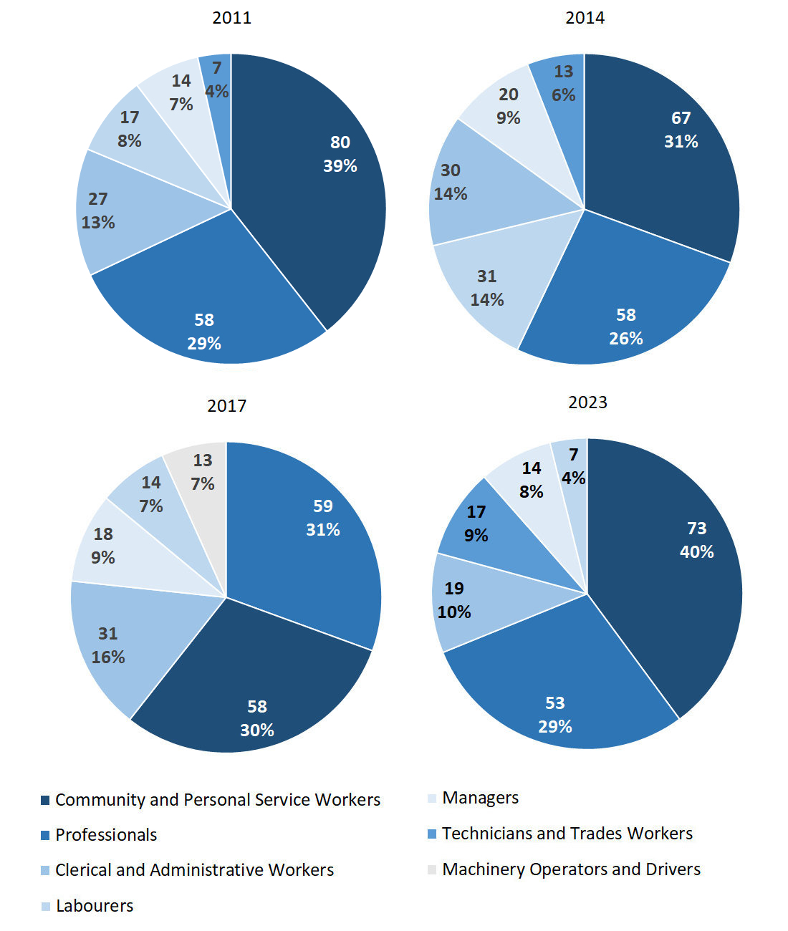

Source: Northern Territory - Department of Industry, Tourism and Trade

**In 2023 in Yuendumu:**

* Community and Personal Service Workers was the **largest occupation classification** in terms of jobs filled, accounting for 73 jobs (37.2% of total jobs filled), an increase of 15 jobs from 2017 and an increase of 6 jobs from 2014
* **other** **significant** occupation classifications were:
* Professionals, accounting for 53 jobs or 27.0% of total jobs a decrease of 6 jobs from 2017 and a decrease of 5 jobs from 2014
* Clerical and Administrative Workers accounting for 19 jobs or 9.7% of total jobs a decrease of 12 jobs from 2017 and a decrease of 11 jobs from 2014
* Technicians and Trades Workers accounting for 17 jobs or 8.7% of total jobs an increase of 12 jobs from 2017 and an increase of 4 jobs from 2014.

**Table 17a: Count of jobs filled by ANZSCO occupation, 2011, 2014, 2017 & 2023 (a)(c)(f)(g)**

|  |  |  |  |  |  |  |  |  |  |  |  |  |  |
| --- | --- | --- | --- | --- | --- | --- | --- | --- | --- | --- | --- | --- | --- |
| **Occupation (ANZSCO major group)** | **2011** | | | **2014** | | | **2017** | | | | **2023** | | |
| **Aboriginal** | **Non-Aboriginal** | **Total** | **Aboriginal** | **Non-Aboriginal** | **Total** | **Aboriginal** | **Non-Aboriginal** | **Total** | **Aboriginal** | | **Non-Aboriginal** | **Total** |
| Clerical and Administrative Workers | 17 | 10 | **27** | 18 | 12 | **30** | 12 | 19 | **31** | 10 | | 9 | **19** |
| Community and Personal Service Workers | 58 | 22 | **80** | 55 | 12 | **67** | 41 | 17 | **58** | 69 | | 4 | **73** |
| Labourers | 11 | 6 | **17** | 20 | 11 | **31** | 8 | 6 | **14** | 3 | | 4 | **7** |
| Machinery Operators and Drivers | 1 | 1 | **2** | 1 | 0 | **1** | 10 | 3 | **13** | 3 | | 1 | **4** |
| Managers | 1 | 13 | **14** | 4 | 16 | **20** | 2 | 16 | **18** | 3 | | 11 | **14** |
| Professionals | 35 | 23 | **58** | 28 | 30 | **58** | 30 | 29 | **59** | 33 | | 20 | **53** |
| Sales Workers | 1 | 2 | **3** | 4 | 5 | **9** | 5 | 1 | **6** | 3 | | 4 | **7** |
| Technicians and Trades Workers | 4 | 3 | **7** | 10 | 3 | **13** | 4 | 1 | **5** | 6 | | 11 | **17** |
| Other Occupations | 0 | 1 | **1** | 0 | 0 | **0** | 0 | 0 | **0** | 1 | | 1 | **2** |
| **Total** | **128** | **81** | **209** | **140** | **89** | **229** | **112** | **92** | **204** | **131** | | **65** | **196** |

Source: Northern Territory - Department of Industry, Tourism and Trade

**Table 17b: Count of jobs filled by ANZSCO occupation, 2011-2014, 2014-2017 & 2017-2023 (a)(c)(f)(g)**

|  |  |  |  |  |  |  |  |  |  |  |
| --- | --- | --- | --- | --- | --- | --- | --- | --- | --- | --- |
| **Occupation (ANZSCO major group)** | **Change 2011-2014** | | | **Change 2014-2017** | | | | **Change 2017-2023** | | |
| **Aboriginal** | **Non-Aboriginal** | **Total** | **Aboriginal** | **Non-Aboriginal** | **Total** | **Aboriginal** | | **Non-Aboriginal** | **Total** |
| Clerical and Administrative Workers | 1 | 2 | **3** | -6 | 7 | **1** | -2 | | -10 | **-12** |
| Community and Personal Service Workers | -3 | -10 | **-13** | -14 | 5 | **-9** | 28 | | -13 | **15** |
| Labourers | 9 | 5 | **14** | -12 | -5 | **-17** | -5 | | -2 | **-7** |
| Machinery Operators and Drivers | 0 | -1 | **-1** | 9 | 3 | **12** | -7 | | -2 | **-9** |
| Managers | 3 | 3 | **6** | -2 | 0 | **-2** | 1 | | -5 | **-4** |
| Professionals | -7 | 7 | **0** | 2 | -1 | **1** | 3 | | -9 | **-6** |
| Sales Workers | 3 | 3 | **6** | 1 | -4 | **-3** | -2 | | 3 | **1** |
| Technicians and Trades Workers | 6 | 0 | **6** | -6 | -2 | **-8** | 2 | | 10 | **12** |
| Other Occupations | 0 | -1 | **-1** | 0 | 0 | **0** | 1 | | 1 | **2** |
| **Total** | **12** | **8** | **20** | **-28** | **3** | **-25** | **19** | | **-27** | **-8** |

Source: Northern Territory - Department of Industry, Tourism and Trade

In 2023 in Yuendumu:

* of the 131 **jobs filled** by **Aboriginal** people, there were:
* 69 Community and Personal Service Workers, an increase of 28 jobs from 2017 and an increase of 14 jobs from 2014
* 33 Professionals, an increase of 3 jobs from 2017 and an increase of 5 jobs from 2014
* 10 Clerical and Administrative Workers, a decrease of 2 jobs from 2017 and a decrease of 8 jobs from 2014
* of the 65 **jobs filled** by **non-Aboriginal** people, there were:
* 20 Professionals, a decrease of 9 jobs from 2017 and a decrease of 10 jobs from 2014
* 11 Managers, a decrease of 5 jobs from 2017 and a decrease of 5 jobs from 2014
* 11 Technicians and Trades Workers, an increase of 10 jobs from 2017 and an increase of 8 jobs from 2014.

# Jobs by industry by occupation

Table 18: Count of jobs filled by industry by occupation, 2011 (a)(f)(g)(h)

|  |  |  |  |  |  |  |  |  |  |  |
| --- | --- | --- | --- | --- | --- | --- | --- | --- | --- | --- |
| **2011** | | | | | | | | | | |
| **Industry (ANZSIC Division)** |  | **Occupation (ANZSCO major group)** | | | | | | | | |
| **Clerical and Administrative Workers** | **Community and Personal Service Workers** | **Labourers** | **Machinery Operators and Drivers** | **Managers** | **Professionals** | **Sales Workers** | **Technicians and Trades Workers** | **Other Occupations** | **Total** |
| Arts and Recreation Services | 1 | 0 | 1 | 0 | 2 | 1 | 1 | 0 | 0 | **6** |
| Construction | 1 | 2 | 3 | 0 | 2 | 1 | 0 | 1 | 0 | **10** |
| Education and Training | 3 | 9 | 7 | 0 | 2 | 19 | 0 | 1 | 0 | **41** |
| Health Care and Social Assistance | 9 | 16 | 1 | 0 | 3 | 9 | 0 | 4 | 1 | **43** |
| Professional, Scientific and Technical Services | 0 | 0 | 0 | 0 | 1 | 21 | 0 | 0 | 0 | **22** |
| Public Administration and Safety | 11 | 47 | 2 | 0 | 1 | 7 | 1 | 1 | 0 | **70** |
| Retail Trade | 2 | 5 | 2 | 2 | 3 | 0 | 1 | 0 | 0 | **15** |
| **Total** | **27** | **80** | **17** | **2** | **14** | **58** | **3** | **7** | **1** | **209** |

Source: Northern Territory - Department of Industry, Tourism and Trade

Table 19: Count of jobs filled by industry by occupation, 2014 (a)(f)(g)(h)

|  |  |  |  |  |  |  |  |  |  |  |
| --- | --- | --- | --- | --- | --- | --- | --- | --- | --- | --- |
| **2014** | | | | | | | | | | |
| **Industry (ANZSIC Division)** |  | **Occupation (ANZSCO major group)** | | | | | | | | |
| **Clerical and Administrative Workers** | **Community and Personal Service Workers** | **Labourers** | **Machinery Operators and Drivers** | **Managers** | **Professionals** | **Sales Workers** | **Technicians and Trades Workers** | **Other Occupations** | **Total** |
| Arts and Recreation Services | 0 | 0 | 0 | 0 | 2 | 11 | 0 | 0 | 0 | **13** |
| Construction | 0 | 0 | 0 | 0 | 1 | 0 | 0 | 0 | 0 | **1** |
| Education and Training | 4 | 10 | 3 | 0 | 1 | 18 | 0 | 1 | 0 | **37** |
| Health Care and Social Assistance | 12 | 28 | 18 | 0 | 6 | 15 | 0 | 9 | 0 | **88** |
| Other Services | 0 | 0 | 0 | 0 | 1 | 13 | 0 | 0 | 0 | **14** |
| Public Administration and Safety | 13 | 29 | 7 | 0 | 4 | 1 | 0 | 3 | 0 | **57** |
| Retail Trade | 1 | 0 | 3 | 1 | 5 | 0 | 9 | 0 | 0 | **19** |
| **Total** | **30** | **67** | **31** | **1** | **20** | **58** | **9** | **13** | **0** | **229** |

Source: Northern Territory - Department of Industry, Tourism and Trade

Table 20: Count of jobs filled by occupation and by industry, 2017 (a)(f)(g)(h)

|  |  |  |  |  |  |  |  |  |  |  |
| --- | --- | --- | --- | --- | --- | --- | --- | --- | --- | --- |
| **2017** | | | | | | | | | | |
| **Industry (ANZSIC Division)** |  | **Occupation (ANZSCO major group)** | | | | | | | | |
| **Clerical and Administrative Workers** | **Community and Personal Service Workers** | **Labourers** | **Machinery Operators and Drivers** | **Managers** | **Professionals** | **Sales Workers** | **Technicians and Trades Workers** | **Other Occupations** | **Total** |
| Arts and Recreation Services | 3 | 0 | 7 | 0 | 2 | 28 | 0 | 0 | 0 | **40** |
| Construction | 1 | 0 | 4 | 4 | 5 | 0 | 4 | 3 | 0 | **21** |
| Education and Training | 8 | 13 | 0 | 0 | 3 | 19 | 0 | 0 | 0 | **43** |
| Health Care and Social Assistance | 11 | 28 | 0 | 0 | 4 | 11 | 0 | 2 | 0 | **56** |
| Public Administration and Safety | 8 | 17 | 0 | 0 | 0 | 1 | 0 | 0 | 0 | **26** |
| Retail Trade | 0 | 0 | 3 | 9 | 4 | 0 | 2 | 0 | 0 | **18** |
| **Total** | **31** | **58** | **14** | **13** | **18** | **59** | **6** | **5** | **0** | **204** |

Source: Northern Territory - Department of Industry, Tourism and Trade

Table 21: Count of jobs filled by occupation and by industry, 2023 (a)(f)(g)(h)

|  |  |  |  |  |  |  |  |  |  |  |
| --- | --- | --- | --- | --- | --- | --- | --- | --- | --- | --- |
| **2023** | | | | | | | | | | |
| **Industry (ANZSIC Division)** |  | **Occupation (ANZSCO major group)** | | | | | | | | |
| **Clerical and Administrative Workers** | **Community and Personal Service Workers** | **Labourers** | **Machinery Operators and Drivers** | **Managers** | **Professionals** | **Sales Workers** | **Technicians and Trades Workers** | **Other Occupations** | **Total** |
| Arts and Recreation Services | 3 | 0 | 0 | 2 | 1 | 13 | 0 | 0 | 0 | **19** |
| Construction | 0 | 0 | 4 | 1 | 1 | 0 | 0 | 11 | 0 | **17** |
| Education and Training | 10 | 10 | 3 | 0 | 0 | 15 | 0 | 0 | 0 | **38** |
| Electricity, Gas, Water and Waste Services | 0 | 0 | 0 | 0 | 3 | 7 | 0 | 0 | 0 | **10** |
| Health Care and Social Assistance | 0 | 1 | 0 | 0 | 0 | 3 | 0 | 0 | 2 | **6** |
| Public Administration and Safety | 6 | 62 | 0 | 0 | 6 | 15 | 0 | 1 | 0 | **90** |
| Retail Trade | 0 | 0 | 0 | 1 | 3 | 0 | 7 | 5 | 0 | **16** |
| **Total** | **19** | **73** | **7** | **4** | **14** | **53** | **7** | **17** | **2** | **196** |

Source: Northern Territory - Department of Industry, Tourism and Trade

In 2023 in Yuendumu:

* the largest occupation group, Community and Personal Service Workers filled the majority of jobs with 73 jobs which were shared across Public Administration and Safety with 62 jobs and Education and Training industries with 10 jobs,
* the second largest occupation group, Professionals filled the majority of jobs with 53 jobs which were shared across Public Administration and Safety with 15 jobs, Education and Training with 15 jobs and Arts and Recreation Services industries with 13 jobs,
* Public Administration and Safety, a major industry group, showed an increase of 64 jobs filled between 2023 and 2017,
* a new industry group, Electricity, Gas, Water and Waste Services, showed an increase in jobs filled of 10 between 2023 and 2017,
* the Health Care and Social Assistance and Arts and Recreation Services industry groups, both showed decreases in jobs filled of 50 and 21, respectively, between 2023 and 2017.

# Jobs by gender

Table 22a: Count of jobs filled by gender[2], 2011, 2014, 2017 & 2023 (a)(c)(i)

|  |  |  |  |  |  |  |  |  |  |  |  |  |  |  |  |  |
| --- | --- | --- | --- | --- | --- | --- | --- | --- | --- | --- | --- | --- | --- | --- | --- | --- |
| **Indicator** | **2011** | | | | **2014** | | | | **2017** | | | | **2023** | | | |
| **Aboriginal** | **Non-Aboriginal** | **Total** | **Aboriginal** | | **Non-Aboriginal** | **Total** | **Aboriginal** | | **Non-Aboriginal** | **Total** | **Aboriginal** | | **Non-Aboriginal** | **Total** |
| Male | 69 | 25 | **94** | 74 | | 35 | **109** | 64 | | 32 | **96** | 62 | | 33 | **95** |
| Female | 59 | 56 | **115** | 66 | | 54 | **120** | 45 | | 60 | **105** | 69 | | 32 | **101** |
| **Total** | **128** | **81** | **209** | **140** | | **89** | **229** | **109** | | **92** | **201** | **131** | | **65** | **196** |

Source: Northern Territory - Department of Industry, Tourism and Trade

Table 22b: Count of jobs filled by gender, 2011-2014, 2014-2017 & 2017-2023 (a)(c)(i)

|  |  |  |  |  |  |  |  |  |  |
| --- | --- | --- | --- | --- | --- | --- | --- | --- | --- |
| **Indicator** | **2011-2014 Change** | | | **2014-2017 Change** | | | **2017-2023 Change** | | |
| **Aboriginal** | **Non-Aboriginal** | **Total** | **Aboriginal** | **Non-Aboriginal** | **Total** | **Aboriginal** | **Non-Aboriginal** | **Total** |
| Male | 5 | 10 | **15** | -10 | -3 | **-13** | -2 | 1 | **-1** |
| Female | 7 | -2 | **5** | -21 | 6 | **-15** | 24 | -28 | **-4** |
| **Total** | **12** | **8** | **20** | **-31** | **3** | **-28** | **22** | **-27** | **-5** |

Source: Northern Territory - Department of Industry, Tourism and Trade

Chart 11: Count of jobs filled by gender, 2011, 2014, 2017 & 2023 (a)(c)(i)

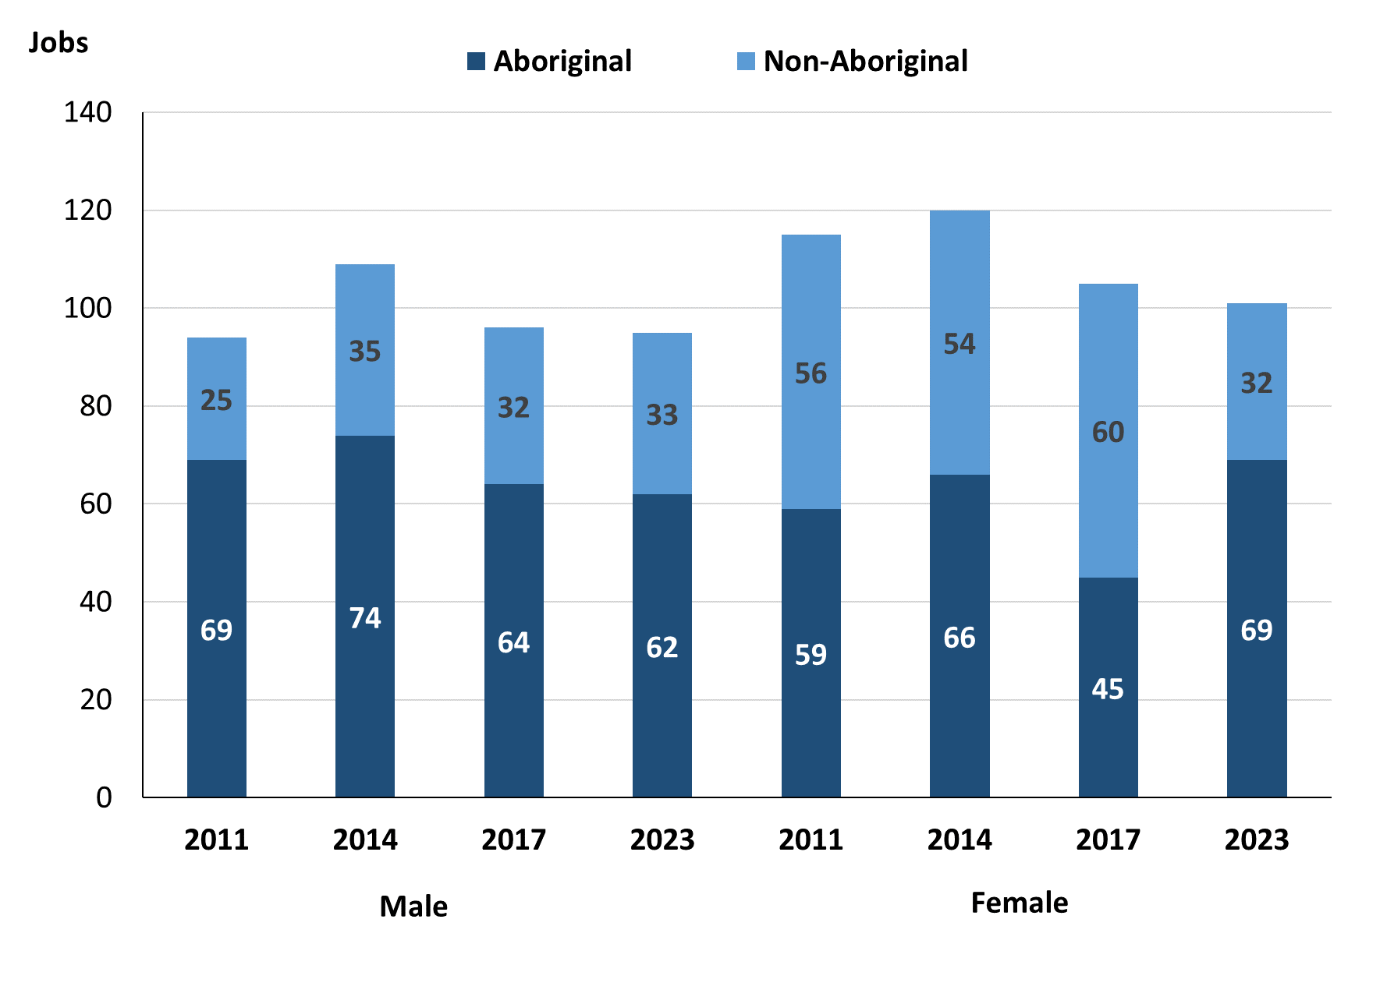

Source: Northern Territory - Department of Industry, Tourism and Trade

In 2023 in Yuendumu:

* there were 95 jobs **filled** **by** **males**, a decrease of 1 job from 2017 and a decrease of 14 jobs from 2014
* of the 95 jobs **filled by males:**
* 62 were **Aboriginal**, a decrease of 2 jobs from 2017 and a decrease of 12 jobs from 2014
* 33 were **Non-Aboriginal**, an increase of 1 job from 2017 and a decrease of 2 jobs from 2014
* there were 101 jobs **filled by females**, a decrease of 4 jobs from 2017 and a decrease of 19 jobs from 2014
* of the 101 jobs **filled by females**:
* 69 were **Aboriginal**, an increase of 24 jobs from 2017 and an increase of 3 jobs from 2014
* 32 were **non-Aboriginal**, a decrease of 28 jobs from 2017 and a decrease of 22 jobs from 2014.

Table 23: Count of jobs filled by gender, by full-time/part-time status, by job permanency and by sector 2011 (a)(b)(c)(d)(e)(i)

|  |  |  |  |  |  |  |  |  |  |
| --- | --- | --- | --- | --- | --- | --- | --- | --- | --- |
| **2011** | | | | | | | | | |
| **Indicator** | **Male** | | | **Female** | | | **Total** | | |
| **Aboriginal** | **Non-Aboriginal** | **Total** | **Aboriginal** | **Non-Aboriginal** | **Total** | **Aboriginal** | **Non-Aboriginal** | **Total** |
| Full-time | 42 | 23 | **65** | 22 | 51 | **73** | 64 | 74 | **138** |
| Part-time | 27 | 2 | **29** | 37 | 5 | **42** | 64 | 7 | **71** |
| **Total** | **69** | **25** | **94** | **59** | **56** | **115** | **128** | **81** | **209** |
| Permanent | 25 | 11 | **36** | 16 | 23 | **39** | 41 | 34 | **75** |
| Temporary | 44 | 14 | **58** | 43 | 33 | **76** | 87 | 47 | **134** |
| **Total** | **69** | **25** | **94** | **59** | **56** | **115** | **128** | **81** | **209** |
| Public Sector | 31 | 11 | **42** | 42 | 29 | **71** | 73 | 40 | **113** |
| Private Sector | 38 | 14 | **52** | 17 | 27 | **44** | 55 | 41 | **96** |
| **Total** | **69** | **25** | **94** | **59** | **56** | **115** | **128** | **81** | **209** |

Source: Northern Territory - Department of Industry, Tourism and Trade

Table 24: Count of jobs filled by gender, by full-time/part-time status, by job permanency and by sector 2014 (a)(b)(c)(d)(e)(i)

|  |  |  |  |  |  |  |  |  |  |
| --- | --- | --- | --- | --- | --- | --- | --- | --- | --- |
| **2014** | | | | | | | | | |
| **Indicator** | **Male** | | | **Female** | | | **Total** | | |
| **Aboriginal** | **Non-Aboriginal** | **Total** | **Aboriginal** | **Non-Aboriginal** | **Total** | **Aboriginal** | **Non-Aboriginal** | **Total** |
| Full-time | 40 | 33 | **73** | 26 | 46 | **72** | 66 | 79 | **145** |
| Part-time | 34 | 2 | **36** | 40 | 8 | **48** | 74 | 10 | **84** |
| **Total** | **74** | **35** | **109** | **66** | **54** | **120** | **140** | **89** | **229** |
| Permanent | 40 | 18 | **58** | 25 | 41 | **66** | 65 | 59 | **124** |
| Temporary | 34 | 17 | **51** | 41 | 13 | **54** | 75 | 30 | **105** |
| **Total** | **74** | **35** | **109** | **66** | **54** | **120** | **140** | **89** | **229** |
| Public Sector | 31 | 9 | **40** | 34 | 25 | **59** | 65 | 34 | **99** |
| Private Sector | 43 | 26 | **69** | 32 | 29 | **61** | 75 | 55 | **130** |
| **Total** | **74** | **35** | **109** | **66** | **54** | **120** | **140** | **89** | **229** |

Source: Northern Territory - Department of Industry, Tourism and Trade

Table 25: Count of jobs filled by gender[3], by full-time/part-time status, by job permanency and by sector 2017 (a)(b)(c)(d)(e)(i)

|  |  |  |  |  |  |  |  |  |  |
| --- | --- | --- | --- | --- | --- | --- | --- | --- | --- |
| **2017** | | | | | | | | | |
| **Indicator** | **Male** | | | **Female** | | | **Total** | | |
| **Aboriginal** | **Non-Aboriginal** | **Total** | **Aboriginal** | **Non-Aboriginal** | **Total** | **Aboriginal** | **Non-Aboriginal** | **Total** |
| Full-time | 26 | 31 | **57** | 22 | 56 | **78** | 51 | 87 | **138** |
| Part-time | 38 | 1 | **39** | 23 | 4 | **27** | 61 | 5 | **66** |
| **Total** | **64** | **32** | **96** | **45** | **60** | **105** | **112** | **92** | **204** |
| Permanent | 17 | 15 | **32** | 28 | 34 | **62** | 48 | 49 | **97** |
| Temporary | 47 | 17 | **64** | 17 | 26 | **43** | 64 | 43 | **107** |
| **Total** | **64** | **32** | **96** | **45** | **60** | **105** | **112** | **92** | **204** |
| Public Sector | 9 | 12 | **21** | 29 | 29 | **58** | 41 | 41 | **82** |
| Private Sector | 55 | 20 | **75** | 16 | 31 | **47** | 71 | 51 | **122** |
| **Total** | **64** | **32** | **96** | **45** | **60** | **105** | **112** | **92** | **204** |

Source: Northern Territory - Department of Industry, Tourism and Trade

Table 26: Count of jobs filled by gender, by full-time/part-time status, by job permanency and by sector 2023 (a)(b)(c)(d)(e)(i)

|  |  |  |  |  |  |  |  |  |  |
| --- | --- | --- | --- | --- | --- | --- | --- | --- | --- |
| **2023** | | | | | | | | | |
| **Indicator** | **Male** | | | **Female** | | | **Total** | | |
| **Aboriginal** | **Non-Aboriginal** | **Total** | **Aboriginal** | **Non-Aboriginal** | **Total** | **Aboriginal** | **Non-Aboriginal** | **Total** |
| Full-time | 48 | 32 | **80** | 53 | 31 | **84** | 101 | 63 | **164** |
| Part-time | 14 | 1 | **15** | 16 | 1 | **17** | 30 | 2 | **32** |
| **Total** | **62** | **33** | **95** | **69** | **32** | **101** | **131** | **65** | **196** |
| Permanent | 13 | 21 | **34** | 20 | 9 | **29** | 33 | 30 | **63** |
| Temporary | 49 | 12 | **61** | 49 | 23 | **72** | 98 | 35 | **133** |
| **Total** | **62** | **33** | **95** | **69** | **32** | **101** | **131** | **65** | **196** |
| Public Sector | 9 | 10 | **19** | 20 | 20 | **40** | 29 | 30 | **59** |
| Private Sector | 53 | 23 | **76** | 49 | 12 | **61** | 102 | 35 | **137** |
| **Total** | **62** | **33** | **95** | **69** | **32** | **101** | **131** | **65** | **196** |

Source: Northern Territory - Department of Industry, Tourism and Trade

In 2023 in Yuendumu:

* of the 95 **jobs** **filled** **by** **males**, there were:
* 62 jobs filled by **Aboriginal males**, a decrease of 2 jobs from 2017 and a decrease of 12 jobs from 2014, including:
* 48 full-time jobs, an increase of 22 jobs from 2017 and an increase of 8 jobs from 2014
* 14 part-time jobs, a decrease of 24 jobs from 2017 and a decrease of 20 jobs from 2014
* 13 permanent jobs, a decrease of 4 jobs from 2017 and a decrease of 27 jobs from 2014
* 49 temporary jobs, an increase of 2 jobs from 2017 and an increase of 15 jobs from 2014
* 9 Public Sector jobs, unchanged from 2017 and a decrease of 22 jobs from 2014
* 53 Private Sector jobs, a decrease of 2 jobs from 2017 and an increase of 10 jobs from 2014
* 33 jobs filled by **non-Aboriginal males**, an increase of 1 job from 2017 and a decrease of 2 jobs from 2014, including:
* 32 full-time jobs, an increase of 1 job from 2017 and a decrease of 1 job from 2014
* 1 part-time job, unchanged from 2017 and a decrease of 1 job from 2014
* 21 permanent jobs, an increase of 6 jobs from 2017 and an increase of 3 jobs from 2014
* 12 temporary jobs, a decrease of 5 jobs from 2017 and a decrease of 5 jobs from 2014
* 10 Public Sector jobs, a decrease of 2 jobs from 2017 and an increase of 1 job from 2014
* 23 Private Sector jobs, an increase of 3 jobs from 2017 and a decrease of 3 jobs from 2014
* of the 101 **jobs** **filled by** **females**, there were:
* 69 jobs filled by **Aboriginal females**, an increase of 24 jobs from 2017 and an increase of 3 jobs from 2014, including:
* 53 full-time jobs, an increase of 31 jobs from 2017 and an increase of 27 jobs from 2014
* 16 part-time jobs, a decrease of 7 jobs from 2017 and a decrease of 24 jobs from 2014
* 20 permanent jobs, a decrease of 8 jobs from 2017 and a decrease of 5 jobs from 2014
* 49 temporary jobs, an increase of 32 jobs from 2017 and an increase of 8 jobs from 2014
* 20 Public Sector jobs, a decrease of 9 jobs from 2017 and a decrease of 14 jobs from 2014
* 49 Private Sector jobs, an increase of 33 jobs from 2017 and an increase of 17 jobs from 2014
* 32 jobs filled by **non-Aboriginal females**, a decrease of 28 jobs from 2017 and a decrease of 22 jobs from 2014, including:
* 31 full-time jobs, a decrease of 25 jobs from 2017 and a decrease of 15 jobs from 2014
* 1 part-time job, a decrease of 3 jobs from 2017 and a decrease of 7 jobs from 2014
* 9 permanent jobs, a decrease of 25 jobs from 2017 and a decrease of 32 jobs from 2014
* 23 temporary jobs, a decrease of 3 jobs from 2017 and an increase of 10 jobs from 2014
* 20 Public Sector jobs, a decrease of 9 jobs from 2017 and a decrease of 5 jobs from 2014
* 12 Private Sector jobs, a decrease of 19 jobs from 2017 and a decrease of 17 jobs from 2014.

# Jobs by age

Table 27a: Count of jobs filled by age, 2011, 2014, 2017 & 2023 (a)(c)(j)

|  |  |  |  |  |  |  |  |  |  |  |  |  |
| --- | --- | --- | --- | --- | --- | --- | --- | --- | --- | --- | --- | --- |
| **Indicator** | **2011** | | | **2014** | | | **2017** | | | **2023** | | |
| **Aboriginal** | **Non-Aboriginal** | **Total** | **Aboriginal** | **Non-Aboriginal** | **Total** | **Aboriginal** | **Non-Aboriginal** | **Total** | **Aboriginal** | **Non-Aboriginal** | **Total** |
| 15-24 years | 16 | 15 | **31** | 18 | 6 | **24** | 20 | 5 | **25** | 10 | 3 | **13** |
| 25-44 years | 52 | 41 | **93** | 88 | 55 | **143** | 63 | 45 | **108** | 71 | 34 | **105** |
| 45+ years | 60 | 25 | **85** | 34 | 28 | **62** | 26 | 42 | **68** | 50 | 27 | **77** |
| **Total** | **128** | **81** | **209** | **140** | **89** | **229** | **112** | **92** | **204** | **131** | **65** | **196** |

Source: Northern Territory - Department of Industry, Tourism and Trade

Table 27b: Count of jobs filled by age, 2011-2014, 2014-2017 & 2017-2023 (a)(c)(j)

|  |  |  |  |  |  |  |  |  |  |
| --- | --- | --- | --- | --- | --- | --- | --- | --- | --- |
| **Indicator** | **Change 2011-2014** | | | **Change 2014-2017** | | | **Change 2017-2023** | | |
| **Aboriginal** | **Non-Aboriginal** | **Total** | **Aboriginal** | **Non-Aboriginal** | **Total** | **Aboriginal** | **Non-Aboriginal** | **Total** |
| 15-24 years | 2 | -9 | **-7** | 2 | -1 | **1** | -10 | -2 | **-12** |
| 25-44 years | 36 | 14 | **50** | -25 | -10 | **-35** | 8 | -11 | **-3** |
| 45+ years | -26 | 3 | **-23** | -8 | 14 | **6** | 24 | -15 | **9** |
| **Total** | **12** | **8** | **20** | **-28** | **3** | **-25** | **22** | **-27** | **-5** |

Source: Northern Territory - Department of Industry, Tourism and Trade

Chart 12: Count of jobs filled by age, 2011, 2014, 2017 & 2023 (a)(c)(j)

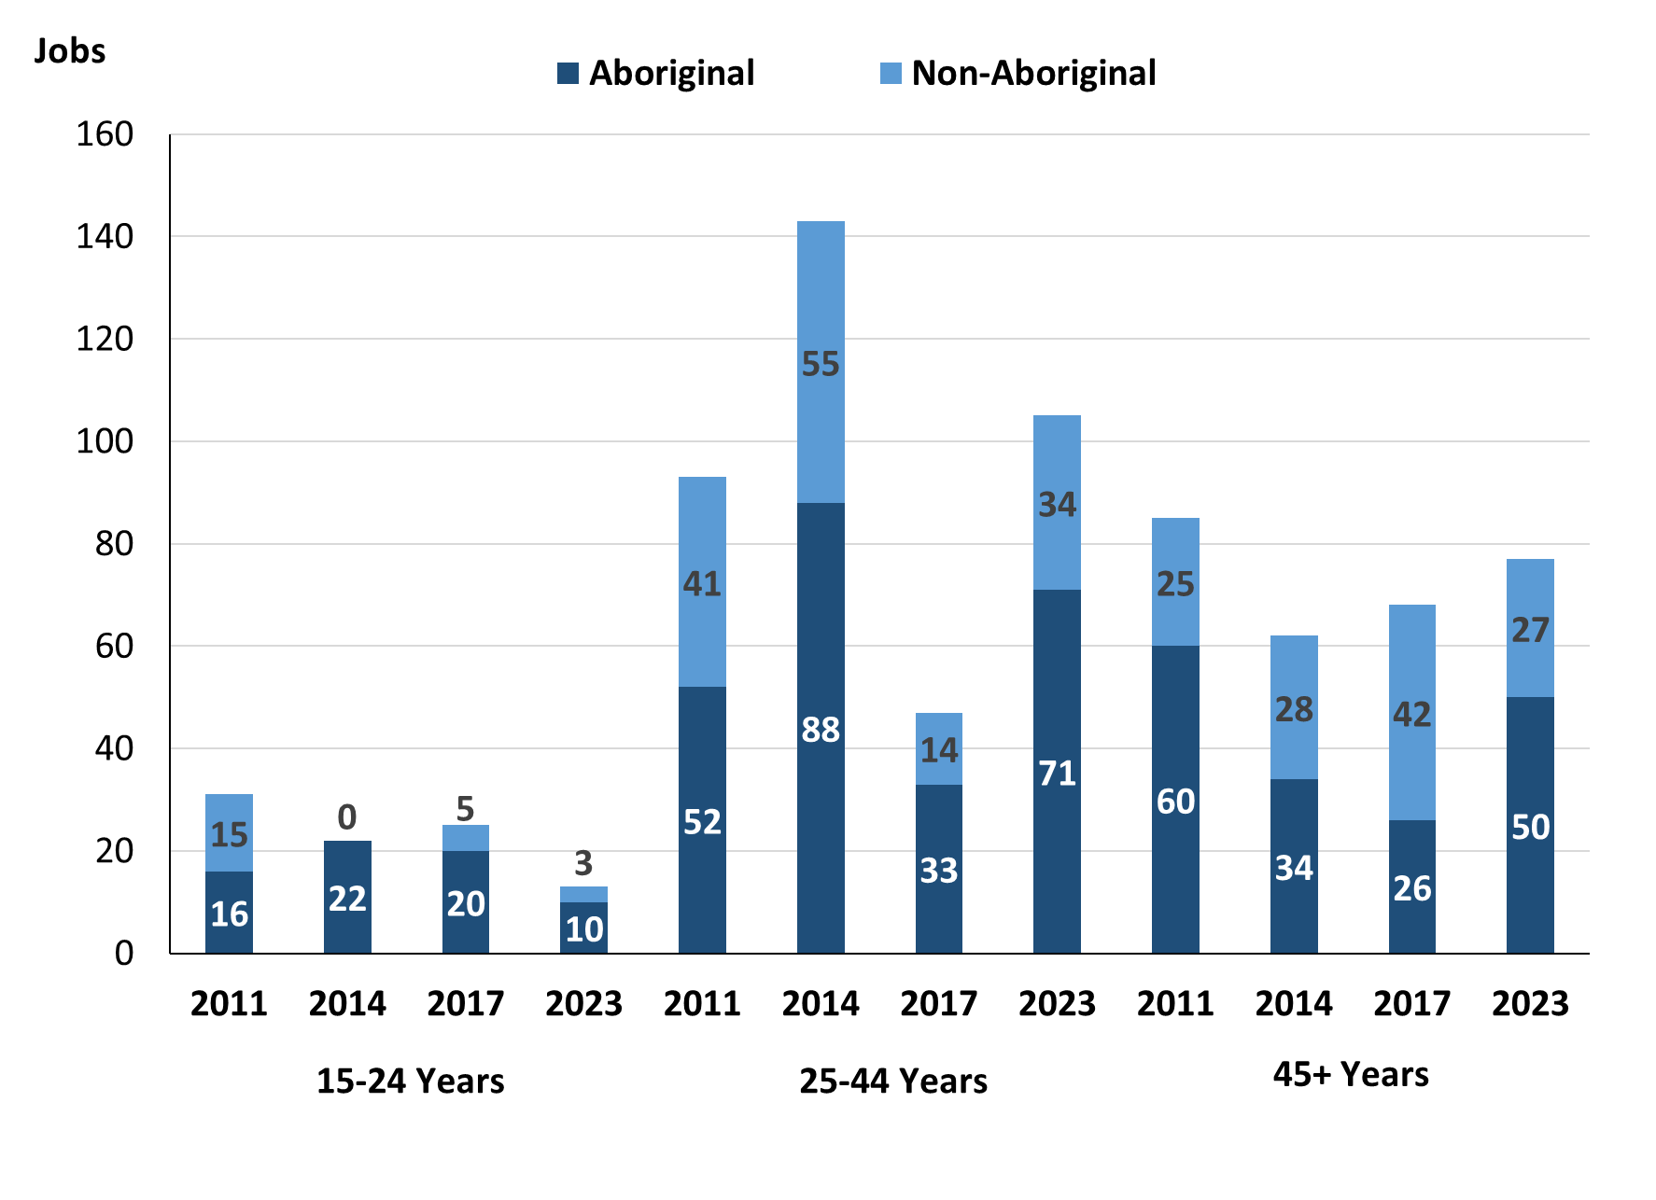

Source: Northern Territory - Department of Industry, Tourism and Trade

In 2023 in Yuendumu there were:

* 13 **jobs filled** by people aged **15-24 years**, a decrease of 12 jobs from 2017 and a decrease of 11 jobs from 2014. Of these:
* **Aboriginal** people filled 10 jobs, a decrease of 10 jobs from 2017 and a decrease of 8 jobs from 2014
* **non-Aboriginal** people filled 3 jobs, a decrease of 2 jobs from 2017 and a decrease of 3 jobs from 2014
* there were 105 **jobs** **filled** by people aged **25-44 years**, a decrease of 3 jobs from 2017 and a decrease of 38 jobs from 2014. Of these:
* **Aboriginal** people filled 71 jobs, an increase of 8 jobs from 2017 and a decrease of 17 jobs from 2014
* **non-Aboriginal** people filled 34 jobs, a decrease of 11 jobs from 2017 and a decrease of 21 jobs from 2014
* there were 77 **jobs** **filled** by people aged **45+ years**, an increase of 9 jobs from 2017 and an increase of 15 jobs from 2014. Of these:
* **Aboriginal** people filled 50 jobs, an increase of 24 jobs from 2017 and an increase of 16 jobs from 2014
* **non-Aboriginal** people filled 27 jobs, a decrease of 15 jobs from 2017 and a decrease of 1 job from 2014.

Table 28: Count of jobs filled by age, by full-time/part-time status, by job permanency and by sector June-July 2011 (a)(b)(c)(d)(e)(i)

|  |  |  |  |  |  |  |  |  |  |  |  |  |  |
| --- | --- | --- | --- | --- | --- | --- | --- | --- | --- | --- | --- | --- | --- |
| **2011** | | | | | | | | | | | | | |
| **Indicator** | **15-24 years** | | | **25-44 years** | | | **45+ years** | | | **Total** | | | |
| **Aboriginal** | **Non-Aboriginal** | **Total** | **Aboriginal** | **Non-Aboriginal** | **Total** | **Aboriginal** | **Non-Aboriginal** | **Total** | **Aboriginal** | **Non-Aboriginal** | **Total** |
| Full-time | 8 | 13 | **21** | 30 | 38 | **68** | 26 | 23 | **49** | 64 | 74 | **138** |
| Part-time | 8 | 2 | **10** | 22 | 3 | **25** | 34 | 2 | **36** | 64 | 7 | **71** |
| **Total** | **16** | **15** | **31** | **52** | **41** | **93** | **60** | **25** | **85** | **128** | **81** | **209** |
| Permanent | 1 | 6 | **7** | 25 | 17 | **42** | 15 | 11 | **26** | 41 | 34 | **75** |
| Temporary | 15 | 9 | **24** | 27 | 24 | **51** | 45 | 14 | **59** | 87 | 47 | **134** |
| **Total** | **16** | **15** | **31** | **52** | **41** | **93** | **60** | **25** | **85** | **128** | **81** | **209** |
| Public Sector | 6 | 1 | **7** | 17 | 23 | **40** | 50 | 16 | **66** | 73 | 40 | **113** |
| Private Sector | 10 | 14 | **24** | 35 | 18 | **53** | 10 | 9 | **19** | 55 | 41 | **96** |
| **Total** | **16** | **15** | **31** | **52** | **41** | **93** | **60** | **25** | **85** | **128** | **81** | **209** |

Source: Northern Territory - Department of Industry, Tourism and Trade

Table 29: Count of jobs filled by age, by full-time/part-time status, by job permanency and by sector June-July 2014 (a)(b)(c)(d)(e)(i)

|  |  |  |  |  |  |  |  |  |  |  |  |  |  |
| --- | --- | --- | --- | --- | --- | --- | --- | --- | --- | --- | --- | --- | --- |
| **2014** | | | | | | | | | | | | | |
| **Indicator** | **15-24 years** | | | **25-44 years** | | | **45+ years** | | | **Total** | | | |
| **Aboriginal** | **Non-Aboriginal** | **Total** | **Aboriginal** | **Non-Aboriginal** | **Total** | **Aboriginal** | **Non-Aboriginal** | **Total** | **Aboriginal** | **Non-Aboriginal** | **Total** |
| Full-time | 8 | 5 | **13** | 40 | 46 | **86** | 18 | 28 | **46** | 66 | 79 | **145** |
| Part-time | 10 | 1 | **11** | 48 | 9 | **57** | 16 | 0 | **16** | 74 | 10 | **84** |
| **Total** | **18** | **6** | **24** | **88** | **55** | **143** | **34** | **28** | **62** | **140** | **89** | **229** |
| Permanent | 12 | 1 | **13** | 33 | 37 | **70** | 20 | 21 | **41** | 65 | 59 | **124** |
| Temporary | 6 | 5 | **11** | 55 | 18 | **73** | 14 | 7 | **21** | 75 | 30 | **105** |
| **Total** | **18** | **6** | **24** | **88** | **55** | **143** | **34** | **28** | **62** | **140** | **89** | **229** |
| Public Sector | 3 | 0 | **3** | 44 | 25 | **69** | 18 | 9 | **27** | 65 | 34 | **99** |
| Private Sector | 15 | 6 | **21** | 44 | 30 | **74** | 16 | 19 | **35** | 75 | 55 | **130** |
| **Total** | **18** | **6** | **24** | **88** | **55** | **143** | **34** | **28** | **62** | **140** | **89** | **229** |

Source: Northern Territory - Department of Industry, Tourism and Trade

Table 30: Count of jobs filled by age, by full-time/part-time status, by job permanency and by sector June-July 2017 (a)(b)(c)(d)(e)(i)

|  |  |  |  |  |  |  |  |  |  |  |  |  |  |
| --- | --- | --- | --- | --- | --- | --- | --- | --- | --- | --- | --- | --- | --- |
| **2017** | | | | | | | | | | | | | |
| **Indicator** | **15-24 years** | | | **25-44 years** | | | **45+ years** | | | **Total** | | | |
| **Aboriginal** | **Non-Aboriginal** | **Total** | **Aboriginal** | **Non-Aboriginal** | **Total** | **Aboriginal** | **Non-Aboriginal** | **Total** | **Aboriginal** | **Non-Aboriginal** | **Total** |
| Full-time | 8 | 5 | **13** | 24 | 41 | **65** | 16 | 41 | **57** | 51 | 87 | **138** |
| Part-time | 12 | 0 | **12** | 39 | 4 | **43** | 10 | 1 | **11** | 61 | 5 | **66** |
| **Total** | **20** | **5** | **25** | **63** | **45** | **108** | **26** | **42** | **68** | **112** | **92** | **204** |
| Permanent | 11 | 1 | **12** | 15 | 25 | **40** | 19 | 23 | **42** | 48 | 49 | **97** |
| Temporary | 9 | 4 | **13** | 48 | 20 | **68** | 7 | 19 | **26** | 64 | 43 | **107** |
| **Total** | **20** | **5** | **25** | **63** | **45** | **108** | **26** | **42** | **68** | **112** | **92** | **204** |
| Public Sector | 2 | 1 | **3** | 20 | 22 | **42** | 16 | 18 | **34** | 41 | 41 | **82** |
| Private Sector | 18 | 4 | **22** | 43 | 23 | **66** | 10 | 24 | **34** | 71 | 51 | **122** |
| **Total** | **20** | **5** | **25** | **63** | **45** | **108** | **26** | **42** | **68** | **112** | **92** | **204** |

Source: Northern Territory - Department of Industry, Tourism and Trade

Table 31: Count of jobs filled by age, by full-time/part-time status, by job permanency and by sector September 2023 (a)(b)(c)(d)(e)(i)

|  |  |  |  |  |  |  |  |  |  |  |  |  |  |
| --- | --- | --- | --- | --- | --- | --- | --- | --- | --- | --- | --- | --- | --- |
| **2023** | | | | | | | | | | | | | |
| **Indicator** | **15-24 years** | | | **25-44 years** | | | **45+ years** | | | **Total** | | | |
| **Aboriginal** | **Non-Aboriginal** | **Total** | **Aboriginal** | **Non-Aboriginal** | **Total** | **Aboriginal** | **Non-Aboriginal** | **Total** | **Aboriginal** | **Non-Aboriginal** | **Total** |
| Full-time | 6 | 3 | **9** | 53 | 34 | **87** | 42 | 25 | **67** | 101 | 63 | **164** |
| Part-time | 4 | 0 | **4** | 18 | 0 | **18** | 8 | 2 | **10** | 30 | 2 | **32** |
| **Total** | **10** | **3** | **13** | **71** | **34** | **105** | **50** | **27** | **77** | **131** | **65** | **196** |
| Permanent | 4 | 1 | **5** | 17 | 13 | **30** | 12 | 15 | **27** | 33 | 30 | **63** |
| Temporary | 6 | 2 | **8** | 54 | 21 | **75** | 38 | 12 | **50** | 98 | 35 | **133** |
| **Total** | **10** | **3** | **13** | **71** | **34** | **105** | **50** | **27** | **77** | **131** | **65** | **196** |
| Public Sector | 1 | 1 | **2** | 10 | 16 | **26** | 18 | 12 | **30** | 29 | 30 | **59** |
| Private Sector | 9 | 2 | **11** | 61 | 18 | **79** | 32 | 15 | **47** | 102 | 35 | **137** |
| **Total** | **10** | **3** | **13** | **71** | **34** | **105** | **50** | **27** | **77** | **131** | **65** | **196** |

Source: Northern Territory - Department of Industry, Tourism and Trade

In 2023 in Yuendumu:

* of the 13 **jobs** **filled** by people aged **15-24 years**, there were:
* 10 jobs filled by **Aboriginal** people, of which
* 6 were full-time jobs, a decrease of 2 jobs from 2017 and a decrease of 2 jobs from 2014
* 4 were part-time jobs, a decrease of 8 jobs from 2017 and a decrease of 6 jobs from 2014
* 4 were permanent jobs, a decrease of 7 jobs from 2017 and a decrease of 8 jobs from 2014
* 6 were temporary jobs, a decrease of 3 jobs from 2017 and unchanged from 2014
* 1 was a Public Sector job, a decrease of 1 job from 2017 and a decrease of 2 jobs from 2014
* 9 were Private Sector jobs, a decrease of 9 jobs from 2017 and a decrease of 6 jobs from 2014
* 3 jobs filled by **non-Aboriginal** people, of which:
* 3 were full-time jobs, a decrease of 2 jobs from 2017 and a decrease of 2 jobs from 2014
* none were part-time jobs, unchanged from 2017 and a decrease of 1 job from 2014
* 1 was a permanent job, unchanged from 2017 and unchanged from 2014
* 2 were temporary jobs, a decrease of 2 jobs from 2017 and a decrease of 3 jobs from 2014
* 1 was a Public Sector job, unchanged from 2017 and an increase of 1 job from 2014
* 2 were Private Sector jobs, a decrease of 2 jobs from 2017 and a decrease of 4 jobs from 2014
* of the 105 **jobs** **filled** by people aged **25-44 years**, there were:
* 71 jobs filled by **Aboriginal** people, of which:
* 53 were full-time jobs, an increase of 29 jobs from 2017 and an increase of 13 jobs from 2014
* 18 were part-time jobs, a decrease of 21 jobs from 2017 and a decrease of 30 jobs from 2014
* 17 were permanent jobs, an increase of 2 jobs from 2017 and a decrease of 16 jobs from 2014
* 54 were temporary jobs, an increase of 6 jobs from 2017 and a decrease of 1 job from 2014
* 10 were Public Sector jobs, a decrease of 10 jobs from 2017 and a decrease of 34 jobs from 2014
* 61 were Private Sector jobs, an increase of 18 jobs from 2017 and an increase of 17 jobs from 2014
* 34 jobs filled by **non-Aboriginal** people, of which:
* 34 were full-time jobs, a decrease of 7 jobs from 2017 and a decrease of 12 jobs from 2014
* none were part-time jobs, a decrease of 4 jobs from 2017 and a decrease of 9 jobs from 2014
* 13 were permanent jobs, a decrease of 12 jobs from 2017 and a decrease of 24 jobs from 2014
* 21 were temporary jobs, an increase of 1 job from 2017 and an increase of 3 jobs from 2014
* 16 were Public Sector jobs, a decrease of 6 jobs from 2017 and a decrease of 9 jobs from 2014
* 18 were Private Sector jobs, a decrease of 5 jobs from 2017 and a decrease of 12 jobs from 2014
* of the 77 **jobs** **filled** by people aged **45+ years**, there were:
* 50 jobs filled by **Aboriginal** people, of which:
* 42 were full-time jobs, an increase of 26 jobs from 2017 and an increase of 24 jobs from 2014
* 8 were part-time jobs, a decrease of 2 jobs from 2017 and a decrease of 8 jobs from 2014
* 12 were permanent jobs, a decrease of 7 jobs from 2017 and a decrease of 8 jobs from 2014
* 38 were temporary jobs, an increase of 31 jobs from 2017 and an increase of 24 jobs from 2014
* 18 were Public Sector jobs, an increase of 2 jobs from 2017 and unchanged from 2014
* 32 were Private Sector jobs, an increase of 22 jobs from 2017 and an increase of 16 jobs from 2014
* 27 jobs filled by **non-Aboriginal** people, of which:
* 25 were full-time jobs, a decrease of 16 jobs from 2017 and a decrease of 3 jobs from 2014
* 2 were part-time jobs, an increase of 1 job from 2017 and an increase of 2 jobs from 2014
* 15 were permanent jobs, a decrease of 8 jobs from 2017 and a decrease of 6 jobs from 2014
* 12 were temporary jobs, a decrease of 7 jobs from 2017 and an increase of 5 jobs from 2014
* 12 were Public Sector jobs, a decrease of 6 jobs from 2017 and an increase of 3 jobs from 2014
* 15 were Private Sector jobs, a decrease of 9 jobs from 2017 and a decrease of 4 jobs from 2014.

# Vocational Education and Training

Note: *The 2010 data is in accordance with the new, standardised reporting procedures that focus on all training activities conducted in the remote town, irrespective of funding source, as compared to earlier publications. As a result, the 2010 VET data values in this publication might not match those in earlier publications.*

*The impact of the Remote Jobs and Communities Program (RJCP), established in 2013, has played a significant role in the reduction of accredited training in many remote towns across the Territory.*

Table 32a: Northern Territory Vocational Education and Training (VET) students, 2010, 2013, 2016 and 2023 (k)

|  |  |  |  |  |  |  |  |  |
| --- | --- | --- | --- | --- | --- | --- | --- | --- |
| **VET Funding Group** | **2010** | | **2013** | | **2016** | | **2023** | |
| **No.** | **% of Total** | **No.** | **% of Total** | **No.** | **% of Total** | **No.** | **% of Total** |
| Arts, Entertainment, Sports and Recreation | 0 | 0% | 13 | 10% | 51 | 17% | 0 | 0% |
| Automotive | 0 | 0% | 2 | 2% | 0 | 0% | 0 | 0% |
| Building and Construction | 0 | 0% | 20 | 15% | 13 | 4% | 21 | 51% |
| Business and Clerical | 2 | 100% | 11 | 8% | 24 | 8% | 0 | 0% |
| Community Services, Health and Education | 0 | 0% | 47 | 36% | 73 | 24% | 0 | 0% |
| Engineering and Mining | 0 | 0% | 0 | 0% | 65 | 21% | 6 | 15% |
| Food Processing | 0 | 0% | 0 | 0% | 10 | 3% | 0 | 0% |
| General Education and Training | 0 | 0% | 6 | 5% | 52 | 17% | 1 | 2% |
| Primary Industry | 0 | 0% | 13 | 10% | 0 | 0% | 1 | 2% |
| Sales and Personal Service | 0 | 0% | 9 | 7% | 9 | 3% | 5 | 12% |
| Tourism and Hospitality | 0 | 0% | 5 | 4% | 0 | 0% | 7 | 17% |
| Transport and Storage | 0 | 0% | 6 | 5% | 8 | 3% | 0 | 0% |
| **Total** | **2** | **100%** | **132** | **100%** | **305** | **100%** | **35** | **100%** |

Source: Northern Territory - Department of Industry, Tourism and Trade

Table 32b: Northern Territory Vocational Education and Training (VET) students, 2010-2013, 2013-2016 and 2016-2023 (k)

|  |  |  |  |
| --- | --- | --- | --- |
| **VET Funding Group** | **Change** | | |
| **2010-2013** | **2013-2016** | **2016-2023** |
| Arts, Entertainment, Sports and Recreation | 13 | 38 | -51 |
| Automotive | 2 | - 2 | 0 |
| Building and Construction | 20 | - 7 | 8 |
| Business and Clerical | 9 | 13 | -24 |
| Community Services, Health and Education | 47 | 26 | -73 |
| Engineering and Mining | 0 | 65 | -59 |
| Food Processing | 0 | 10 | -10 |
| General Education and Training | 6 | 46 | -51 |
| Primary Industry | 13 | - 13 | 1 |
| Sales and Personal Service | 9 | 0 | -4 |
| Tourism and Hospitality | 5 | - 5 | 7 |
| Transport and Storage | 6 | 2 | -8 |
| **Total** | **130** | **173** | **-270** |

Source: Northern Territory - Department of Industry, Tourism and Trade

In 2023 in Yuendumu:

* there were 35 **VET students**, a decrease of 270 students from 2016 and a decrease of 97 students from 2013,
* VET activity with the most students were Building and Construction with 21 students,
* Tourism and Hospitality with 7 students,
* Engineering and Mining had 6 students,
* Building and Construction reported the largest increase in students with 8 more students compared to 2016,
* Community Services, Health and Education reported the largest decrease in students with 73 less students over the same period.

Table 33a: Northern Territory Vocational Education and Training (VET) unit enrolments, 2010, 2013, 2016 and 2023 (l)

|  |  |  |  |  |  |  |  |  |  |
| --- | --- | --- | --- | --- | --- | --- | --- | --- | --- |
| **VET Funding Group** | **2010** | | **2013** | | **2016** | | | **2023** | |
| **No.** | **% of Total** | **No.** | **% of Total** | **No.** | **% of Total** | **No.** | | **% of Total** |
| Arts, Entertainment, Sports and Recreation | 0 | 0% | 82 | 15% | 255 | 15% | 0 | | 0% |
| Automotive | 0 | 0% | 5 | 1% | 0 | 0% | 0 | | 0% |
| Building and Construction | 0 | 0% | 66 | 12% | 126 | 7% | 51 | | 46% |
| Business and Clerical | 12 | 100% | 49 | 9% | 97 | 6% | 0 | | 0%% |
| Community Services, Health and Education | 0 | 0% | 163 | 30% | 175 | 10% | 0 | | 0% |
| Engineering and Mining | 0 | 0% | 0 | 0% | 438 | 26% | 6 | | 5% |
| Food Processing | 0 | 0% | 0 | 0% | 190 | 11% | 0 | | 0% |
| General Education and Training | 0 | 0% | 12 | 2% | 347 | 20% | 2 | | 2% |
| Primary Industry | 0 | 0% | 18 | 3% | 0 | 0% | 1 | | 1% |
| Sales and Personal Service | 0 | 0% | 99 | 18% | 51 | 3% | 43 | | 39% |
| Tourism and Hospitality | 0 | 0% | 36 | 7% | 0 | 0% | 7 | | 6% |
| Transport and Storage | 0 | 0% | 6 | 1% | 32 | 2% | 0 | | 0% |
| **Total** | **12** | **100%** | **536** | **100%** | **1 711** | **100%** | **110** | | **100%** |

Source: Northern Territory - Department of Industry, Tourism and Trade

Table 33b: Northern Territory Vocational Education and Training (VET) unit enrolments, 2010-2013, 2013-2016, 2016-2023 (l)

|  |  |  |  |
| --- | --- | --- | --- |
| **VET Funding Group** | **Change** | | |
| **2010-2013** | **2013-2016** | **2016-2023** |
| Arts, Entertainment, Sports and Recreation | 82 | 173 | -255 |
| Automotive | 5 | - 5 | 0 |
| Building and Construction | 66 | 60 | -75 |
| Business and Clerical | 37 | 48 | -97 |
| Community Services, Health and Education | 163 | 12 | -175 |
| Engineering and Mining | 0 | 438 | -432 |
| Food Processing | 0 | 190 | -190 |
| General Education and Training | 12 | 335 | -345 |
| Primary Industry | 18 | - 18 | 1 |
| Sales and Personal Service | 99 | - 48 | -8 |
| Tourism and Hospitality | 36 | - 36 | 7 |
| Transport and Storage | 6 | 26 | -32 |
| **Total** | **524** | **1 175** | **-1 601** |

Source: Northern Territory - Department of Industry, Tourism and Trade

In 2023 in Yuendumu:

* there were 110 **VET unit enrolments**, a decrease of 1,601-unit enrolments from 2016 and a decrease of 426-unit enrolments from 2013,
* VET activity with the most unit enrolments was Tourism and Hospitality with 7-unit enrolments,
* Tourism and Hospitality reported the largest increase in unit enrolments with 7 more-unit enrolments compared to 2016,
* Engineering and Mining reported the largest decrease in unit enrolments with 432 less unit enrolments over the same period.

Table 34a: Northern Territory Vocational Education and Training (VET) nominal hours, 2010, 2013, 2016 and 2023 (m)

|  |  |  |  |  |  |  |  |  |  |
| --- | --- | --- | --- | --- | --- | --- | --- | --- | --- |
| **VET Funding Group** | **2010** | | **2013** | | **2016** | | | **2023** | |
| **No.** | **% of Total** | **No.** | **% of Total** | **No.** | **% of Total** | **No.** | | **% of Total** |
| Arts, Entertainment, Sports and Recreation | 0 | 0% | 1,831 | 13% | 5,946 | 15% | 0 | | 0% |
| Automotive | 0 | 0% | 130 | 1% | 0 | 0% | 0 | | 0% |
| Building and Construction | 0 | 0% | 1,522 | 11% | 3,684 | 9% | 1,332 | | 43% |
| Business and Clerical | 345 | 100% | 1,650 | 12% | 2,345 | 6% | 0 | | 0% |
| Community Services, Health and Education | 0 | 0% | 5,555 | 39% | 2,045 | 5% | 0 | | 0% |
| Engineering and Mining | 0 | 0% | 0 | 0% | 13,480 | 34% | 120 | | 4% |
| Food Processing | 0 | 0% | 0 | 0% | 6,000 | 15% | 0 | | 0% |
| General Education and Training | 0 | 0% | 360 | 3% | 4,410 | 11% | 130 | | 4% |
| Primary Industry | 0 | 0% | 780 | 6% | 0 | 0% | 50 | | 2% |
| Sales and Personal Service | 0 | 0% | 1,404 | 10% | 460 | 1% | 1,370 | | 44% |
| Tourism and Hospitality | 0 | 0% | 664 | 5% | 0 | 0% | 105 | | 3% |
| Transport and Storage | 0 | 0% | 240 | 2% | 880 | 2% | 0 | | 0% |
| **Total** | **345** | **100%** | **14,136** | **100%** | **39,250** | **100%** | **3,107** | | **100%** |

Source: Northern Territory - Department of Industry, Tourism and Trade

Table 34b: Northern Territory Vocational Education and Training (VET) nominal hours, 2010-2013, 2013-2016 and 2016-2023 (m)

|  |  |  |  |
| --- | --- | --- | --- |
| **VET Funding Group** | **Change** | | |
| **2010-2013** | **2013-2016** | **2016-2023** |
| Arts, Entertainment, Sports and Recreation | 1,831 | 4,115 | -5,946 |
| Automotive | 130 | - 130 | 0 |
| Building and Construction | 1,522 | 2,162 | -2,352 |
| Business and Clerical | 1,305 | 695 | -2,345 |
| Community Services, Health and Education | 5,555 | -3,510 | -2,045 |
| Engineering and Mining | 0 | 13,480 | -13,360 |
| Food Processing | 0 | 6,000 | -6,000 |
| General Education and Training | 360 | 4,050 | -4,280 |
| Primary Industry | 780 | - 780 | 50 |
| Sales and Personal Service | 1,404 | - 944 | 910 |
| Tourism and Hospitality | 664 | - 664 | 105 |
| Transport and Storage | 240 | 640 | -880 |
| **Total** | **13,791** | **25,114** | **-36,143** |

Source: Northern Territory - Department of Industry, Tourism and Trade

In 2023 in Yuendumu:

* there were 3,107 **VET nominal hours** delivered, a decrease of 36,143 nominal hours delivered from 2016 and a decrease of 11,029 nominal hours delivered from 2013,
* VET activity with the most nominal hours delivered was Sales and Personal Service with 910 nominal hours delivered,
* Sales and Personal Service reported the largest increase in nominal hours delivered with 910 more nominal hours compared to 2016,
* Engineering and Mining reported the largest decrease in nominal hours delivered with 13,360 less nominal hours delivered over the same period.

Caveat: *Nominal hours are based on the hours funded through Northern Territory Government contracts and fee for service. Students and units include delivery that may have been funded in a previous year. Because of these factors, a direct match cannot be made between hours and student/units.*

Table 35a: Northern Territory Vocational Education and Training (VET) unit completions, 2010, 2013, 2016 and 2023 (n)

|  |  |  |  |  |  |  |  |  |
| --- | --- | --- | --- | --- | --- | --- | --- | --- |
| **VET Funding Group** | **2010** | | **2013** | | **2016** | | **2023** | |
| **No.** | **% of Total** | **No.** | **% of Total** | **No.** | **% of Total** | **No.** | **% of Total** |
| Arts, Entertainment, Sports and Recreation | 0 | 0% | 10 | 3% | 148 | 16% | 0 | 0% |
| Automotive | 0 | 0% | 4 | 1% | 0 | 0% | 0 | 0% |
| Building and Construction | 0 | 0% | 66 | 18% | 51 | 6% | 43 | 70% |
| Business and Clerical | 12 | 100% | 16 | 4% | 52 | 6% | 0 | 0% |
| Community Services, Health and Education | 0 | 0% | 135 | 36% | 160 | 17% | 0 | 0% |
| Engineering and Mining | 0 | 0% | 0 | 0% | 159 | 17% | 6 | 10% |
| Food Processing | 0 | 0% | 0 | 0% | 180 | 20% | 0 | 0% |
| General Education and Training | 0 | 0% | 0 | 0% | 137 | 15% | 0 | 0% |
| Primary Industry | 0 | 0% | 18 | 5% | 0 | 0% | 1 | 2% |
| Sales and Personal Service | 0 | 0% | 99 | 27% | 0 | 0% | 7 | 11% |
| Tourism and Hospitality | 0 | 0% | 20 | 5% | 0 | 0% | 4 | 7% |
| Transport and Storage | 0 | 0% | 5 | 1% | 32 | 3% | 0 | 0% |
| **Total** | **12** | **100%** | **373** | **100%** | **919** | **100%** | **61** | **100%** |

Source: Northern Territory - Department of Industry, Tourism and Trade

Table 35b: Northern Territory Vocational Education and Training (VET) unit completions, 2010-2013, 2013-2016 and 2016-2023 (n)

|  |  |  |  |
| --- | --- | --- | --- |
| **VET Funding Group** | **Change** | | |
| **2010-2013** | **2013-2016** | **2016-2023** |
| Arts, Entertainment, Sports and Recreation | 10 | 138 | -148 |
| Automotive | 4 | - 4 | 0 |
| Building and Construction | 66 | - 15 | -8 |
| Business and Clerical | 4 | 36 | -52 |
| Community Services, Health and Education | 135 | 25 | -160 |
| Engineering and Mining | 0 | 159 | -153 |
| Food Processing | 0 | 180 | -180 |
| General Education and Training | 0 | 137 | -137 |
| Primary Industry | 18 | - 18 | 1 |
| Sales and Personal Service | 99 | - 99 | 7 |
| Tourism and Hospitality | 20 | - 20 | 4 |
| Transport and Storage | 5 | 27 | -32 |
| **Total** | **361** | **546** | **-858** |

Source: Northern Territory - Department of Industry, Tourism and Trade

In 2023 in Yuendumu:

* there were 61 **VET unit completions,** a decrease of 858-unit completions from 2016 and a decrease of 312-unit completions from 2013,
* VET activity with the most unit completions was Sales and Personal Service with 7-unit completions,
* Sales and Personal Service reported the largest increase in unit completions with 7 more-unit completions compared to 2016,
* Food Processing reported the largest decrease in unit completions with 180 less unit completions over the same period.

# Population

**Table 36: Population distribution by gender and age (p)(r)**

|  |  |  |  |  |  |  |  |  |  |
| --- | --- | --- | --- | --- | --- | --- | --- | --- | --- |
| **Indicator** | **2011** | | | **2021** | | | **Change (2011-2021)** | | |
| **Male** | **Female** | **Total** | **Male** | **Female** | **Total** | **Male** | **Female** | **Total** |
| **0-4 years** | 42 | 29 | **71** | 36 | 24 | **60** | -6 | -5 | **-11** |
| **5-14 years** | 69 | 59 | **128** | 81 | 62 | **143** | 12 | 3 | **15** |
| **15-24 years** | 59 | 60 | **119** | 59 | 53 | **112** | 0 | -7 | **-7** |
| **25-44 years** | 98 | 125 | **223** | 109 | 110 | **219** | 11 | -15 | **-4** |
| **45-64 years** | 49 | 63 | **112** | 68 | 85 | **153** | 19 | 22 | **41** |
| **65+ years** | 6 | 28 | **34** | 19 | 30 | **49** | 13 | 2 | **15** |
| **Total** | **323** | **366** | **689** | **370** | **368** | **738** | **47** | **2** | **49** |

*Source: Australian Bureau of Statistics*

In 2021 in Yuendumu:

* there were an estimated 738 people, of which:
* 370 (50.1%) were male
* 368 (49.9%) were female
* between 2011 and 2021, the **overall population** in Yuendumu increased by 49 people from 2011, or an average of 0.7% per year compared to -0.5% across the 28 remote towns and 1.0% Territory wide
* the **male population** increased by 47 people from 2011
* the **female population** increased by 2 people from 2011
* in 2021, the **working age population** (15 years and over) in Yuendumu was an estimated 533 people (72.2% of the total population) compared with 488 people (70.8% of the total population) in 2011. Of these:
* 112 (15.1%) were between 15 and 24 years of age
* 219 (29.7%) were between 25 and 44 years of age
* 153 (20.7%) were between 45 and 64 years of age
* 49 (6.6%) were over 65 years of age
* of the 533 people of **working age**:
* 255 (47.8%) were male
* 278 (52.2%) were female.

There were 0.5 jobs in Yuendumu per working age person compared to 0.3 jobs per working age person across the 28 remote towns in the Northern Territory.

**Chart 13: Population comparison (p)(q)**

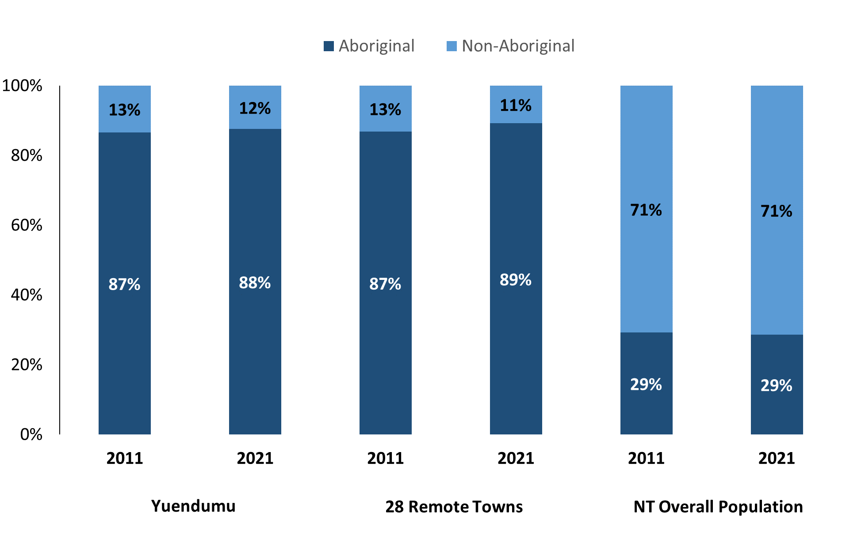

*Source: Australian Bureau of Statistics*

In 2021:

* 88.0% of the population in Yuendumu were **Aboriginal**, compared to 87.0% in 2011
* 89.0% of the population across the 28 remote towns were **Aboriginal**
* 29.0% of the NT population were **Aboriginal**.

**Table 37: Unemployment and Aboriginal participation rates (q)**

|  |  |  |  |  |  |  |
| --- | --- | --- | --- | --- | --- | --- |
|  | **Yuendumu** | | | **Northern Territory** | | |
| **Aboriginal** | **Non-Aboriginal** | **Total** | **Aboriginal** | **Non-Aboriginal** | **Total** |
| **Unemployment rate** | 30.5% | 0.0% | 17.7% | 20.8% | 3.2% | 5.6% |
| **Participation rate** | 22.7% | 88.5% | 36.1% | 35.4% | 78.3% | 64.9% |

*Source: Australian Bureau of Statistics*

In 2021 in Yuendumu the:

* **total unemployment rate** was 17.7% compared to 5.6% for the total Northern Territory
* **Aboriginal unemployment rate** was 30.5% compared to 20.8% for the total Northern Territory
* **non-Aboriginal unemployment rate** was 0.0% compared to 3.2% for the total Northern Territory
* **total participation rate** was 36.1% compared to 64.9% for the total Northern Territory
* **Aboriginal** **participation rate** was 22.7% compared to 35.4% for the total Northern Territory
* **non-Aboriginal** **participation rate** was 88.5% compared to 78.3% for the total Northern Territory.

# Community Development Program

**Table 38: Community Development Program Aboriginal Job Seekers, 31 December 2023 (o)**

|  |  |  |
| --- | --- | --- |
| **Indicator** | **Aboriginal** | |
| **No.** | **%** |
| **Total Aboriginal Job Seekers** | 235 | N/A |
| **Age (years)** | | |
| 15-24 | 63 | 26.8% |
| 25-44 | 109 | 46.4% |
| 45+ | 63 | 26.8% |
| **Total** | 235 | 100.0% |
| **Gender** | | |
| Male | 139 | 59.1% |
| Female | 96 | 40.9% |
| **Total** | 235 | 100.0% |
| **Employment Outcome – 1 January 2023 to 31 December 2023** | | |
| 13 Weeks | <20 | N/A |
| 26 Weeks | <20 | N/A |

*Source: Department of Prime Minister and Cabinet*

**Chart 14: Community Development Program Aboriginal Job Seekers by Gender and Age Group, 31 December 2023 (o)**

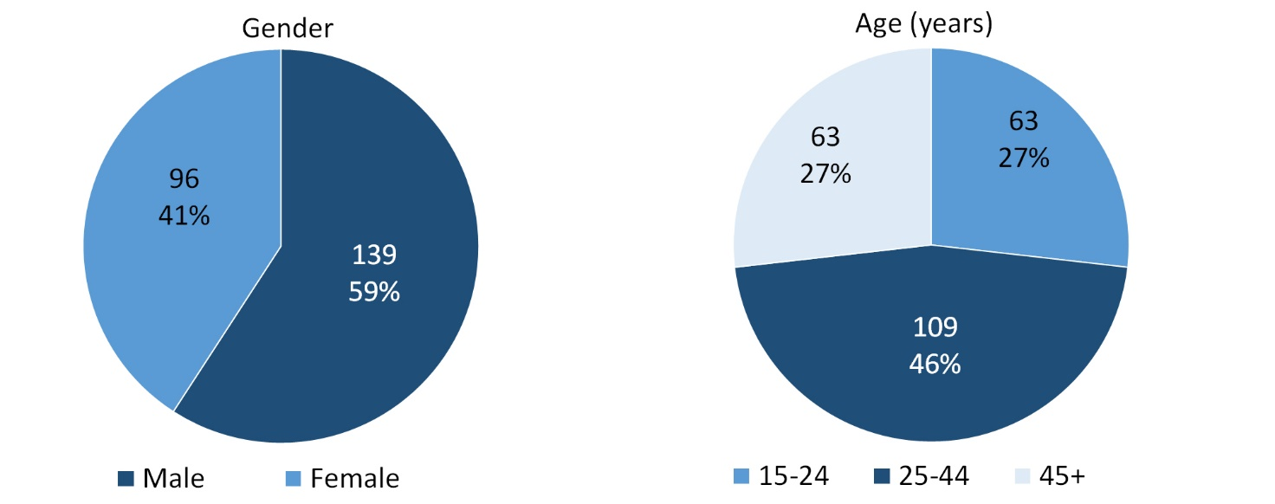

*Source: Department of Prime Minister and Cabinet*

As at 31 December 2023, in Yuendumu, there were 235 CDP **Aboriginal** job seekers, of these:

* 139 (59.1%) were male and 96 (40.9%) were female
* 63 (26.8%) were aged 15-24 years, 109 (46.4%) were aged 25-44 years, and 63 (26.8%) were aged 45+ years
* between 1 January 2023 to 31 December 2023, < 20 had reached the 13 week reporting milestone and < 20 had reached the 26 week reporting milestone.

# Businesses

**Table 39: Businesses by sector (d)(s)**

|  |  |  |  |  |
| --- | --- | --- | --- | --- |
| **Business Name** | **Reported on in 2011** | **Reported on in 2014** | **Reported on in 2017** | **Reported on in 2023** |
| **PUBLIC SECTOR** | | | | |
| **Central Desert Regional Council** | **Yes** | **Yes** | **Yes** | **Yes** |
| **Department of Education** | **Yes** | **Yes** | **Yes** | **Yes** |
| **Department of Health** | **Yes** | **Yes** | **Yes** | **Yes** |
| Department of Housing, Local Government and Regional Services (DHLGRS) | Yes | No | No | No |
| Department of Human Services trading as Centrelink | Yes | Yes | Yes | No |
| Department of the Prime Minister and Cabinet | Yes | Yes | Yes | No |
| **National Indigenous Australians Agency** | **No** | **No** | **No** | **Yes** |
| **Northern Territory Police, Fire Emergency Services** | **Yes** | **Yes** | **Yes** | **Yes** |
| **Territory Families** | **No** | **No** | **Yes** | **Yes** |
| **PRIVATE SECTOR** | | | | |
| Batchelor Institute of Indigenous Tertiary Education (BIITE) | Yes | No | No | No |
| **Central Land Council** | **Yes** | **Yes** | **Yes** | **Yes** |
| **Centrebuild Pty Ltd** | **No** | **No** | **No** | **Yes** |
| Mampu Maninja Kurlangu Jarlu Patuk Ku Aboriginal Corporation - Yuendumu Old Peoples Home | Yes | Yes | Yes | No |
| Mellors Construction | Yes | No | No | No |
| Ngurratjuta Pmara Ntjarra Aboriginal Corporation trading as Ngurratjuta Aboriginal Corporation | No | Yes | No | No |
| **Nguru Walalja Store (Outback Stores Pty Ltd)** | **Yes** | **Yes** | **Yes** | **Yes** |
| **Pintubi Anmatjere Warlpiri Media and Communication (Warlpiri Media Aboriginal Corporation)** | **Yes** | **Yes** | **Yes** | **Yes** |
| Steps Group Australia Limited | No | Yes | Yes | No |
| **Southern Tanami Kurdiji Indigenous Corporation** | **No** | **No** | **No** | **Yes** |
| Tanami Cleaning and Maintenance Pty Ltd | No | Yes | No | No |
| Wallcon Pty Ltd | Yes | Yes | No | No |
| **WANTA Aboriginal Corporation** | **No** | **No** | **No** | **Yes** |
| Warlpiri Youth Development Aboriginal Corporation (WYDAC) | Yes | Yes | Yes | No |
| Warlukurlangu Artists Aboriginal Corporation | Yes | Yes | Yes | No |
| Western Desert Nganampa Walytja Palyantjaku Tjutaku Aboriginal Corporation trading as Western Desert Dialysis | No | Yes | Yes | No |
| Willow Tree Training Pty Ltd | No | Yes | No | No |
| World Vision | No | Yes | No | No |
| **Yapa-Kurlangu Ngurrara Aboriginal Corporation (YKNAC)** | **No** | **No** | **Yes** | **Yes** |
| Yuendumu Mining Company | No | Yes | Yes | No |
| **Yuendumu Store** | **Yes** | **Yes** | **Yes** | **Yes** |
| Yuendumu Womens Centre Aboriginal Corporation | Yes | Yes | Yes | No |

*Source: Northern Territory - Department of Industry, Tourism and Trade*

*Note: Business names captured across the four survey periods have been identified by the current 2023 Business ABN name listed as at 2023.*

In 2023 in Yuendumu:

* there were 14 businesses reported on, of which:
* 6 businesses were from the Public Sector (43%)
* 8 businesses were from the Private Sector (57%)
* there were 4 businesses operating that were not operating in 2017.

# Notes

1. These counts represent numbers of jobs filled and not the number of people. As such the totals represent the total number of jobs filled, not the total number of employees. This count is not directly comparable to the total number of employed people as a person may have several jobs or one job may be shared by more than one person.
2. Full-time is defined as a job usually requiring 35 hours or more per week or that required 35 hours or more work during the reference week. Part-time is defined as a job usually requiring less than 35 hours per week or that required less than 35 hours work during the reference week. The reference week refers to the period that respondents were asked to provide information about. In most instances, it would be the week prior to the week the questionnaire was completed. Questionnaires were predominantly conducted in June and July.
3. Care needs to be taken when analysing the counts of jobs filled by Aboriginal people. Aboriginality was reported by the business representative completing the questionnaire.
4. Sector was classified using the Standard Economic Sector of Classifications of Australia (SESCA), 2008.
5. Job permanency is classified according to what the business believes the level of job permanency is based on guidelines provided by data collectors. Those guidelines state a permanent job has paid annual and/or sick leave entitlements while a temporary job includes casual and fixed-term contract jobs.
6. Classified according to the Australian and New Zealand Standard Classification of Occupations (ANZSCO), 2006, major occupation level.
7. Other Occupations include jobs where occupation was not stated, not known or inadequately described.
8. Classified using the Australian and New Zealand Standard Industrial Classification (ANZSIC), 2006, division level.
9. Care needs to be taken when analysing the counts of jobs filled by the gender of people in the jobs. The gender of the person employed in a job is reported by the business representative completing the questionnaire.
10. Care needs to be taken when analysing the counts of jobs filled by the age of people in the jobs. The age of the person employed in a job is reported by the business representative completing the questionnaire.
11. Students represent the number of individual clients that enrolled in a Vocational Education and Training unit during the calendar year.
12. Unit enrolments represent the count of individual units that students enrolled in during the calendar year.
13. Nominal hours delivered is the sum of the nominal hours of the units commenced during the calendar year regardless of when the course enrolment commenced.
14. Unit completions are the count of all successfully completed units reported in the calendar year regardless of the year of commencement of the units.
15. The Community Development Program (CDP) supports job seekers in remote Australia to build skills, address barriers and contribute to their communities through a range of flexible activities. Under the CDP, job seekers with activity requirements are expected to do up to 25 hours per week of work-like activities that benefit their community. It should be noted that some CDP participants may be reported on within the profile if they are attached to a filled position with an employer captured in the survey. Due to confidentiality issues, data below 20 people is not published.
16. Population estimates for both 2011 and 2021 are taken from the estimated resident population (ERP) data produced by the Australian Bureau of Statistics (ABS) and based on Australian Statistical Geography Standard (ASGS) Statistical Area Level 1 (SA1) regions. ERP are official estimates of the Australian population, which link people to a place of usual residence with Australia. All ERP data sources, including the Census of Population and Housing (Census), are subject to error (including inaccuracies in collection, recording and processing data) and should be used with caution.
17. Indigenous population proportions, unemployment and workforce participation rates are based on ABS Census counts at ASGS Indigenous Locations (ILOCs) for each remote town.
18. Working-age population includes all residents aged 15 years and over (commonly referred to as the civilian population) and consists of people that are employed, unemployed or not in the labour force.
19. A ‘business’ has been defined as any organisation that has undertaken productive activities in the last year, including companies, non-profit organisations, government departments and enterprises operating within the designated remote geography (town), and has one or more employees in paid employment and an Australian Business Number (ABN).

# Abbreviations and Acronyms

ABN Australian Business Number

ABS Australian Bureau of Statistics

ANZSCO Australian and New Zealand Standard Classification of Occupations

ANZSIC Australian and New Zealand Standard Industrial Classification

ASGS Australian Statistical Geography Standard

CDP Community Development Program

ERP Estimated Resident Population

ILOC Indigenous Locations

nec Not Elsewhere Classified

No. Number

Perm Permanent

ppt Percentage point

RJCP Remote Jobs and Communities Program

Temp Temporary

SA1 Statistical Area Level 1

VET Vocational Education and Training

1. The number of jobs filled does not represent number of people as a person may have several jobs or one job may be shared by more than one person.
2. 3 Aboriginal jobs filled gender status not identified in 2017
3. 3 Aboriginal jobs filled gender status not identified in 2017