Mineral Titles Act 2010
NOTICE OF LAND CEASING TO BE A MINERAL TITLE AREA
Title Type and Number: | Exploration Licence 33626
Area Ceased on: | 31 October 2024
Area: | 250 Blocks, 820.03 km²
Locality: | WATERLOO
Name of Applicant(s)/Holder(s): | 100% BAUDIN RESOURCES PTY LTD [ACN. 618 455 593]
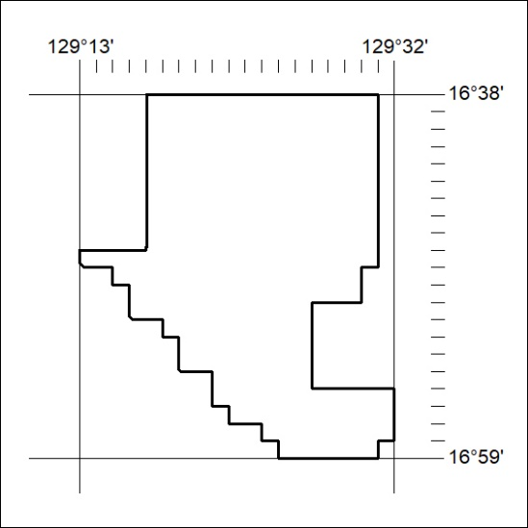

398/24

Mineral Titles Act 2010
NOTICE OF LAND CEASING TO BE A MINERAL TITLE AREA
Title Type and Number: | Exploration Licence 33627
Area Ceased on: | 31 October 2024
Area: | 250 Blocks, 821.90 km²
Locality: | KIMON
Name of Applicant(s)/Holder(s): | 100% BAUDIN RESOURCES PTY LTD [ACN. 618 455 593]
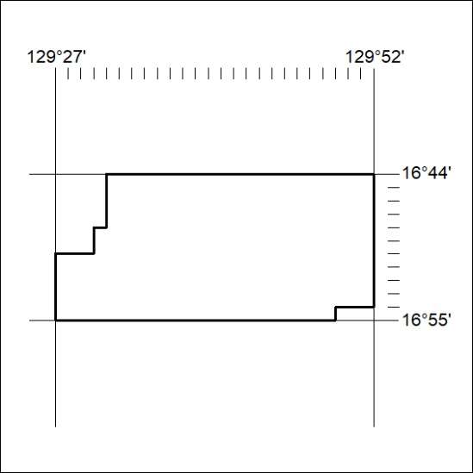

399/24

