Mineral Titles Act 2010
NOTICE OF LAND CEASING TO BE A MINERAL TITLE AREA
Title Type and Number: | Exploration Licence 32886
Area Ceased on: | 17 June 2024
Area: | 68 Blocks, 220.95 km²
Locality: | TIPPERARY
Name of Applicant(s)/Holder(s): | 100% MANGUSTA MINERALS PTY LTD [ACN. 653 950 522]
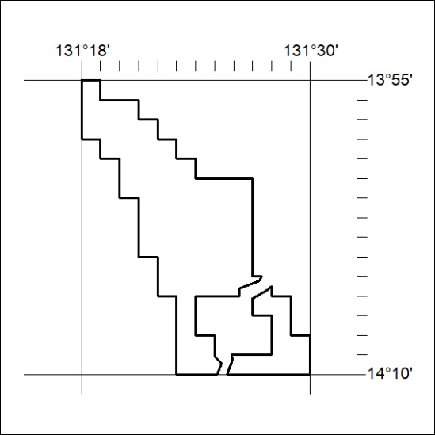
257/24

