Mineral Titles Act
NOTICE OF GRANT OF A MINERAL TITLE
Title Type and Number: | Exploration Licence 33681
Granted: | 07 June 2024, for a period of 6 Years
Area: | 7 Blocks, 11.17 km²
Locality: | CONICAL HILL
Name of Holder/s: | 100% IGO LIMITED* [ACN. 092 786 304]
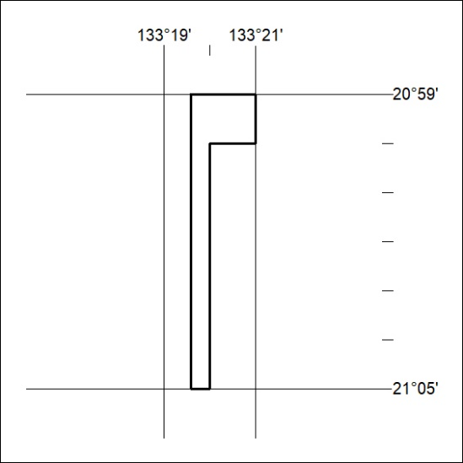
Area granted is indicated above. The titleholder is not permitted to exercise occupational rights on any land that is subject to a development title, or an application for a development title. Any land the subject of a Reserved Land gazettal under the Mineral Titles Act and all land vested in the Commonwealth of Australia is also excluded by description but not excised from the grant area.
255/24

Mineral Titles Act
NOTICE OF GRANT OF A MINERAL TITLE
Title Type and Number: | Exploration Licence 33652
Granted: | 17 June 2024, for a period of 6 Years
Area: | 17 Blocks, 53.67 km²
Locality: | LAUGHLEN
Name of Holder/s: | 100% GEMPART (NT) PTY LTD* [ACN. 081 859 896]
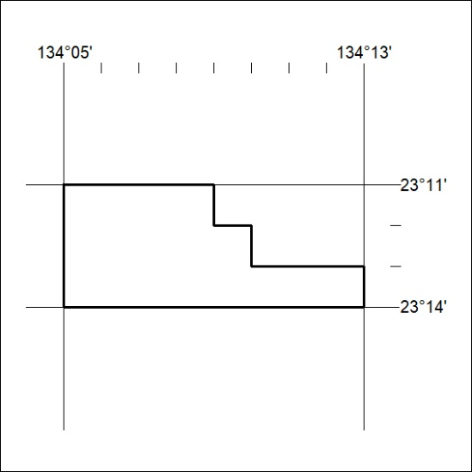
Area granted is indicated above. The titleholder is not permitted to exercise occupational rights on any land that is subject to a development title, or an application for a development title. Any land the subject of a Reserved Land gazettal under the Mineral Titles Act and all land vested in the Commonwealth of Australia is also excluded by description but not excised from the grant area.
256/24

