Mineral Titles Act 2010
NOTICE OF LAND CEASING TO BE A MINERAL TITLE AREA
Title Type and Number: | Extractive Mineral Exploration Licence 32590
Area Ceased on: | 05 June 2024
Area: | 4 Blocks, 13.12 km²
Locality: | NEWCASTLE WATERS
Name of Applicant(s)/Holder(s): | 100% TERRITORY SANDS PTY LTD [ACN. 632 797 972]
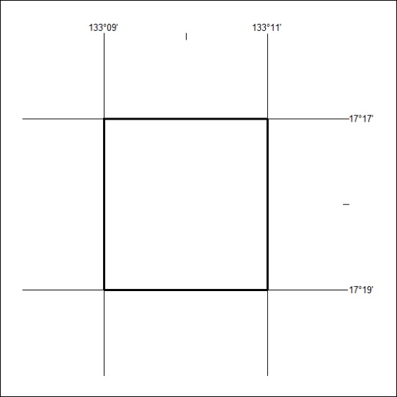
241/24

Mineral Titles Act 2010
NOTICE OF LAND CEASING TO BE A MINERAL TITLE AREA
Title Type and Number: | Extractive Mineral Exploration Licence 32591
Area Ceased on: | 05 June 2024
Area: | 4 Blocks, 13.12 km²
Locality: | NEWCASTLE WATERS
Name of Applicant(s)/Holder(s): | 100% TERRITORY SANDS PTY LTD [ACN. 632 797 972]
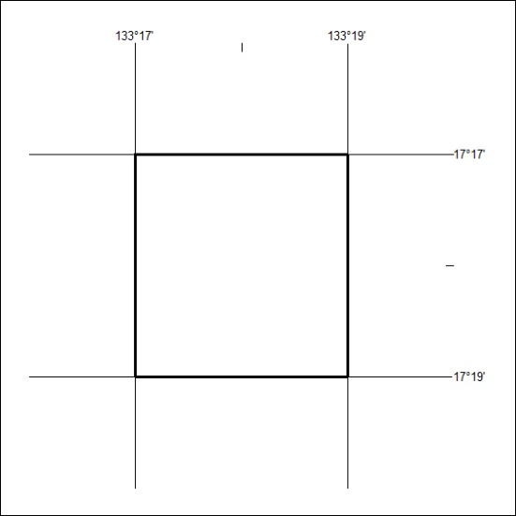
242/24

Mineral Titles Act 2010
NOTICE OF LAND CEASING TO BE A MINERAL TITLE AREA
Title Type and Number: | Extractive Mineral Exploration Licence 32592
Area Ceased on: | 05 June 2024
Area: | 4 Blocks, 13.11 km²
Locality: | NEWCASTLE WATERS
Name of Applicant(s)/Holder(s): | 100% TERRITORY SANDS PTY LTD [ACN. 632 797 972]
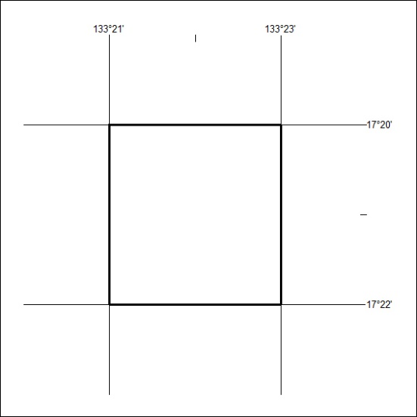
243/24

Mineral Titles Act 2010
NOTICE OF LAND CEASING TO BE A MINERAL TITLE AREA
Title Type and Number: | Extractive Mineral Exploration Licence 32595
Area Ceased on: | 05 June 2024
Area: | 4 Blocks, 13.24 km²
Locality: | LARRIMAH
Name of Applicant(s)/Holder(s): | 100% TERRITORY SANDS PTY LTD [ACN. 632 797 972]
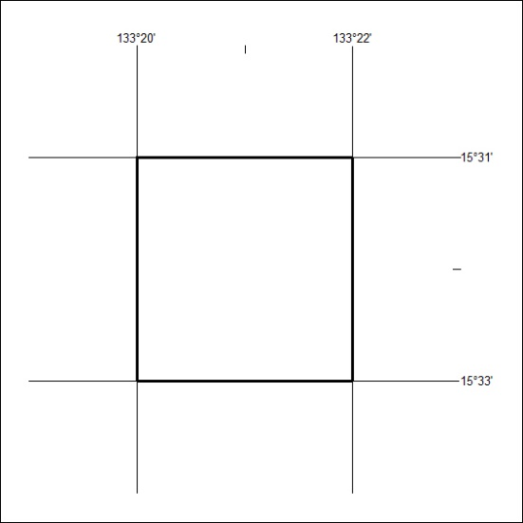
244/24

Mineral Titles Act 2010
NOTICE OF LAND CEASING TO BE A MINERAL TITLE AREA
Title Type and Number: | Extractive Mineral Exploration Licence 32596
Area Ceased on: | 05 June 2024
Area: | 4 Blocks, 13.24 km²
Locality: | LARRIMAH
Name of Applicant(s)/Holder(s): | 100% TERRITORY SANDS PTY LTD [ACN. 632 797 972]
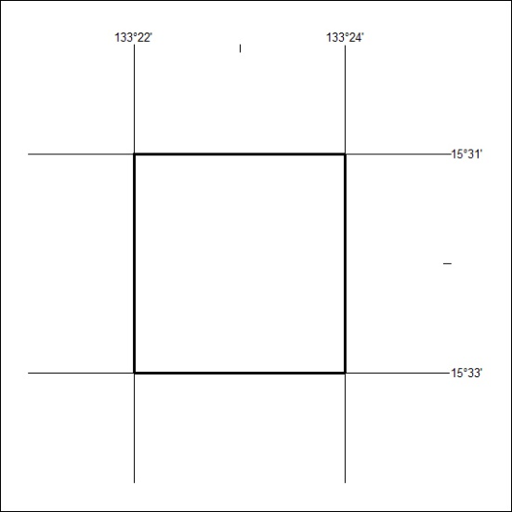
245/24

Mineral Titles Act 2010
NOTICE OF LAND CEASING TO BE A MINERAL TITLE AREA
Title Type and Number: | Extractive Mineral Exploration Licence 32609
Area Ceased on: | 05 June 2024
Area: | 4 Blocks, 13.12 km²
Locality: | NEWCASTLE WATERS
Name of Applicant(s)/Holder(s): | 100% TERRITORY SANDS PTY LTD [ACN. 632 797 972]
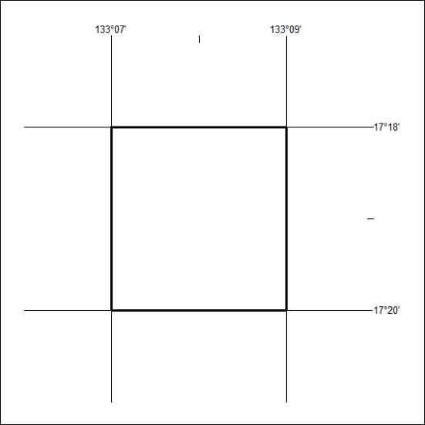
246/24

Mineral Titles Act 2010
NOTICE OF LAND CEASING TO BE A MINERAL TITLE AREA
Title Type and Number: | Mineral Lease 30678
Area ceased on: | 05 June 2024
Area: | 160.00 Hectares
Locality: | BATCHELOR
Name of Applicants(s)Holder(s): | 100% AU79 HOLDINGS PTY LTD [ACN. 627 906 209]
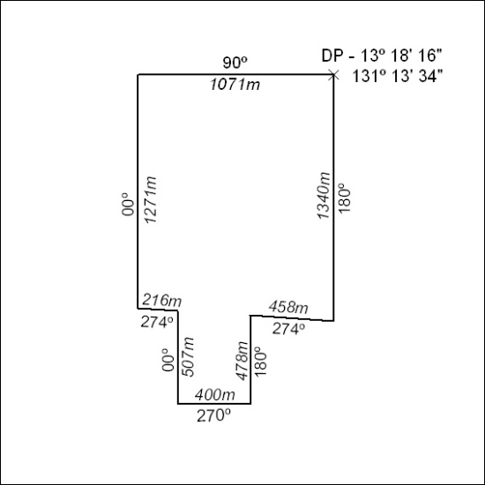
(Area now amalgamated into Mineral Lease 33871 under s102)
247/24

Mineral Titles Act 2010
NOTICE OF LAND CEASING TO BE A MINERAL TITLE AREA
Title Type and Number: | Mineral Lease 30711
Area ceased on: | 05 June 2024
Area: | 17.00 Hectare
Locality: | BATCHELOR
Name of Applicants(s)Holder(s): | 100% AU79 HOLDINGS PTY LTD [ACN. 627 906 209]
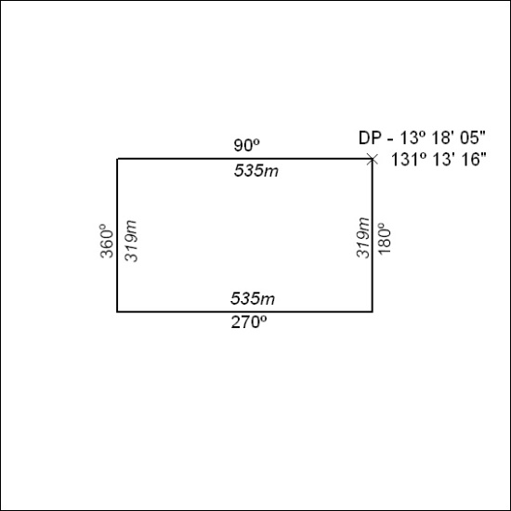
(Area now amalgamated into Mineral Lease 33871 under s102)
248/24

Corrigendum
Notice Number 223/24 appearing in MN66/24 on 04 June 2024 is hereby cancelled and replaced by the following:

Mineral Titles Act
NOTICE OF GRANT OF A MINERAL TITLE
Title Type and Number: | Extractive Mineral Exploration Licence 33702
Granted: | 24 May 2024, for a period of 2 Years
Area: | 4 Blocks, 13.16 km²
Locality: | WARRAMBAN
Name of Holder/s: | 100% TAMBORAN INFRASTRUCTURE PTY LTD [ACN. 163 215 156]
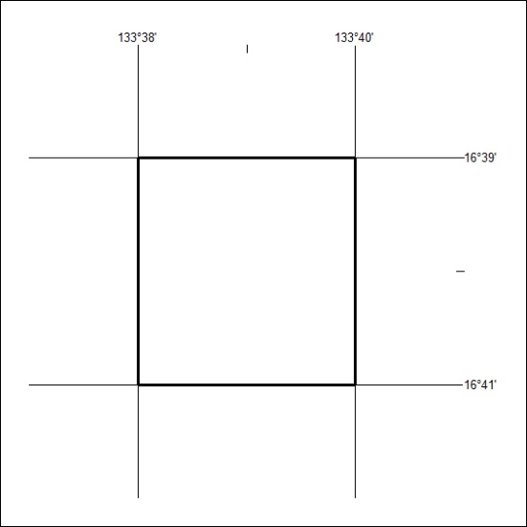
Area granted is indicated above. The titleholder is not permitted to exercise occupational rights on any land that is subject to a development title, or an application for a development title. Any land the subject of a Reserved Land gazettal under the Mineral Titles Act and all land vested in the Commonwealth of Australia is also excluded by description but not excised from the grant area.
249/24

Mineral Titles Act
NOTICE OF GRANT OF A MINERAL TITLE
Title Type and Number: | Exploration Licence 33653
Granted: | 12 June 2024, for a period of 6 Years
Area: | 30 Blocks, 92.27 km²
Locality: | LAUGHLEN
Name of Holder/s: | 100% WILUNA WEST GOLD PTY LTD [ACN. 116 550 111]
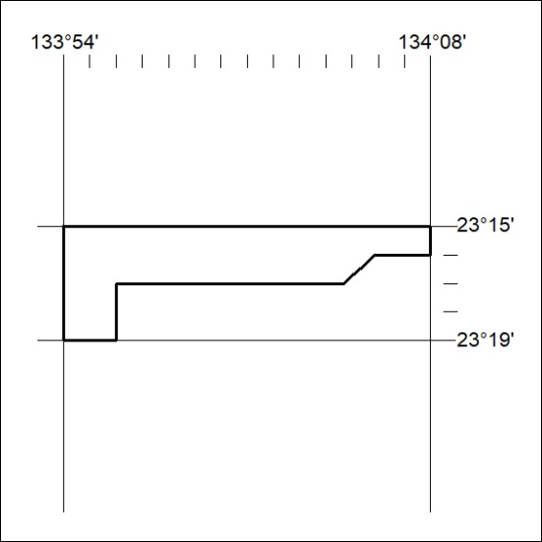
Area granted is indicated above. The titleholder is not permitted to exercise occupational rights on any land that is subject to a development title, or an application for a development title. Any land the subject of a Reserved Land gazettal under the Mineral Titles Act and all land vested in the Commonwealth of Australia is also excluded by description but not excised from the grant area.
250/24

