Mineral Titles Act 2010
NOTICE OF LAND CEASING TO BE A MINERAL TITLE AREA
Title Type and Number: | Exploration Licence 32450
Area Ceased on: | 21 May 2024
Area: | 228 Blocks, 747.23 km²
Locality: | KILGOUR
Name of Applicant(s)/Holder(s): | 100% TRANSITION MINERALS LIMITED* [ACN. 641 565 139]
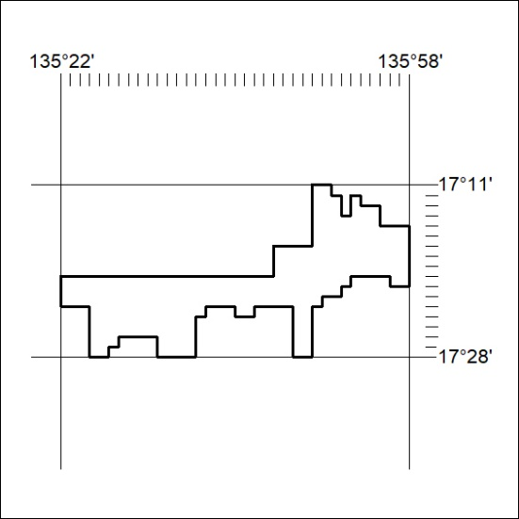
201/24

Mineral Titles Act 2010
NOTICE OF LAND CEASING TO BE A MINERAL TITLE AREA
Title Type and Number: | Exploration Licence 32451
Area Ceased on: | 21 May 2024
Area: | 223 Blocks, 730.89 km²
Locality: | LANCEWOOD
Name of Applicant(s)/Holder(s): | 100% TRANSITION MINERALS LIMITED* [ACN. 641 565 139]
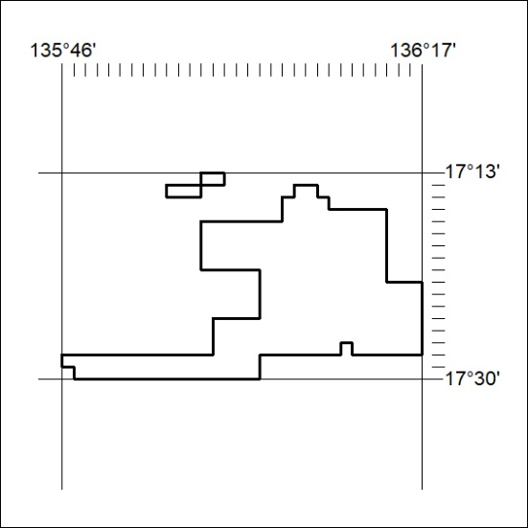
202/24

Mineral Titles Act 2010
NOTICE OF LAND CEASING TO BE A MINERAL TITLE AREA
Title Type and Number: | Exploration Licence 32472
Area Ceased on: | 21 May 2024
Area: | 249 Blocks, 802.94 km²
Locality: | BLOODWOOD CREEK
Name of Applicant(s)/Holder(s): | 100% TRANSITION MINERALS LIMITED* [ACN. 641 565 139]
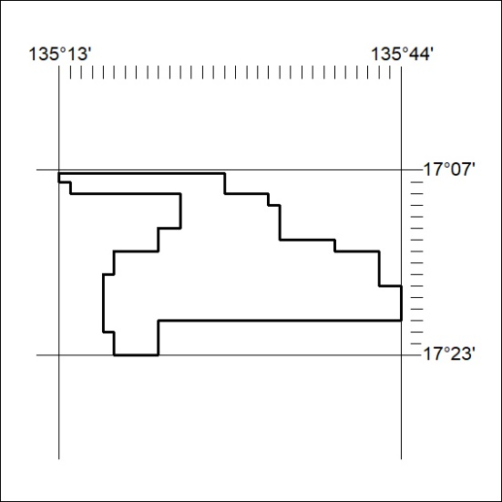
203/24

Mineral Titles Act
NOTICE OF GRANT OF A MINERAL TITLE
Title Type and Number: | Exploration Licence 33670
Granted: | 20 May 2024, for a period of 6 Years
Area: | 156 Blocks, 464.92 km²
Locality: | TIPPERARY
Name of Holder/s: | 100% GEMPART (NT) PTY LTD* [ACN. 081 859 896]
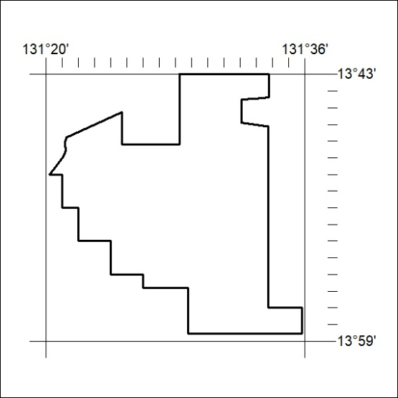
Area granted is indicated above. The titleholder is not permitted to exercise occupational rights on any land that is subject to a development title, or an application for a development title. Any land the subject of a Reserved Land gazettal under the Mineral Titles Act and all land vested in the Commonwealth of Australia is also excluded by description but not excised from the grant area.
204/24

Corrigendum
Notice Number 199/24 appearing in MN57/24 on 15 May 2024 is hereby cancelled and replaced by the following:

Mineral Titles Act 2010
NOTICE OF LAND CEASING TO BE A MINERAL TITLE APPLICATION AREA
Title Type and Number: | Exploration Licence 33682
Area Ceased on: | 15 May 2024
Area: | 20 Blocks, 64.11 km²
Locality: | CRAWFORD
Name of Applicant(s)/Holder(s): | 100% ROX 1 PTY LTD [ACN. 649 500 916]
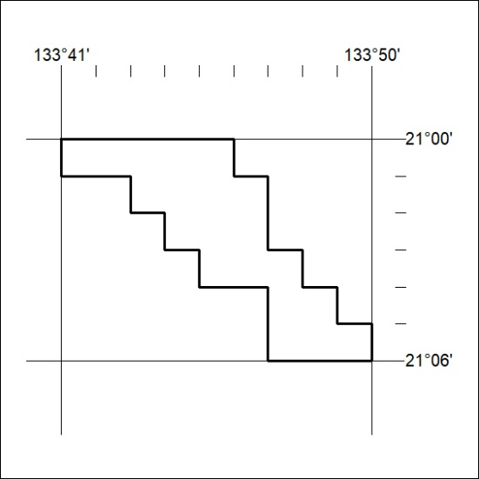
205/24

