Mineral Titles Act
NOTICE OF GRANT OF A MINERAL TITLE
Title Type and Number: | Exploration Licence 33640
Granted: | 08 May 2024, for a period of 6 Years
Area: | 15 Blocks, 47.67 km²
Locality: | VAUGHAN
Name of Holder/s: | 100% NORTH TENNANT MINERALS PTY LTD [ACN. 654 828 912]
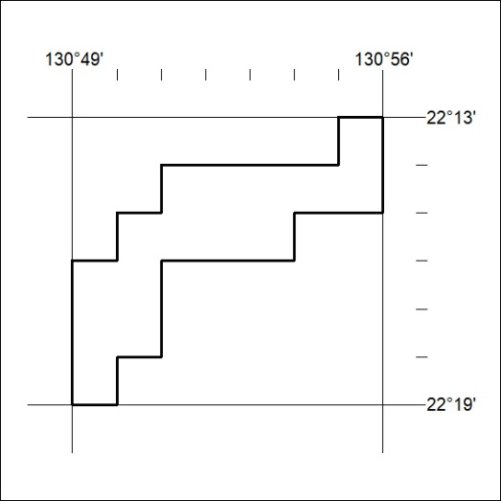
Area granted is indicated above. The titleholder is not permitted to exercise occupational rights on any land that is subject to a development title, or an application for a development title. Any land the subject of a Reserved Land gazettal under the Mineral Titles Act and all land vested in the Commonwealth of Australia is also excluded by description but not excised from the grant area.

188/24

Mineral Titles Act
NOTICE OF GRANT OF A MINERAL TITLE
Title Type and Number: | Exploration Licence 33641
Granted: | 08 May 2024, for a period of 6 Years
Area: | 44 Blocks, 139.32 km²
Locality: | NAPPERBY
Name of Holder/s: | 100% NORTH TENNANT MINERALS PTY LTD [ACN. 654 828 912]
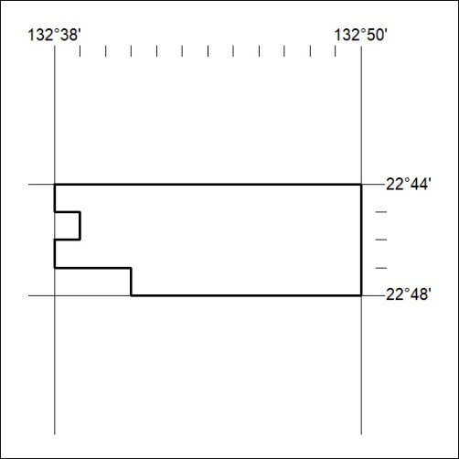
Area granted is indicated above. The titleholder is not permitted to exercise occupational rights on any land that is subject to a development title, or an application for a development title. Any land the subject of a Reserved Land gazettal under the Mineral Titles Act and all land vested in the Commonwealth of Australia is also excluded by description but not excised from the grant area.

189/24

Mineral Titles Act
NOTICE OF GRANT OF A MINERAL TITLE
Title Type and Number: | Exploration Licence 33649
Granted: | 08 May 2024, for a period of 6 Years
Area: | 28 Blocks, 89.81 km²
Locality: | NUMAGALONG
Name of Holder/s: | 100% NORTH TENNANT MINERALS PTY LTD [ACN. 654 828 912]
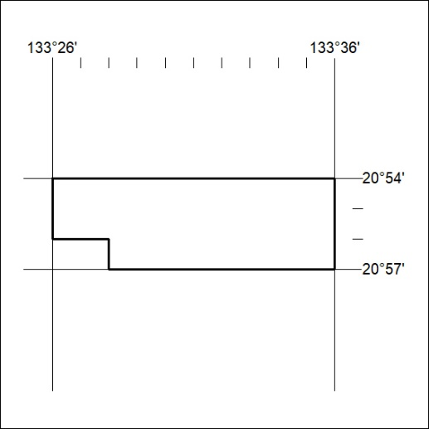
Area granted is indicated above. The titleholder is not permitted to exercise occupational rights on any land that is subject to a development title, or an application for a development title. Any land the subject of a Reserved Land gazettal under the Mineral Titles Act and all land vested in the Commonwealth of Australia is also excluded by description but not excised from the grant area.

190/24

Mineral Titles Act
NOTICE OF GRANT OF A MINERAL TITLE
Title Type and Number: | Exploration Licence 33650
Granted: | 08 May 2024, for a period of 6 Years
Area: | 54 Blocks, 173.14 km²
Locality: | CRAWFORD
Name of Holder/s: | 100% NORTH TENNANT MINERALS PTY LTD [ACN. 654 828 912]
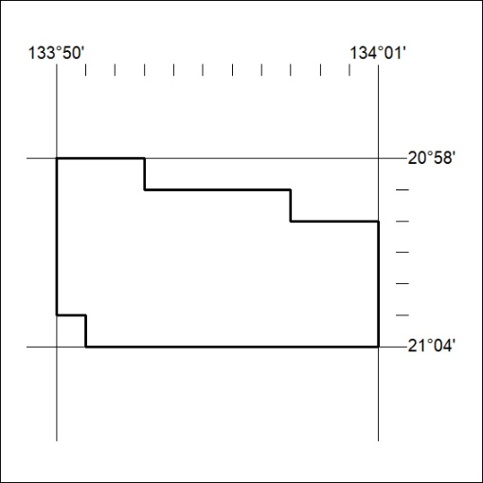
Area granted is indicated above. The titleholder is not permitted to exercise occupational rights on any land that is subject to a development title, or an application for a development title. Any land the subject of a Reserved Land gazettal under the Mineral Titles Act and all land vested in the Commonwealth of Australia is also excluded by description but not excised from the grant area.

191/24

Mineral Titles Act
NOTICE OF GRANT OF A MINERAL TITLE
Title Type and Number: | Exploration Licence 33673
Granted: | 09 May 2024, for a period of 6 Years
Area: | 46 Blocks, 149.05 km²
Locality: | FLYNN
Name of Holder/s: | 100% NORTH TENNANT MINERALS PTY LTD [ACN. 654 828 912]
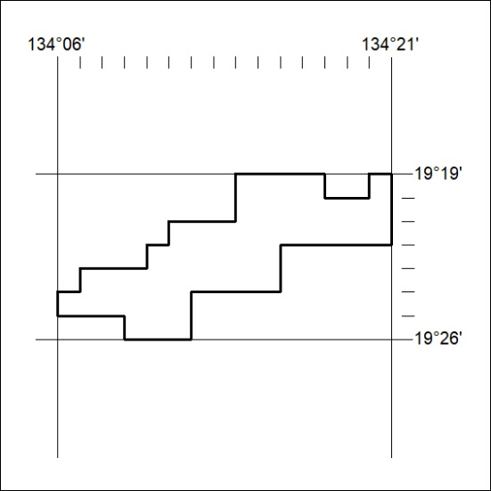
Area granted is indicated above. The titleholder is not permitted to exercise occupational rights on any land that is subject to a development title, or an application for a development title. Any land the subject of a Reserved Land gazettal under the Mineral Titles Act and all land vested in the Commonwealth of Australia is also excluded by description but not excised from the grant area.

192/24

