Mineral Titles Act 2010
NOTICE OF LAND CEASING TO BE A MINERAL TITLE AREA
Title Type and Number: | Exploration Licence 32835
Area Ceased on: | 08 April 2024
Area: | 122 Blocks, 389.09 km²
Locality: | HOME OF BULLION
Name of Applicant(s)/Holder(s): | 100% PEGMATITE ONE PTY LTD [ACN. 652 853 391]
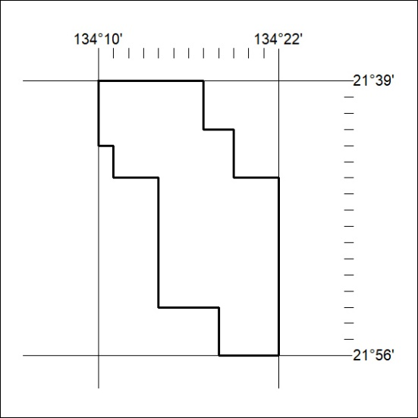

100/24

Mineral Titles Act 2010
NOTICE OF LAND CEASING TO BE A MINERAL TITLE AREA
Title Type and Number: | Exploration Licence 32847
Area Ceased on: | 08 April 2024
Area: | 22 Blocks, 70.38 km²
Locality: | TAYLOR
Name of Applicant(s)/Holder(s): | 100% PEGMATITE ONE PTY LTD [ACN. 652 853 391]
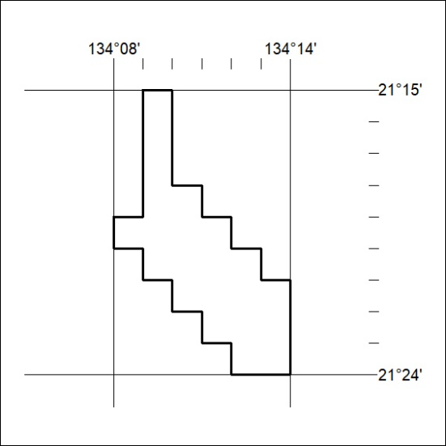

101/24
Mineral Titles Act 2010
NOTICE OF LAND CEASING TO BE A MINERAL TITLE AREA
Title Type and Number: | Exploration Licence 32853
Area Ceased on: | 08 April 2024
Area: | 8 Blocks, 25.45 km²
Locality: | DENISON
Name of Applicant(s)/Holder(s): | 100% PEGMATITE ONE PTY LTD [ACN. 652 853 391]
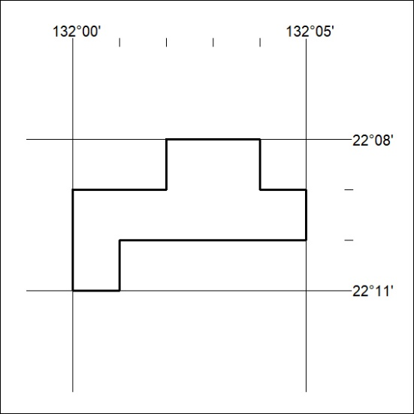

102/24

Mineral Titles Act 2010
NOTICE OF LAND CEASING TO BE A MINERAL TITLE AREA
Title Type and Number: | Exploration Licence 32853
Area Ceased on: | 08 April 2024
Area: | 8 Blocks, 25.45 km²
Locality: | DENISON
Name of Applicant(s)/Holder(s): | 100% PEGMATITE ONE PTY LTD [ACN. 652 853 391]

103/24
Mineral Titles Act 2010
NOTICE OF LAND CEASING TO BE A MINERAL TITLE AREA
Title Type and Number: | Exploration Licence 32863
Area Ceased on: | 08 April 2024
Area: | 40 Blocks, 127.78 km²
Locality: | ANNINGIE
Name of Applicant(s)/Holder(s): | 100% PEGMATITE ONE PTY LTD [ACN. 652 853 391]
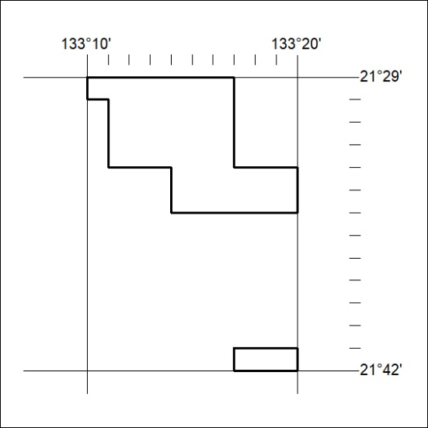

104/24

Mineral Titles Act 2010
NOTICE OF LAND CEASING TO BE A MINERAL TITLE AREA
Title Type and Number: | Exploration Licence 33283
Area Ceased on: | 08 April 2024
Area: | 12 Blocks, 38.18 km²
Locality: | DOREEN
Name of Applicant(s)/Holder(s): | 100% TODD RIVER METALS PTY LTD [ACN. 600 314 038]
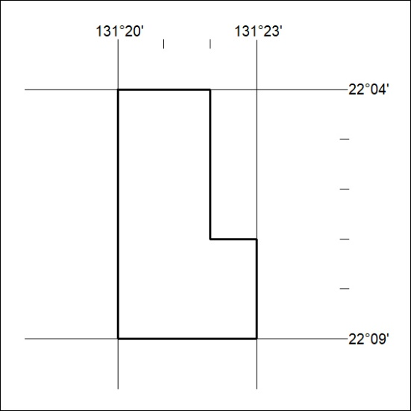

105/24
Corrigendum
Notice Number 94/24 appearing in MN36/24 on 5 April 2024 is hereby cancelled and replaced by the following:

Mineral Titles Act
NOTICE OF GRANT OF A MINERAL TITLE
Title Type and Number: | Exploration Licence 33598
Granted: | 05 April 2024, for a period of 6 Years
Area: | 32 Blocks, 97.51 km²
Locality: | PALM VALLEY
Name of Holder/s: | 100% TERRALITH METALS PTY LTD [ACN. 669 527 360]
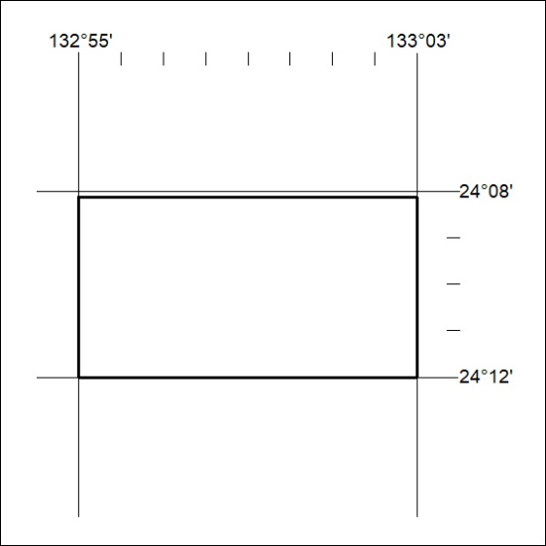
Area granted is indicated above. The titleholder is not permitted to exercise occupational rights on any land that is subject to a development title, or an application for a development title. Any land the subject of a Reserved Land gazettal under the Mineral Titles Act and all land vested in the Commonwealth of Australia is also excluded by description but not excised from the grant area.

106/24

