Mineral Titles Act 2010
NOTICE OF LAND CEASING TO BE A MINERAL TITLE APPLICATION AREA
Title Type and Number: | Exploration Licence 33361
Area Ceased on: | 12 March 2024
Area: | 40 Blocks, 121.44 km²
Locality: | GURNER
Name of Applicant(s)/Holder(s): | 100% RIO TINTO EXPLORATION PTY LIMITED [ACN. 000 057 125]
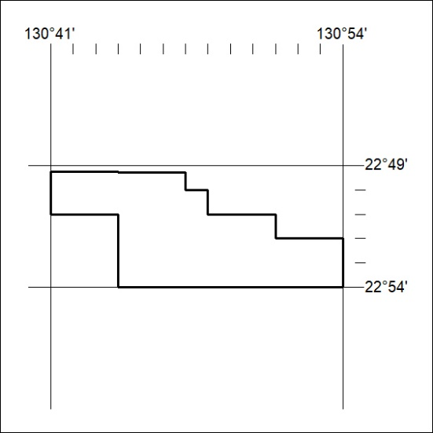

56/24

