Mineral Titles Act 2010
NOTICE OF LAND CEASING TO BE A MINERAL TITLE AREA
Title Type and Number: | Exploration Licence 32978
Area Ceased on: | 07 February 2024
Area: | 245 Blocks, 760.88 km²
Locality: | ERLDUNDA
Name of Applicant(s)/Holder(s): | 100% CORE URANIUM LIMITED [ACN. 652 691 579]
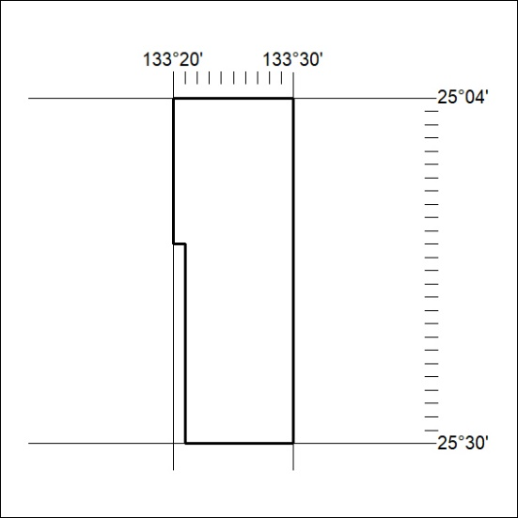

28/24

Mineral Titles Act 2010
NOTICE OF LAND CEASING TO BE A MINERAL TITLE AREA
Title Type and Number: | Exploration Licence 32981
Area Ceased on: | 07 February 2024
Area: | 249 Blocks, 773.25 km²
Locality: | IDRA COWRA
Name of Applicant(s)/Holder(s): | 100% CORE URANIUM LIMITED [ACN. 652 691 579]
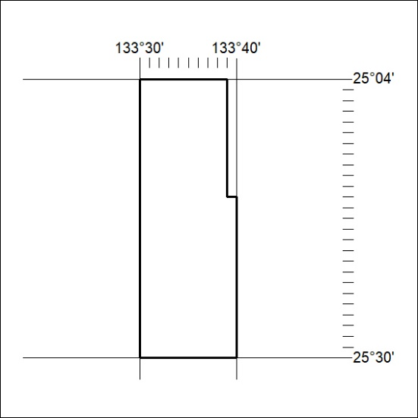

29/24
Mineral Titles Act 2010
NOTICE OF LAND CEASING TO BE A MINERAL TITLE AREA
Title Type and Number: | Exploration Licence 32982
Area Ceased on: | 07 February 2024
Area: | 245 Blocks, 760.88 km²
Locality: | IDRA COWRA
Name of Applicant(s)/Holder(s): | 100% CORE URANIUM LIMITED [ACN. 652 691 579]
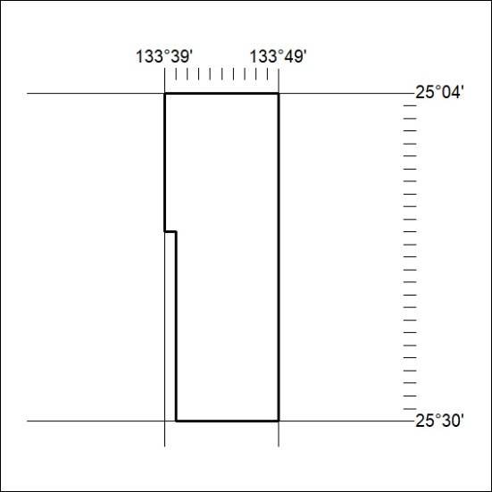

30/24

