Mineral Titles Act 2010
NOTICE OF LAND CEASING TO BE A MINERAL TITLE AREA
Title Type and Number: | Exploration Licence 32736
Area Ceased on: | 16 January 2024
Area: | 100 Blocks, 280.91 km²
Locality: | UNDOOLYA
Name of Applicant(s)/Holder(s): | 100% RIO TINTO EXPLORATION PTY LIMITED [ACN. 000 057 125]
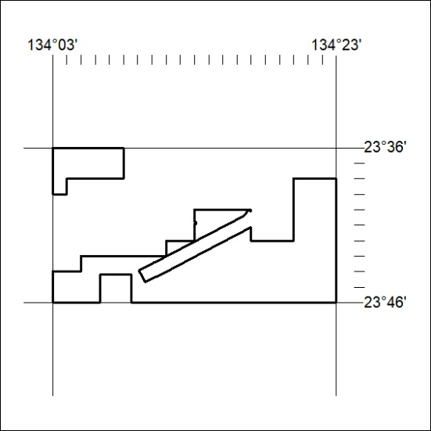

11/24

Mineral Titles Act 2010
NOTICE OF LAND CEASING TO BE A MINERAL TITLE APPLICATION AREA
Title Type and Number: | Exploration Licence 33233
Area Ceased on: | 16 January 2024
Area: | 6 Blocks, 18.96 km²
Locality: | BRAHMA
Name of Applicant(s)/Holder(s): | 50% SMITH Scott William, 50% SMITH Kimberley Alice
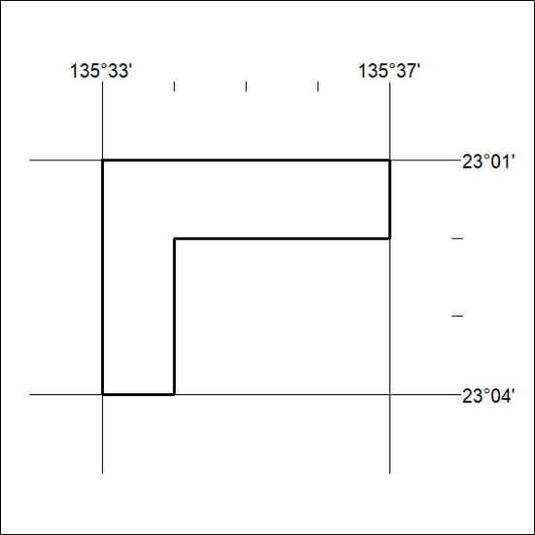

12/24

