Mineral Titles Act 2010
NOTICE OF LAND CEASING TO BE A MINERAL TITLE AREA
Title Type and Number: | Exploration Licence 9843
Area Ceased on: | 15 January 2024
Area: | 8 Blocks, 25.81 km²
Locality: | INNINGARRA
Name of Applicant(s)/Holder(s): | 50% NORTHERN STAR (TANAMI) PTY LTD [ACN. 603 860 831], 50% TANAMI (NT) PTY LTD [ACN. 141 658 933]
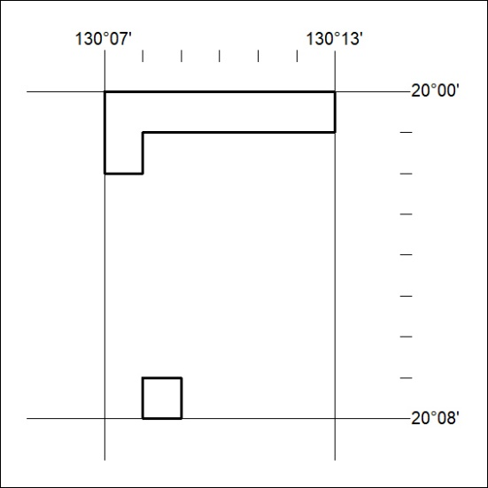

06/24

Mineral Titles Act 2010
NOTICE OF LAND CEASING TO BE A MINERAL TITLE AREA
Title Type and Number: | Exploration Licence 10411
Area Ceased on: | 15 January 2024
Area: | 7 Blocks, 21.32 km²
Locality: | FRANKENIA
Name of Applicant(s)/Holder(s): | 50% NORTHERN STAR (TANAMI) PTY LTD [ACN. 603 860 831], 50% TANAMI (NT) PTY LTD [ACN. 141 658 933]
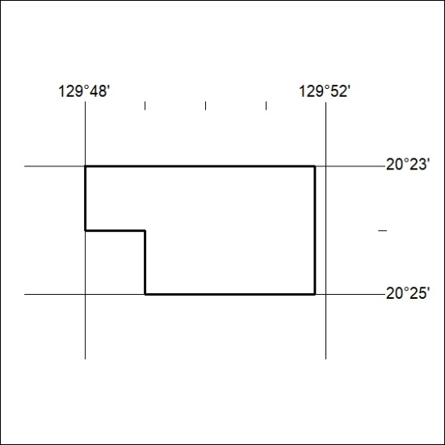

07/24
Mineral Titles Act 2010
NOTICE OF LAND CEASING TO BE A MINERAL TITLE AREA
Title Type and Number: | Exploration Licence 22061
Area Ceased on: | 15 January 2024
Area: | 10 Blocks, 32.24 km²
Locality: | GRANITES
Name of Applicant(s)/Holder(s): | 50% NORTHERN STAR (TANAMI) PTY LTD [ACN. 603 860 831], 50% TANAMI (NT) PTY LTD [ACN. 141 658 933]
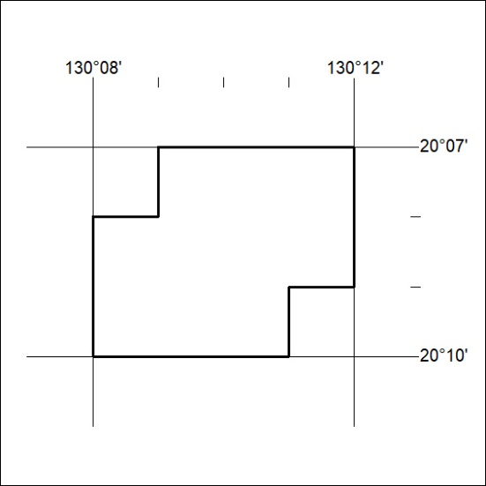

08/24

Mineral Titles Act 2010
NOTICE OF LAND CEASING TO BE A MINERAL TITLE AREA
Title Type and Number: | Exploration Licence 22378
Area Ceased on: | 15 January 2024
Area: | 6 Blocks, 19.32 km²
Locality: | FRANKENIA
Name of Applicant(s)/Holder(s): | 50% NORTHERN STAR (TANAMI) PTY LTD [ACN. 603 860 831], 50% TANAMI (NT) PTY LTD [ACN. 141 658 933]
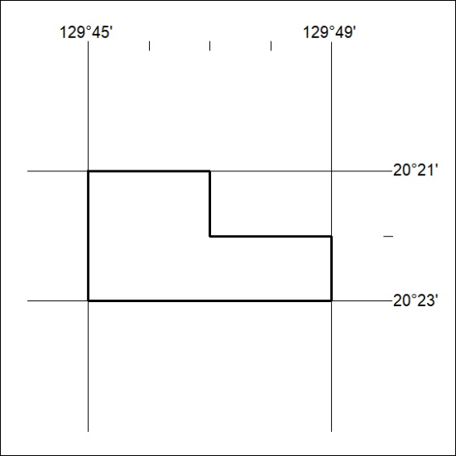

09/24
Mineral Titles Act 2010
NOTICE OF LAND CEASING TO BE A MINERAL TITLE APPLICATION AREA
Title Type and Number: | Exploration Licence 32792
Area Ceased on: | 12 January 2024
Area: | 88 Blocks, 288.80 km²
Locality: | NEGRI
Name of Applicant(s)/Holder(s): | 100% OMNIA PANTON PTY LTD [ACN. 648 190 934]
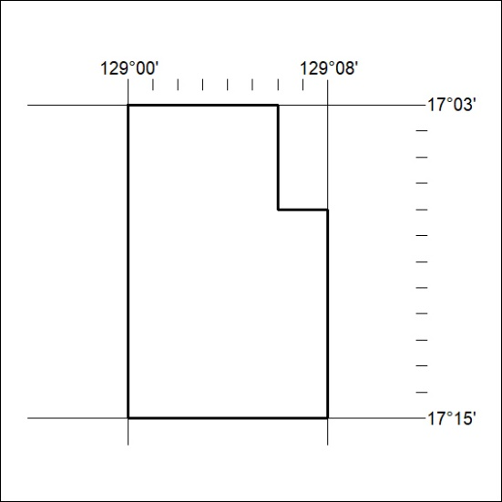

10/24

