Right to negotiate process for applications on native title affected land
(Read this in conjunction with the Native Title Act 1993 (NTA) and exploration and mining on native title affected land)
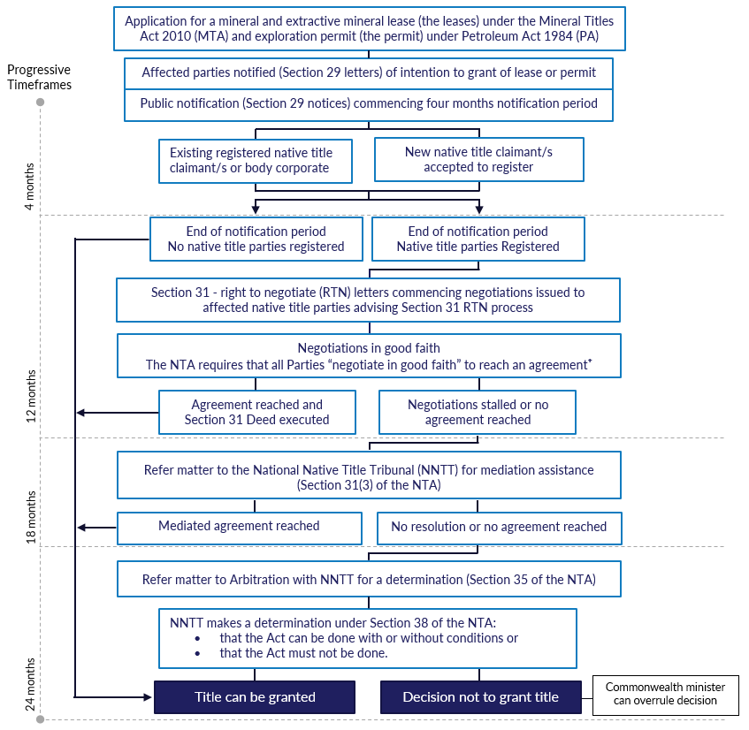
All legislative requirements must be achieved prior to the grant of an application. The above timeframes are indicative, although all parties are required to ‘negotiate in good faith’ in order to reach an agreement.
⁺Additional obligations are imposed on a permit applicant in accordance with recommendation 11.4 of the Independent Scientific Inquiry into Hydraulic Fracturing in the Northern Territory.

Right to negotiate process for applications on native title affected land flowchart description
- Application for a mineral and extractive mineral lease (the lease) under the Mineral Titles Act 2010 (MTA) and exploration permit (the permit) under the Petroleum Act 1994 (PA)
- Affected parties notified (Section 29 letters) of intention to grant of lease or permit
The Department of Industry, Tourism and Trade (DITT) will give written notice of proposed grant of the lease or permit (Section 29 letters) to:
- any affected registered body corporate
- any registered native title claimant/s
- the representative body (land council)
- the lease or permit applicant
- the registrar of the arbitral body the National Native Title Tribunal (NNTT).
- Public notification (Section 29 notices) commencing four months notification period
The DITT will prepare Section 29 notices (advertisements) for publication in the major newspapers.
- Existing registered native title claimant/s or body corporate - any existing registered claims will secure the right to negotiate process. The lease or permit will proceed through the RTN process.
- New native title claimant/s accepted to register - any new claims must be placed on the Register of Native Title Claims (RNTC) within four months of the date given in the notice for the claimant/s to secure the right to negotiate.
- End of notification period
- No native title parties registered - if at the end of the four months notification period there is no native title claim on the RNTC, the lease or permit can proceed to grant (go to step 14).
- Native title parties registered - if at the end of the four months notification period there is a native title claim (body corporate or claimant group) registered on the RNTC, the lease or permit will proceed through the right to negotiate process (go to next step).
- Section 31 - right to negotiate (RTN) letters commencing negotiations issued to affected native title parties advising Section 31 RTN process
Letter will contain:
- details of the native title claim/s over the application area of the lease or permit
- contact details of the relevant representative body (land council)
- advice that the DITT expects that all parties will negotiate in good faith in order to reach an agreement
- advice that, for a permit, the grantee party (the permit applicant) must provide a statement to the native title parties and the relevant representative body (land council) containing information of the kind required under section 41(6) of the Aboriginal Land Rights (Northern Territory) Act 1976 (Cwth)
- a request that the grantee party keep the DITT informed of progress by providing copies of any documents exchanged
- a copy of the Section 31 Deed and information sheet
- a copy of the notices (advertisements)
- a copy of the native title fact sheet and flowchart.
- Negotiations in good faith
The NTA requires that all Parties “negotiate in good faith” to reach an agreement.
The DITT expects that the grantee party (the lease or permit applicant) will approach negotiations in a responsible and serious manner, with an open mind and genuine desire to reach an agreement. The DITT expects that a permit applicant will, at the start of negotiations, provide a statement to the native title parties and relevant representative body (land council) containing information of the kind required under section 41(6) of the Aboriginal Land Rights (Northern Territory) Act 1976 (Cwth).
Importantly, there is an expectation that the grantee party actively progress their application within a minimum period of 24 months from the date of the Section 29 notice, although there is flexibility if negotiations are actively progressing.
- Agreement reached and Section 31 Deed executed
The grantee party and the native title parties reach an agreement.
The grantee party, native title parties and the government party sign a covering Section 31 (Deed) (go to step 14).
- Negotiations stalled or no agreement reached (see below)
- Refer matter to the National Native Title Tribunal (NNTT) for mediation assistance (Section 31(3) of the NTA)
If negotiations have stalled or if no agreement is reached, the matter may be referred to the NNTT for mediation assistance by any of the negotiation parties (see below).
- Mediated agreement reached (go to step 14)
- No resolution or no agreement reached
If mediation fails to reach an agreement, an application can be made to NNTT for a determination under Section 35 of the NTA (see below).
- Refer matter to Arbitration with the NNTT for a determination (Section 35 of the NTA)
The NNTT will determine whether the future Act may be done or must not be done.
Even though a Section 35 application has been made, negotiations may continue between the native title parties with a view of reaching an agreement.
If an agreement is reached before a determination is made, the section 35 application is taken to have been withdrawn.
- NNTT makes a determination under Section 38 of the NTA
- That the Act can be done with or without conditions or
- That the Act must not be done.
- Title can be granted.
The grant of the lease or permit process can commence, under the MTA or PA.
- Decision not to grant title
The Commonwealth minister can overrule decision.

The notices must specify a day as the notification date and contain a statement to the effect that, under section 30 of the NTA, persons who claim to hold native title over the lease or permit area, but are not yet a registered claimant, must lodge a native title application with the NNTT within three months of the date given in the s29 notice.
See recommendation 11.4 of the Independent Scientific Inquiry into Hydraulic Fracturing in the Northern Territory.

