Mineral Titles Act 2010
NOTICE OF LAND CEASING TO BE A MINERAL TITLE AREA
Title Type and Number: | Exploration Licence 8766
Area Ceased on: | 13 October 2023
Area: | 43 Blocks, 129.72 km²
Locality: | WINNALL
Name of Applicant(s)/Holder(s): | 100% PRODIGY GOLD NL* [ACN. 009 127 020]
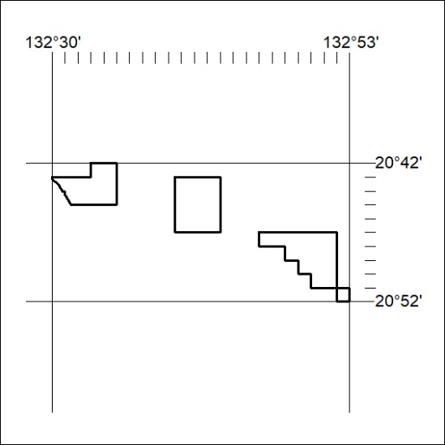

425/23

Mineral Titles Act 2010
NOTICE OF LAND CEASING TO BE A MINERAL TITLE AREA
Title Type and Number: | Exploration Licence 23880
Area Ceased on: | 13 October 2023
Area: | 5 Blocks, 15.99 km²
Locality: | WINNALL
Name of Applicant(s)/Holder(s): | 100% PRODIGY GOLD NL* [ACN. 009 127 020]
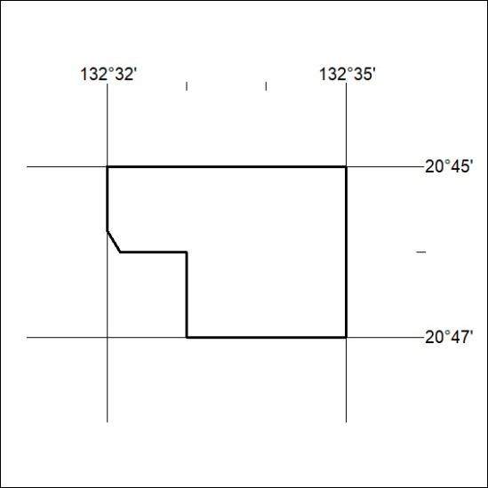

426/23
Mineral Titles Act 2010
NOTICE OF LAND CEASING TO BE A MINERAL TITLE AREA
Title Type and Number: | Exploration Licence 23883
Area Ceased on: | 13 October 2023
Area: | 18 Blocks, 47.80 km²
Locality: | LANDER
Name of Applicant(s)/Holder(s): | 100% PRODIGY GOLD NL* [ACN. 009 127 020]
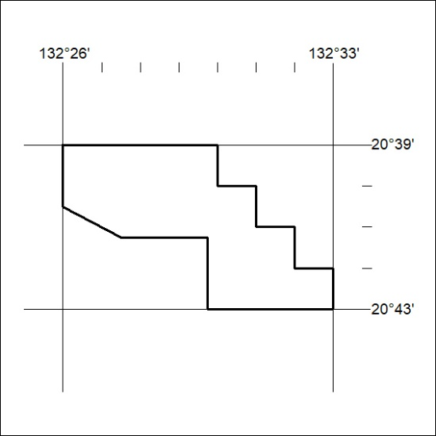

427/23

Mineral Titles Act 2010
NOTICE OF LAND CEASING TO BE A MINERAL TITLE AREA
Title Type and Number: | Exploration Licence 23884
Area Ceased on: | 13 October 2023
Area: | 63 Blocks, 199.66 km²
Locality: | JARRAH JARRAH
Name of Applicant(s)/Holder(s): | 100% PRODIGY GOLD NL* [ACN. 009 127 020]
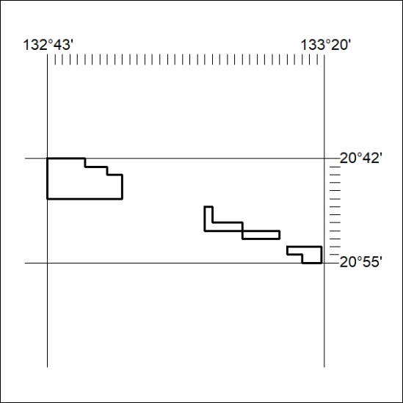

428/23
Mineral Titles Act 2010
NOTICE OF LAND CEASING TO BE A MINERAL TITLE AREA
Title Type and Number: | Exploration Licence 23885
Area Ceased on: | 13 October 2023
Area: | 118 Blocks, 372.29 km²
Locality: | JARRAH JARRAH
Name of Applicant(s)/Holder(s): | 100% PRODIGY GOLD NL* [ACN. 009 127 020]
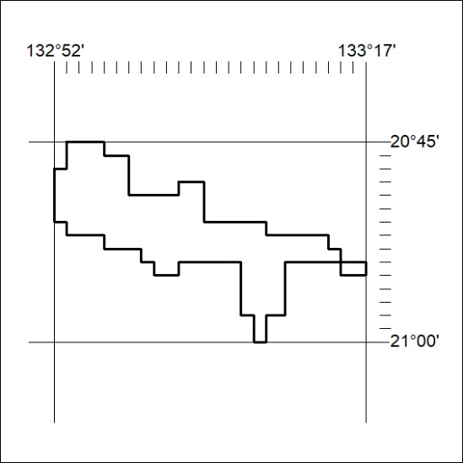

429/23

Mineral Titles Act 2010
NOTICE OF LAND CEASING TO BE A MINERAL TITLE AREA
Title Type and Number: | Exploration Licence 23886
Area Ceased on: | 13 October 2023
Area: | 56 Blocks, 162.05 km²
Locality: | JARRAH JARRAH
Name of Applicant(s)/Holder(s): | 100% PRODIGY GOLD NL* [ACN. 009 127 020]
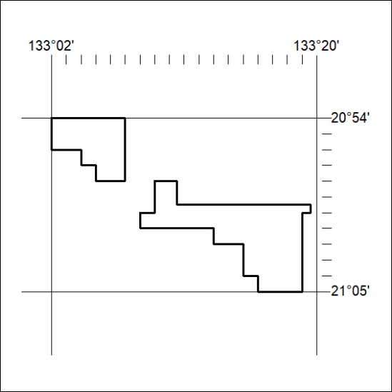

430/23

Mineral Titles Act
NOTICE OF GRANT OF A MINERAL TITLE
Title Type and Number: | Exploration Licence 33438
Granted: | 13 October 2023, for a period of 6 Years
Area: | 14 Blocks, 45.62 km²
Locality: | HELEN
Name of Holder/s: | 100% SCRIVEN EXPLORATION PTY LTD [ACN. 006 264 615]
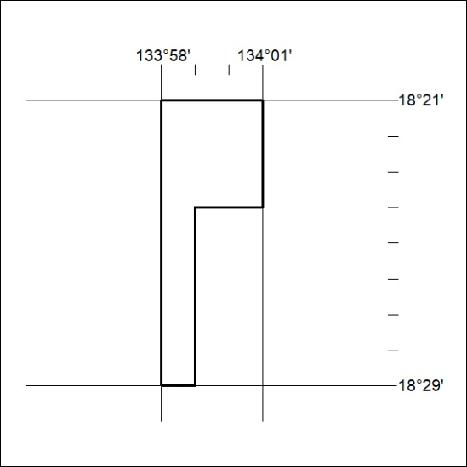
Area granted is indicated above. The titleholder is not permitted to exercise occupational rights on any land that is subject to a development title, or an application for a development title. Any land the subject of a Reserved Land gazettal under the Mineral Titles Act and all land vested in the Commonwealth of Australia is also excluded by description but not excised from the grant area.

431/23

