Mineral Titles Act 2010
NOTICE OF LAND CEASING TO BE A MINERAL TITLE APPLICATION AREA
Title Type and Number: | Extractive Mineral Permit 32141
Area ceased on: | 06 October 2023
Area: | 71.00 Hectare
Locality: | NOONAMAH
Name of Applicants(s)Holder(s): | 100% OSTOJIC GROUP PTY LTD* [ACN. 009 629 805]
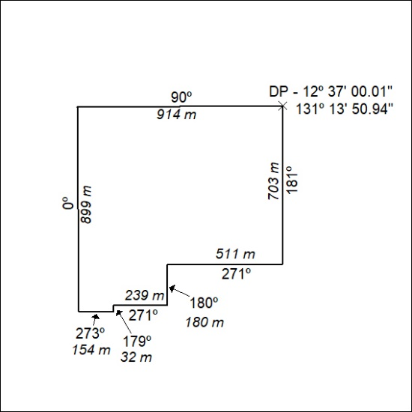

417/23

Mineral Titles Act 2010
NOTICE OF LAND CEASING TO BE A MINERAL TITLE APPLICATION AREA
Title Type and Number: | Extractive Mineral Permit 32142
Area ceased on: | 06 October 2023
Area: | 53.00 Hectare
Locality: | NOONAMAH
Name of Applicants(s)Holder(s): | 100% OSTOJIC GROUP PTY LTD* [ACN. 009 629 805]
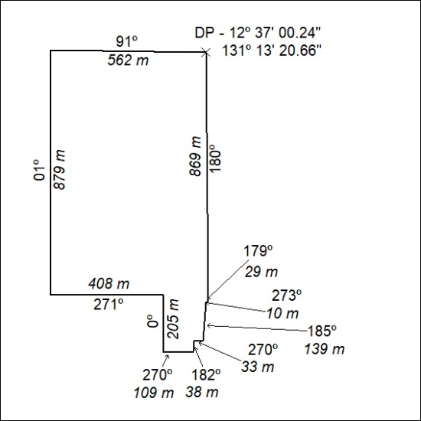

418/23

