Mineral Titles Act 2010
NOTICE OF LAND CEASING TO BE A MINERAL TITLE APPLICATION AREA
Title Type and Number: | Exploration Licence 31720
Area Ceased on: | 21 August 2023
Area: | 233 Blocks, 631.88 km²
Locality: | SIDDELEY
Name of Applicant(s)/Holder(s): | 100% IGO LIMITED* [ACN. 092 786 304]
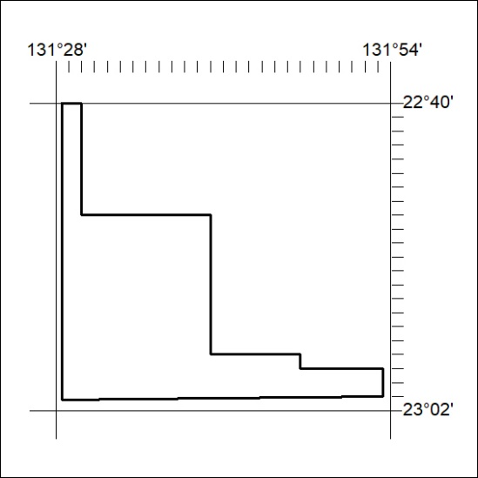

352/23

