Mineral Titles Act
NOTICE OF GRANT OF A MINERAL TITLE
Title Type and Number: | Exploration Licence 33379
Granted: | 04 July 2023, for a period of 6 Years
Area: | 84 Blocks, 270.63 km²
Locality: | EPENARRA
Name of Holder/s: | 100% BREMA RESOURCES PTY LTD [ACN. 643 480 693]
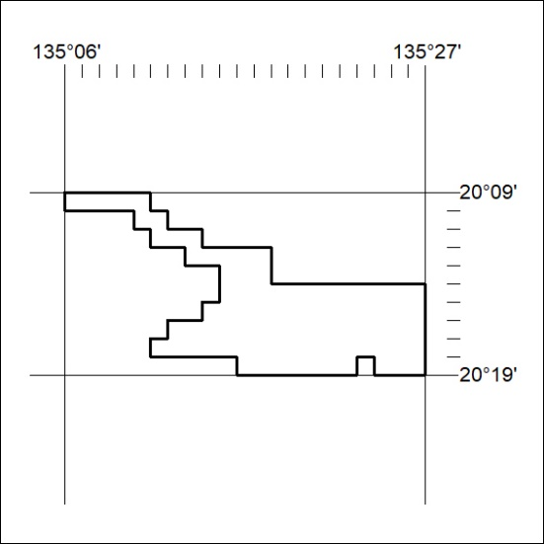
Area granted is indicated above. The titleholder is not permitted to exercise occupational rights on any land that is subject to a development title, or an application for a development title. Any land the subject of a Reserved Land gazettal under the Mineral Titles Act and all land vested in the Commonwealth of Australia is also excluded by description but not excised from the grant area.

250/23

