Mineral Titles Act
NOTICE OF GRANT OF A MINERAL TITLE
Title Type and Number: | Exploration Licence 33386
Granted: | 19 June 2023, for a period of 6 Years
Area: | 250 Blocks, 740.10 km²
Locality: | NAPPERBY
Name of Holder/s: | 100% TERRITORY MINERALS LTD* [ACN. 121 200 299]
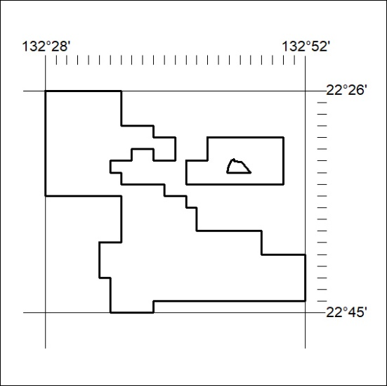
Area granted is indicated above. The titleholder is not permitted to exercise occupational rights on any land that is subject to a development title, or an application for a development title. Any land the subject of a Reserved Land gazettal under the Mineral Titles Act and all land vested in the Commonwealth of Australia is also excluded by description but not excised from the grant area.
219/23

