Mineral Titles Act 2010
NOTICE OF LAND CEASING TO BE A MINERAL TITLE APPLICATION AREA
Title Type and Number: | Exploration Licence 33307
Area Ceased on: | 01 June 2023
Area: | 127 Blocks, 395.63 km²
Locality: | BURT
Name of Applicant(s)/Holder(s): | 100% GEMPART (NT) PTY LTD* [ACN. 081 859 896]
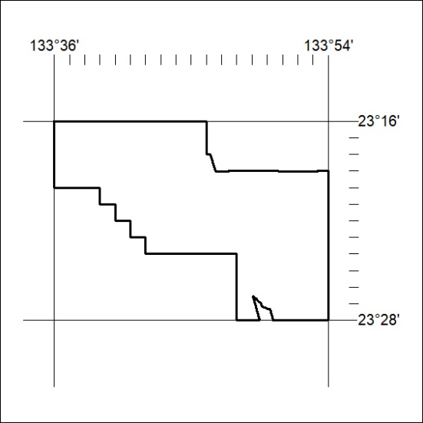

169/23

Mineral Titles Act
NOTICE OF GRANT OF A MINERAL TITLE
Title Type and Number: | Exploration Licence 33326
Granted: | 31 May 2023, for a period of 6 Years
Area: | 154 Blocks, 484.89 km²
Locality: | GLEN HELEN
Name of Holder/s: | 100% PIETROVIN CONSULTANTS PTY LTD [ACN. 163 916 998]
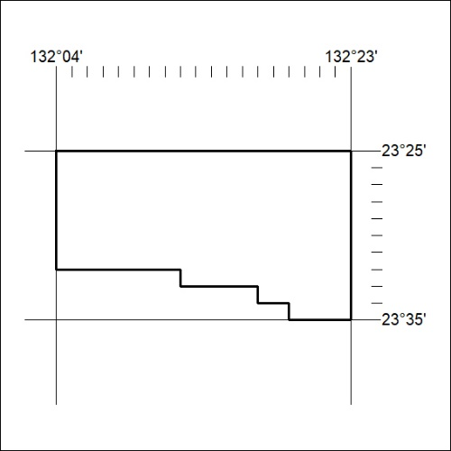
Area granted is indicated above. The titleholder is not permitted to exercise occupational rights on any land that is subject to a development title, or an application for a development title. Any land the subject of a Reserved Land gazettal under the Mineral Titles Act and all land vested in the Commonwealth of Australia is also excluded by description but not excised from the grant area.

170/23

Mineral Titles Act
NOTICE OF GRANT OF A MINERAL TITLE
Title Type and Number: | Exploration Licence 33329
Granted: | 31 May 2023, for a period of 6 Years
Area: | 76 Blocks, 241.88 km²
Locality: | VAUGHAN
Name of Holder/s: | 100% PIETROVIN CONSULTANTS PTY LTD [ACN. 163 916 998]
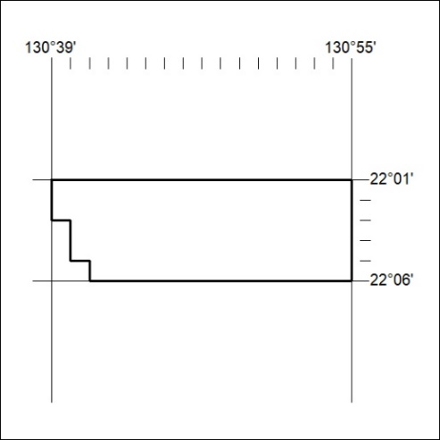
Area granted is indicated above. The titleholder is not permitted to exercise occupational rights on any land that is subject to a development title, or an application for a development title. Any land the subject of a Reserved Land gazettal under the Mineral Titles Act and all land vested in the Commonwealth of Australia is also excluded by description but not excised from the grant area.

171/23

