Mineral Titles Act 2010
NOTICE OF LAND CEASING TO BE A MINERAL TITLE AREA
Title Type and Number: | Exploration Licence 27711
Area Ceased on: | 09 May 2023
Area: | 52 Blocks, 170.77 km²
Locality: | KILGOUR
Name of Applicant(s)/Holder(s): | 100% TODD RIVER METALS PTY LTD [ACN. 600 314 038]
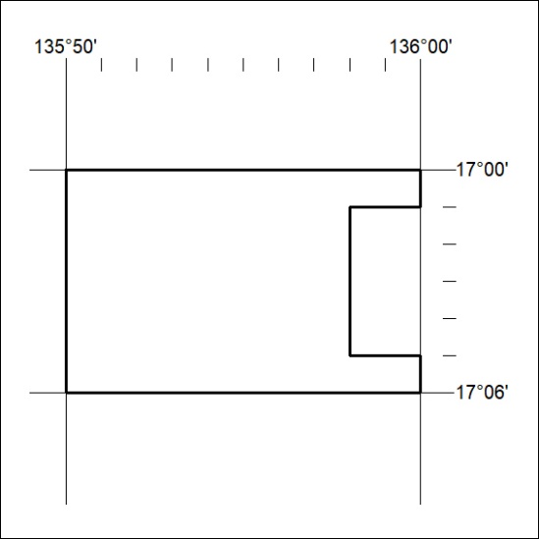

138/23

Mineral Titles Act 2010
NOTICE OF LAND CEASING TO BE A MINERAL TITLE AREA
Title Type and Number: | Exploration Licence 31703
Area Ceased on: | 09 May 2023
Area: | 18 Blocks, 59.11 km²
Locality: | MALLAPUNYAH
Name of Applicant(s)/Holder(s): | 100% TODD RIVER METALS PTY LTD [ACN. 600 314 038]
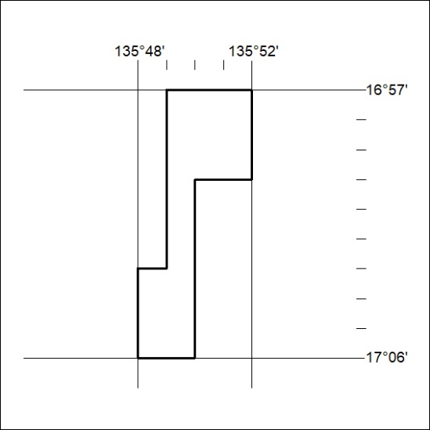

139/23
Mineral Titles Act 2010
NOTICE OF LAND CEASING TO BE A MINERAL TITLE AREA
Title Type and Number: | Exploration Licence 31704
Area Ceased on: | 09 May 2023
Area: | 14 Blocks, 45.93 km²
Locality: | KILGOUR
Name of Applicant(s)/Holder(s): | 100% TODD RIVER METALS PTY LTD [ACN. 600 314 038]
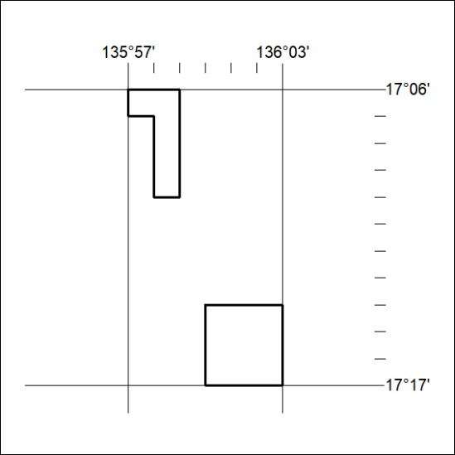

140/23

Mineral Titles Act 2010
NOTICE OF LAND CEASING TO BE A MINERAL TITLE AREA
Title Type and Number: | Exploration Licence 32597
Area Ceased on: | 09 May 2023
Area: | 250 Blocks, 807.39 km²
Locality: | KILGOUR
Name of Applicant(s)/Holder(s): | 100% TODD RIVER METALS PTY LTD [ACN. 600 314 038]
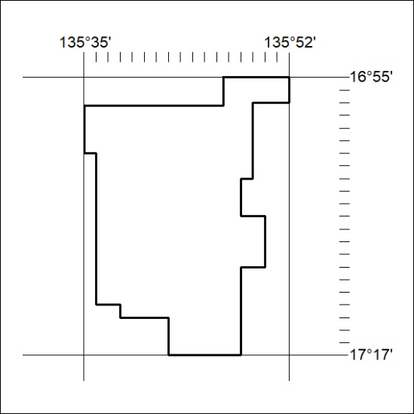

141/23

