Corrigendum
Notice Number 065/23 appearing in MN024/23 on 15 March 2023 is hereby cancelled and replaced by the following:

Mineral Titles Act 2010
NOTICE OF LAND CEASING TO BE A MINERAL TITLE AREA
Title Type and Number: | Extractive Mineral Exploration Licence 32564
Area Ceased on: | 14 March 2023
Area: | 4 Blocks, 10.50 km²
Locality: | MANBULLOO
Name of Applicant(s)/Holder(s): | 100% WARRIJA CONSTRUCTION AND CIVIL PTY. LTD. [ACN. 616 177 845]
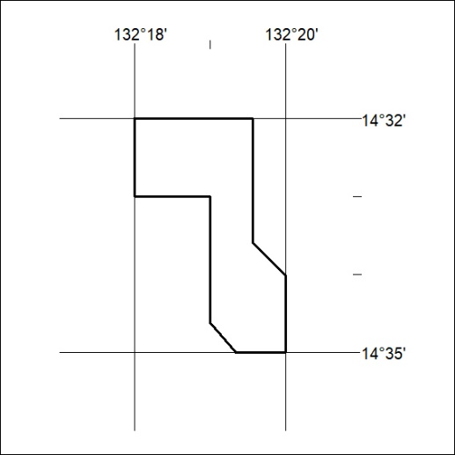

067/23

Corrigendum
Notice Number 065/23 appearing in MN024/23 on 15 March 2023 is hereby cancelled and replaced by the following:

Mineral Titles Act 2010
NOTICE OF LAND CEASING TO BE A MINERAL TITLE AREA
Title Type and Number: | Mineral Lease 29795
Area ceased on: | 14 March 2018
Locality: | PINE CREEK
Name of Applicants(s)Holder(s): | 100% SINGLETON Robert Bruce
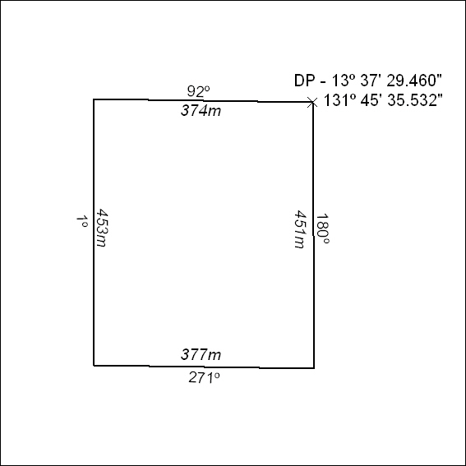

068/23

