Mineral Titles Act 2010
NOTICE OF LAND CEASING TO BE A MINERAL TITLE APPLICATION AREA
Title Type and Number: | Exploration Licence 33298
Area Ceased on: | 03 February 2023
Area: | 20 Blocks, 66.14 km²
Locality: | WESTERN CREEK
Name of Applicant(s)/Holder(s): | 100% ALLUP SILICA LIMITED [ACN. 163 173 224]
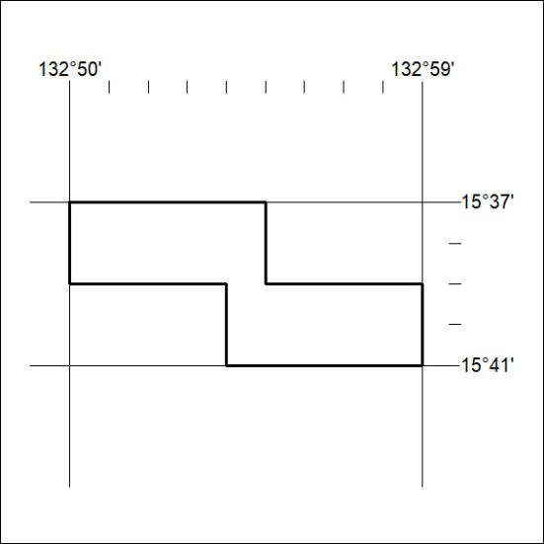

033/23

Mineral Titles Act
NOTICE OF GRANT OF A MINERAL TITLE
Title Type and Number: | Exploration Licence 33217
Granted: | 03 February 2023, for a period of 6 Years
Area: | 14 Blocks, 46.00 km²
Locality: | PINE CREEK
Name of Holder/s: | 100% PNX METALS LIMITED* [ACN. 127 446 271]
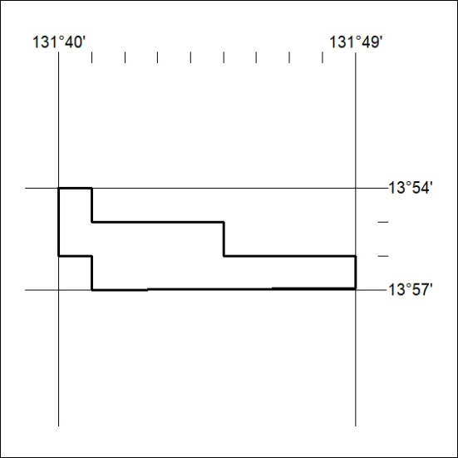
Area granted is indicated above. The titleholder is not permitted to exercise occupational rights on any land that is subject to a development title, or an application for a development title. Any land the subject of a Reserved Land gazettal under the Mineral Titles Act and all land vested in the Commonwealth of Australia is also excluded by description but not excised from the grant area.

034/23

Mineral Titles Act
NOTICE OF GRANT OF A MINERAL TITLE
Title Type and Number: | Exploration Licence 33232
Granted: | 03 February 2023, for a period of 6 Years
Area: | 141 Blocks, 445.54 km²
Locality: | OORADIDGEE
Name of Holder/s: | 100% F&H BROTHERS METALS PTY LTD [ACN. 658 805 228]
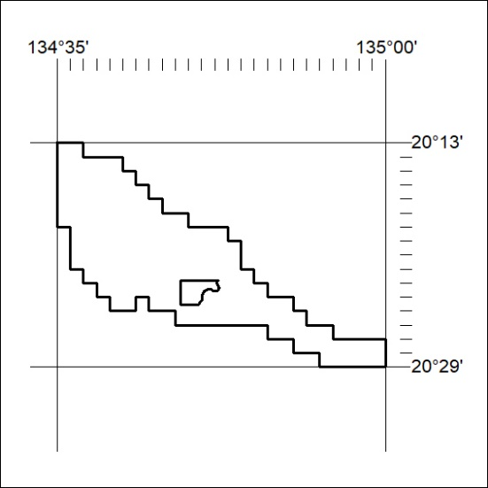
Area granted is indicated above. The titleholder is not permitted to exercise occupational rights on any land that is subject to a development title, or an application for a development title. Any land the subject of a Reserved Land gazettal under the Mineral Titles Act and all land vested in the Commonwealth of Australia is also excluded by description but not excised from the grant area.

035/23

