Corrigendum
Notice Number 021/23 appearing in MN007/23 on 17 January 2023 is hereby cancelled and replaced by the following:

Mineral Titles Act
NOTICE OF GRANT OF A MINERAL TITLE
Title Type and Number: | Exploration Licence 33188
Granted: | 13 January 2023, for a period of 6 Years
Area: | 25 Blocks, 75.69 km²
Locality: | BATCHELOR
Name of Holder/s: | 100% MANGUSTA MINERALS PTY LTD [ACN. 653 950 522]
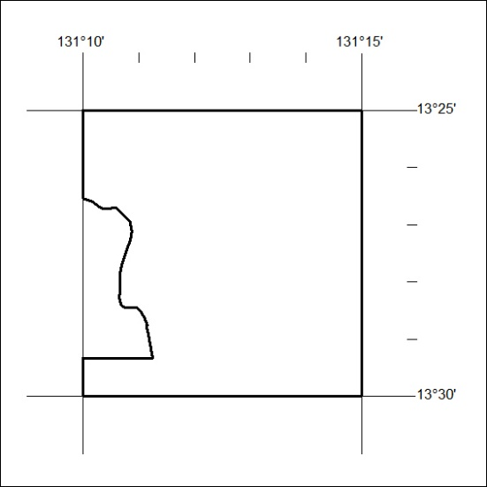
Area granted is indicated above. The titleholder is not permitted to exercise occupational rights on any land that is subject to a development title, or an application for a development title. Any land the subject of a Reserved Land gazettal under the Mineral Titles Act and all land vested in the Commonwealth of Australia is also excluded by description but not excised from the grant area.

023/23

