Mineral Titles Act
NOTICE OF GRANT OF A MINERAL TITLE
Title Type and Number: | Mineral Lease 32704
Granted: | 25 March 2022, for a period of 30 Years
Area: | 1444.00 Hectares
Locality: | LANGDON
Name of Holder/s: | 100% WINCHELSEA MINING PTY LTD [ACN. 626 747 037]
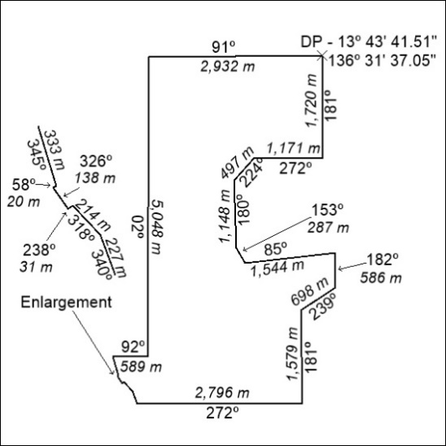

113/22

Mineral Titles Act
NOTICE OF GRANT OF A MINERAL TITLE
Title Type and Number: | Exploration Licence 32858
Granted: | 08 April 2022, for a period of 6 Years
Area: | 69 Blocks, 213.38 km²
Locality: | VICTORY
Name of Holder/s: | 100% HAVELOCK MINING PTY LTD [ACN. 628 961 142]
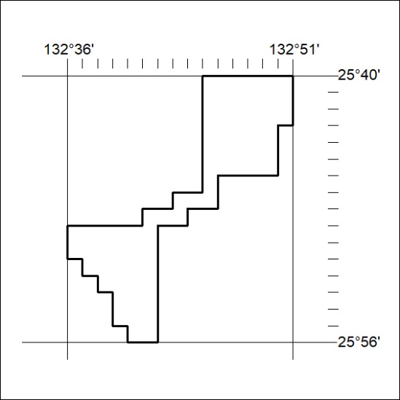
Area granted is indicated above. The titleholder is not permitted to exercise occupational rights on any land that is subject to a development title, or an application for a development title. Any land the subject of a Reserved Land gazettal under the Mineral Titles Act and all land vested in the Commonwealth of Australia is also excluded by description but not excised from the grant area.

114/22

Mineral Titles Act
NOTICE OF GRANT OF A MINERAL TITLE
Title Type and Number: | Exploration Licence 32859
Granted: | 08 April 2022, for a period of 6 Years
Area: | 108 Blocks, 334.01 km²
Locality: | SENTINEL BORE
Name of Holder/s: | 100% HAVELOCK MINING PTY LTD [ACN. 628 961 142]
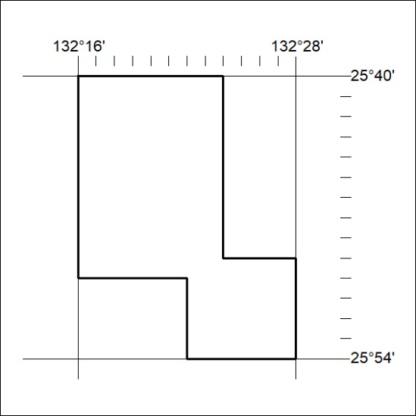
Area granted is indicated above. The titleholder is not permitted to exercise occupational rights on any land that is subject to a development title, or an application for a development title. Any land the subject of a Reserved Land gazettal under the Mineral Titles Act and all land vested in the Commonwealth of Australia is also excluded by description but not excised from the grant area.

115/22

