Mineral Titles Act 2010
NOTICE OF LAND CEASING TO BE A MINERAL TITLE AREA
Title Type and Number: | Exploration Licence 31701
Area Ceased on: | 16 December 2021
Area: | 250 Blocks, 823.67 km²
Locality: | KILDURK
Name of Applicant(s)/Holder(s): | 100% GEVINA AND YAYIN PTY LTD [ACN. 099 438 203]
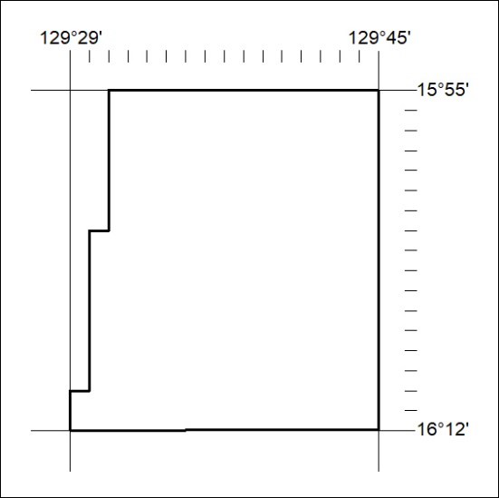

473/21

