Standard Operating Procedure
Cleaning of toilet facility
  - Department of Tourism, Sport and Culture
  - Parks and Wildlife Division
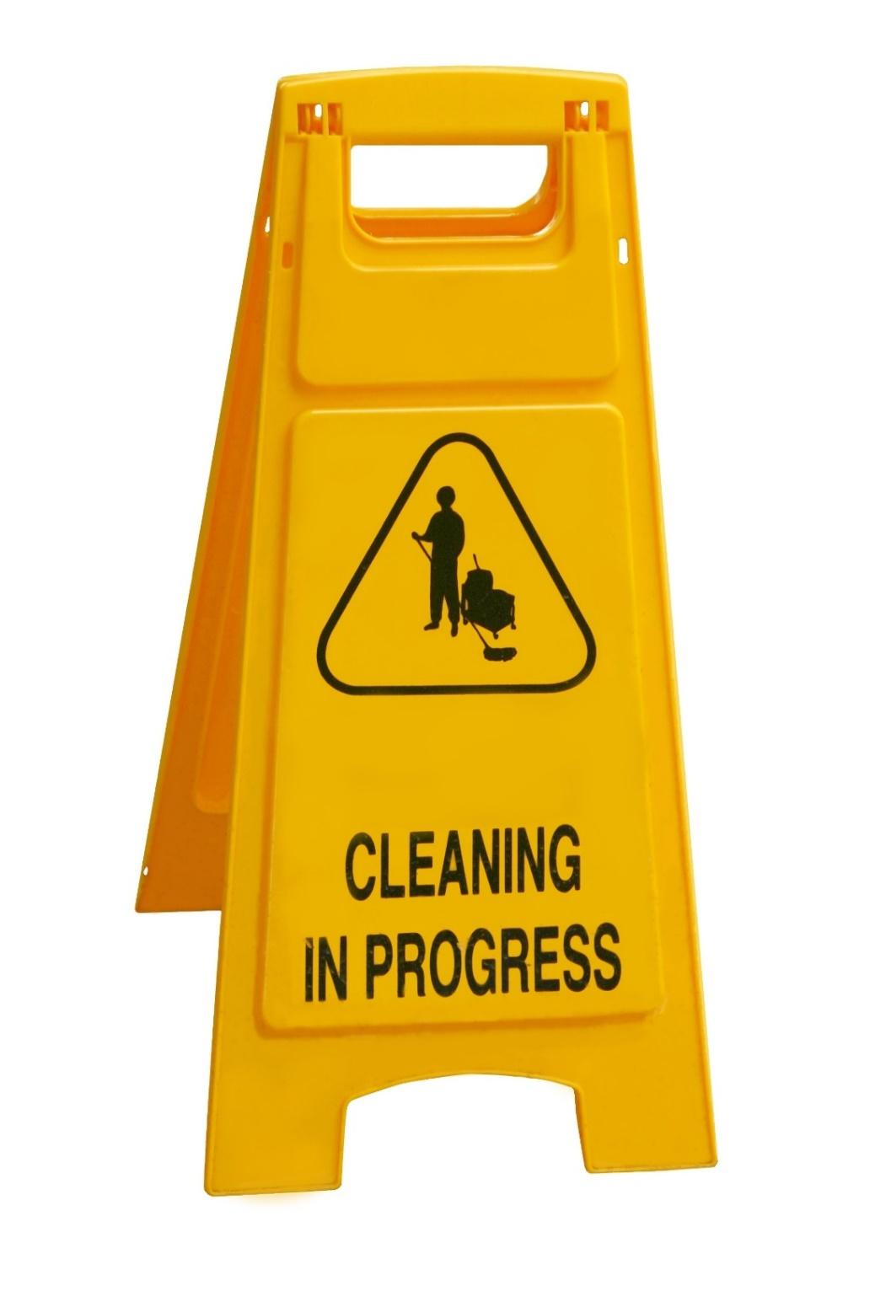
  - April 2020

Document title | Standard Operating Procedure  Cleaning of toilet facility
Contact details | Nicole Joy - Parks and Wildlife – 08 8951 8245
Approved by | Sally Egan – Executive Director Parks and Wildlife
Date approved
Signature
Document review | Annually
TRM number | DPW2020/0058~0008

Version | Date | Author | Changes made
1.0 | 08.04.2020 | Nicole Joy | First Version
1.1 | 29 April 2020 | Neva McCartney | Amendments to align with visitor and COVID-19 messaging.

Acronyms | Full form
COVID-19 | Corona Virus Disease 2019
PPE | Personal Protective Equipment
SOP | Standard Operating Procedure

Contents
1. Introduction 4
2. Purpose 4
3. Scope 4
4. Record Keeping 4
5. Standard Precautions 4
6. COVID-19 Precautions 5
7. Equipment 5
8. COVID-19 Cleaning Schedule 6
9. Cleaning Procedure 8
9.1. Preparation 8
9.2. Start 8
9.3. Finish 9
10. Notification of a confirmed COVID-19 case 10
11. References 11
12. Annexure A – Good Hygiene sign 12
13. Annexure B – SOP Toilet cleaning Checklist 13
14. Annexure C – Environmental cleaning and disinfection principles for COVID-19 14

Introduction
This document address cleaning of the physical environment in toilets. The practices recommended in this document reflect the best evidence available at the time of writing, a list of reference documents are provided at the end of this Standard Operating Procedure. This document is intended for those who have a role in cleaning and infection prevention and control.

Purpose
This Standard Operating Procedure has been written to:
- Ensure effective maintenance of toilets.
- Minimise health risks to visitors and cleaning staff.
- Provide a professional high standard service to visitors.
- Ensure visitors are aware of cleaning frequencies and supplies available in toilet facilities on parks and reserves.

Scope
This Standard Operating Procedure relates to all people working on Parks who may be involved in toilet facilities cleaning. This includes staff and volunteers. Contractors will be directed and will abide by terms and conditions of the contract for the company they work for.
This does not include touch points that are outside of a toilet facility. I.e. viewing platform handrails, seats, benches, interpretative / directional signage, emergency call devices etc.

Record Keeping
Where applicable, the following should be made available for view during an inspection:
- an up to date register (electronic or hard copy) of staff responsible for cleaning
- copies of pest control reports
- cleaning schedules
- emergency and after hours contact details.

Standard Precautions
Standard precautions involve adherence to all of the following work practices:
- Performing hand hygiene / cough etiquette and avoid touching your face
  - Hand hygiene - Soap and water should be used for hand hygiene when hands are visibly soiled and alcohol based hand rub at other times (e.g. when hands have been contaminated from contact with environmental surfaces). Cleaning hands also helps to reduce environmental contamination.
  - Cough etiquette – cough into bend of elbow or disposable tissue
  - Avoid touching your face
- Appropriate and correct use of Personal Protective Equipment (PPE)
  - Wear impermeable disposable gloves and a dust surgical mask plus eye protection or a face shield while cleaning. Advice should be sought from your work health and safety advisor on correct procedures for wearing PPE.
- Use of aseptic technique
  - Use freshly made disinfectant / bleach solution and follow manufacturer’s instructions for appropriate dilution.
- Performing routine cleaning outlined in this SOP
- Cleaning of shared equipment
  - Routine cleaning of frequently touched hard surfaces with detergent/disinfectant solution/wipe. Providing adequate alcohol-based hand rub for staff to use. Alcohol-based hand rub stations should be available, especially in areas of frequent touching occurs including in vehicles. Training staff on use of alcohol-based hand rub.
- Safe use and disposal of sharps (use best practice)
- Safe handling and disposal of waste (use best practice)

COVID-19 Precautions
Visitors to parks and reserves will be notified using signage, social media and other messaging that the toilet facilities will be cleaned once a day. Visitors will be advised to bring their own hand sanitiser and/or soap supplies as these are not provided in toilet facilities in parks and reserves.
Visitors will also be encouraged to bring toilet paper as a safeguard in the event that supplies are stolen.
Messaging will also state that sanitary receptacles for women are not supplied.
Parks and reserves that do not clean daily will have appropriate visible signage for visitors, prior to them entering the toilet facility.

Equipment
Four categories of equipment to perform cleaning of toilet facility:
- Personal Protective Equipment:
  - Impermeable disposable gloves, dust surgical mask, eye protection or face shield, safety boots and high visual vest (disposable overalls are optional).
- Cleaning Equipment:
- Clean single use cloths - blue for surfaces and red for toilet bowls  - Micro fibre cloth - blue for surfaces and red for toilet bowls (require laundering)  - Mop buckets and wringers – (use a white bucket and disposable mop heads for body fluids)  - Dust mop and dustpan  - Spray bottle for sanitiser  - Toilet brush  - Garbage bags, Sanitary bins and bags  - BBQ tongs | - Dry broom & wet broom  - Duster  - Rubbish bin  - Squeeze bottle with bowl cleaner  - Paper towels or best to use hand dryer  - Garden hose, tap fittings  - Key to open  - Storage cupboard located at amenity – secured  - High pressure cleaner  - Vehicle mounted pressure pump and water tank.
- Consumables
- Multi-purpose hard surface cleaner  - Hard surface disinfectant  - Mould remover  - Abrasive hard surface creme cleaner  - Non-acid disinfectant  - Hand soap  - Glass cleaner  - Toilet bowl cleaner  - Graffiti remover | - Paper towels – single use  - Detergent wipes  - Porcelain and metal cleaner  - Toilet paper  - Air freshener or urinal mats  - Drain bacterial digestant/deodorant.  - Safety Data Sheets (SDS) - Up to date and spill procedures identified  - Disinfectants - concentration of active ingredient must achieve a 1000 ppm (0.1%) bleach solution or hospital grade.
- Other
- Hygiene signs – behind toilet doors: Annexure A: COVID-19 Hand Washing
- Door stop / toilet closed signs and location of nearest toilet
- Extra white board sign to leave notes for next cleaner on duty if needed
- Storage / trolley for carrying cleaning equipment
- Putty knife to remove chewing gum
- Plunger / plumber’s snakes / ladder

COVID-19 Cleaning Schedule
Toilet facilities across the parks and reserves are routinely cleaned with detergent / disinfectant solution. The frequency of cleaning is dependent on visitor numbers and the location of the facility.
Due to COVID-19 the recommended frequency, methods and items of equipment for cleaning toilet facilities in parks that are open to the public are listed below.
Item of equipment | Recommended frequency of cleaning | Recommended method of cleaning
Alcohol gel bottles/soap holders | Daily | Detergent and water / detergent wipe
Baby changing bench | Daily | Detergent wipes
Buckets | After use | Disinfectant and Water dry after washing
Chairs / benches | Weekly or when visibly soiled | Detergent wipes
Cleaning trolleys | Daily | Detergent and water / detergent wipes
Fans | Wall or ceiling mounted – 6 monthly or earlier to keep dust free | Detergent and water / detergent wipes
Floors | Daily  or after notification from the public of a spillage of body fluids | Sweep then mop with disinfectant and water  Use an absorbent paper towel for the bulk of the spillage and dispose of in a clinical waste bag (or alternative).  Clean with disinfectant and water using white disposable single use mop head and white bucket.
Light Fittings | Weekly | Duster
Mirrors | Daily | Glass cleaner and single use paper towel
Mops | After use | Rinse and then use detergent and water
Notice boards or signs inside the toilet facility | Daily | Detergent wipes
Showers | Daily | Disinfectant and water
Sinks / hand wash basin / taps | Daily | Creme cleanser, mild phosphoric acid solution or disinfectant solution
Toilets | Daily  Includes cistern, seat, outside bowl and door handles inside and out  Inside toilet bowel | Non-acid disinfectant solution or single use detergent wipes  toilet bowl cleaner, disinfectant and toilet brush
Toilet door | Wipe inside and outside of door weekly | Disinfectant and water / detergent wipes
Urinal/s | Daily | non-acid disinfectant solution or single use detergent wipes

Where toilet facilities are NOT cleaned daily, signage to that effect will be placed in an area visible to visitors prior to them entering the toilet facility.

Cleaning Procedure

Preparation
- Personal Protective Equipment check: wear proper PPE - Wash your hands for 20 seconds every 20 minutes
- Vehicle check: Spray sanitiser: over door knobs inside and out, steering wheel indicator and wiper controls, radio and dash. Keep a bottle of sanitiser gel or wipes in the vehicle. Ensure vehicle air set to fresh, not recirculate.
- Supply Check: Prepare all equipment and supplies required and proceed to cleaning destination.
- Toilet facility check: Call out with a friendly greeting “ Hello, cleaning staff here”, if the entry door is closed knock on the door and announce your intention to enter, if restroom is occupied, wait until it is empty, when empty, enter, immediately post “Restroom Closed” sign and prop door open with doorstop.

Start
1) Wash hands with soap for twenty seconds, put on PPE (gloves, mask, boots, eye protection and high visual vest (disposable overalls are optional).
2) Visual inspection, open all toilet doors, apply toilet bowl cleaner and disinfectant and allow cleaner to stand as directed, move on to next task while waiting.
3) Use tongs to pick up any rubbish and place rubbish in bin lined with a garbage bag.
4) Dust high to low - tops of doors / fixtures / basin / fans with a duster (as per cleaning schedule).
5) Use a broom to sweep floor, use dust pan to pick up loose rubbish and place in rubbish bin.
6) If body fluids are present use an absorbent paper towel for the bulk of the spillage and dispose of in a clinical waste bag. Clean with disinfectant using disposable single use mop head and white bucket.
7) Wet cleaning - using a spray bottle spray disinfectant solution over surfaces, wipe using blue cloth for surfaces - all partitions, tops and bottoms of doors, doorknobs, receptacles, and dispensers.
8) Spot clean using blue cloth all other above-ground surfaces with disinfectant solution.
9) Clean all light fixtures, mirrors and glass surfaces with glass cleaner & single use paper towel.
10) Clean wash basins using blue cloth with creme cleanser, mild phosphoric acid solution or disinfectant solution.
11) Clean interior of sink using blue cloth, allowing disinfectant solution a full ten minutes of contact time for effectiveness.
12) Spot clean using garden hose / fire unit blue cloth exterior surfaces, faucets, pipes and under basins.
13) Wipe all metal surfaces using blue cloth.
14) Scrub inside the toilet with toilet brush, clean the rim, waterline areas.
15) Wipe over toilet seat using red cloth and non-acid disinfectant solution or single use detergent wipes.
16) Check operation of faucets and drains and treat drains with bacterial digestant/deodorant.
17) Spot clean all other above-ground surfaces using blue cloth with disinfectant solution.
18) Remove old bin liner and replace new garbage bag in rubbish bin, wipe over bin using blue cloth with disinfectant solution – never use hands to press down rubbish (beware sharps!).
19) Sanitary napkin receptacles / Sharps bin maintained (where supplied and where possible serviced by a contractor).
20) If required use garden hose connected to a tap and hose all surfaces, take care for any electrical fittings.
21) Use mop and bucket to mop floor dry.
22) Refill toilet tissue.
23) On parks where it is supplied, refill hand soaps, deodorisers and hand towel dispenser. Check dispensers are operating properly.
24) Put all cleaning equipment in vehicle or back in amenity storage area on site. Remove all PPE and put disposable items in the rubbish.
25) Return to toilet facility and thoroughly wash hands for 20 seconds. Return to vehicle and apply hand sanitiser.

Finish
- Dispose of rubbish in the designated waster transfer area, including disposable PPE and wash the high visual vest.
- Return to base, report any maintenance issues, clean equipment, place chemicals in storage and complete a SOP checklist (Annexure B).
If poisoning occurs, contact a doctor or Poisons Information Centre Phone Australia 131 126

Notification of a confirmed COVID-19 case
Upon notification of a confirmed COVID-19 case on a park: -
- Close the toilet facility immediately, secure with site closure tape and notify the Executive Director Parks and Wildlife.
- The Executive Director Parks and Wildlife will notify the appropriate agencies through the WEBEOC.
- Follow any instructions provided.
- An appropriate cleaning hygienist will be procured to undertake a thorough cleaning before the facility can be re-opened to the public.
Parks and Wildlife employees are not to undertake any cleaning of a facility if it has been identified as being used by person/s with confirmed COVID-19.

References
Australian Government Department of Health – Coronavirus disease (COVID – 19) Environmental cleaning and disinfection principles for COVID-19 (Annexure C)
DAILY CLEANING OF TOILETS and WEEKLY NINJA. Kings Canyon Day Use Area and Sunset Viewing area. Parks and Wildlife NT. Nov 2014.
Government of South Australia, SA Health, Cleaning Standard for South Australian Healthcare Facilities 2014 (Updated 2017)
Infection Prevention and Control Policy, NSW Government, Health, June 2017
NORTHERN TERRITORY OF AUSTRALIA PUBLIC AND ENVIRONMENTAL HEALTH ACT 2011
As in force at 26 March 2020 / PUBLIC AND ENVIRONMENTAL HEALTH REGULATIONS 2014, 42 Water and ablution facilities
Northern territory Government Department of Health. Public and Environmental Health Guidelines for Public Accommodation 2016. AS1668.2-2002: The use of ventilation and air conditioning in buildings and AS/NZS 3666.1:2002 Air handling and water systems of buildings - microbial control – design, installation and commissioning and NCC Part F4.
Safety Data Sheet - Product Name: Fresh Lemons Reference No: 50297 Issued: 2018-10-18 Version: 1 Page 1 of 7 1300 789 852 | enquiry@dominant.com.au | www.dominant.com.au 24 Hour Medical Emergency Line 13 11 26 Fresh Lemons Hazardous Chemical, NON-Dangerous Goods

Annexure A – Good Hygiene sign
You can view the Good Hygiene is in your hands poster on the Northern Territory Government Coronavirus (COVID-19) website.

Annexure B – Toilet Cleaning SOP
  - Checklist

Park________________________________ Visitor Node___________________ Facility___________________

CLEANED | Tick or N/A | CHECKED STOCK | Tick or N/A
Alcohol gel bottles / soap holders |  | Toilet Paper
Baby Changing bench |  | Paper Towels
Chairs / benches |  | Soap
Cleaning Trolleys |  | Hand Lotion
Fans |  | Feminine Hygiene
Floors |  | Air Freshener
Light Fittings |  | MAITENANCE REQUIREMENTS
Mirrors
Notice boards / signs inside facility
Showers
Sinks / hand basin / taps |  | ADDITIONAL COMMENTS
Toilets
Urinals/s

Has there been any notification of the facility being associated with a confirmed COVID-19 case?
Yes ☐ No ☐
If YES, what date was the facility secured and the Executive Director notified? Date: ____________________
Name/s: ______________________________________ _____________________________________

Signature/s: _______________________________________ _____________________________________
Date/s: ______________________________________ _____________________________________

Annexure C – Environmental cleaning and disinfection principles for COVID-19
You can view Environmental cleaning and disinfection principles for COVID-19 on the Australian Government website.

