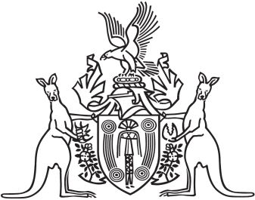
Northern Territory of Australia

Government Gazette
ISSN-0157-833X
No. S89 15 November 2018
Assent to Proposed Laws
Her Honour the Administrator declared assent to the following proposed laws:
08 November 2018
Domestic and Family Violence Amendment (Information Sharing) Act 2018 (Act No. 21 of 2018)
Interpretation Legislation Amendment Act 2018 (Act No. 22 of 2018)
Local Court Amendment (Judicial Appointments) Act 2018 (Act No. 23 of 2018)
Northern Territory Civil and Administrative Tribunal Amendment Act 2018 (Act No 24. of 2018)
Michael Tatham
Clerk of the Legislative Assembly
12 November 2018

