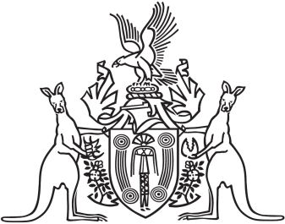
Northern Territory of Australia

Government Gazette
ISSN-0157-833X
No. S77 28 September 2018
Northern Territory of Australia
Police Administration Amendment Act 2016
Commencement Notice
I, Vicki Susan O'Halloran, Administrator of the Northern Territory of Australia, under section 2 of the Police Administration Amendment Act 2016 (No. 30 of 2016), fix the day on which this notice is published in the Gazette as the day on which the Act commences.
Dated 27 September 2018
V. S. O'Halloran
Administrator

