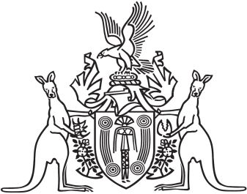
Northern Territory of Australia

Government Gazette
ISSN-0157-833X
No. S74 20 September 2018
Northern Territory of Australia

Crown Lands Act
Reserve No. 1281 (Olive Pink Botanic Garden)
Termination and Appointment of Trustees
I, Gerald Francis McCarthy, Minister for Housing and Community Development:
(a) under section 79(2) of the Crown Lands Act, terminate the appointment of each person named in Schedule 1 as trustees of Reserve No. 1281 (Olive Pink Botanic Garden); and
(b) under section 79(1) of the Act, appoint each person named in Schedule 2 to be a trustee of Reserve No. 1281; and
(c) under section 79(1) of the Act, appoint Frances Mary Kilgariff to be Chairman of the trustees.
Dated 18 September 2018
G. F. McCarthy
Minister for Housing and Community Development
Schedule 1
James Andrew Cocking
Susan Mary Dugdale
Geoffrey Brian Kenna
Helen Kilgariff
Elizabeth Anne Prell
Jeanette Gail Wormald
Schedule 2
Sarah Elizabeth Fairhead
Frances Mary Kilgariff
Hayley Cherie Michener
Scott Maurice Pullyblank
Robina Anne Pye
Peter Graeme Renehen

