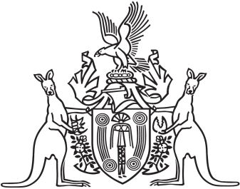
Northern Territory of Australia

Government Gazette
ISSN-0157-833X
No. S52 5 July 2018
Northern Territory of Australia

Motor Accidents (Compensation) Commission Act
Appointment of Commissioner
I, Nicole Susan Manison, Treasurer, under section 6(1)(a) of the Motor Accidents (Compensation) Commission Act, appoint James Mitchell Colvin to be the Motor Accidents (Compensation) Commissioner from the date on which this instrument is published in the Gazette to 30 June 2021.
Dated 4 July 2018
N. S. Manison
Treasurer

