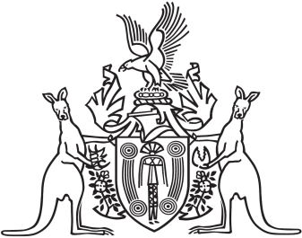
Northern Territory of Australia

Government Gazette
ISSN-0157-833X
No. S32 21 May 2018
Northern Territory of Australia

Plant Health Act
Control of Citrus Canker
Declaration of Quarantine Place
I, Sarah Kathryn Corcoran, Chief Inspector of Plant Health:
(a) under section 18(1) of the Plant Health Act, declare the following areas to be a quarantine place for the control of the declared pest Citrus Canker Xanthomonas citri subsp. citri (the declared pest):
(i) all the land located in an area shaded in grey on a plan in Schedule 1 and the whole of any parcel of land that is partly located in such a shaded area (the restricted area); and
(ii) all the land located in an area shaded in grey on the plan in Schedule 2 and the whole of any parcel of land that is partly located in such a shaded area (the control area); and
(b) declare the quarantine place for the purposes mentioned in section 18(2)(a), (b), (c)(i) to (iv) and (d) of the Act; and
(c) specify that the following prohibitions apply to the whole of the restricted area:
(i) the entry into the restricted area of any host plant for the declared pest (a host plant) or plant-related material is prohibited, other than:
(A) entry of fruit and juice imported from outside the control area for human consumption (the imported products); or
(B) entry in accordance with a written permit given by the Chief Inspector;
(ii) the movement within the restricted area of any host plant or plant-related material is prohibited, other than:
(A) movement of imported products; or
(B) movement in accordance with a written permit given by the Chief Inspector;
(iii) the removal from the restricted area of any host plant or plant-related material is prohibited, other than:
(A) removal of imported products; or
(B) removal in accordance with a written permit given by the Chief Inspector;
(iv) the cultivation, propagation or planting within the restricted area of any host plant is prohibited, other than cultivation, propagation or planting in accordance with a written permit given by the Chief Inspector; and
(d) specify that the removal of any host plant or plant-related material from the control area is prohibited, other than:
(i) removal of imported products; or
(ii) removal in accordance with a written permit given by the Chief Inspector; and
(e) specify that the reason for the decision to make this declaration is because the quarantine place is affected by the declared pest; and
(f) specify that a person whose interests are or might be affected by the decision has a right to apply under section 58 of the Act for reconsideration of the decision.
Dated 18 May 2018
S. K. Corcoran
Chief Inspector of Plant Health

Schedule 1
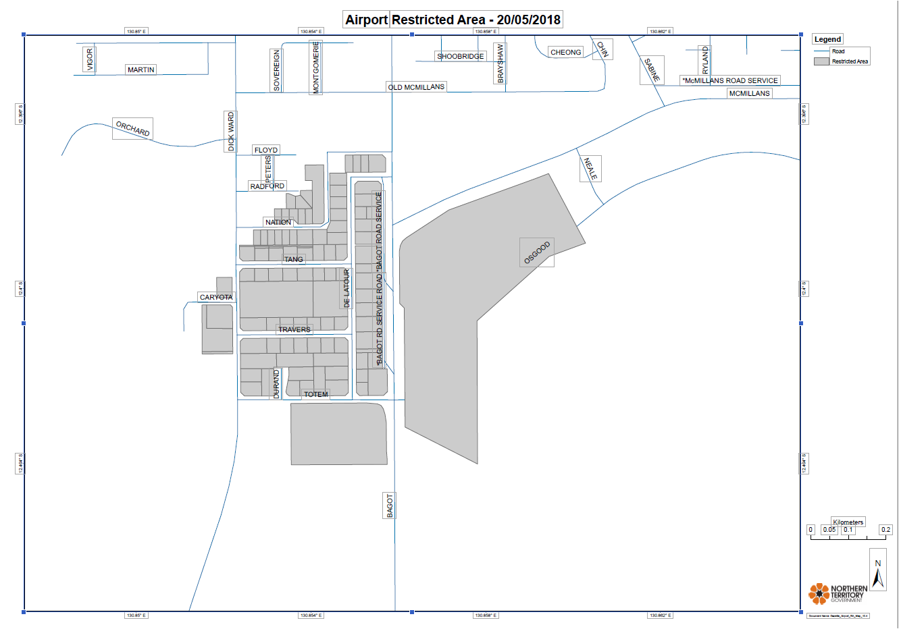
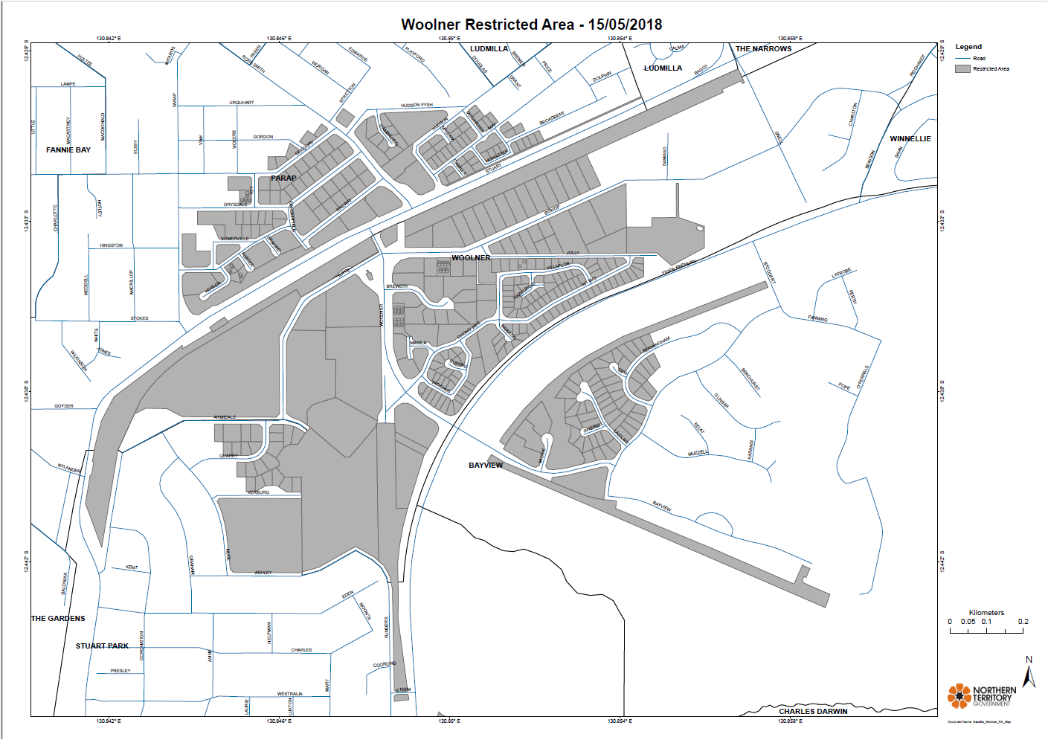
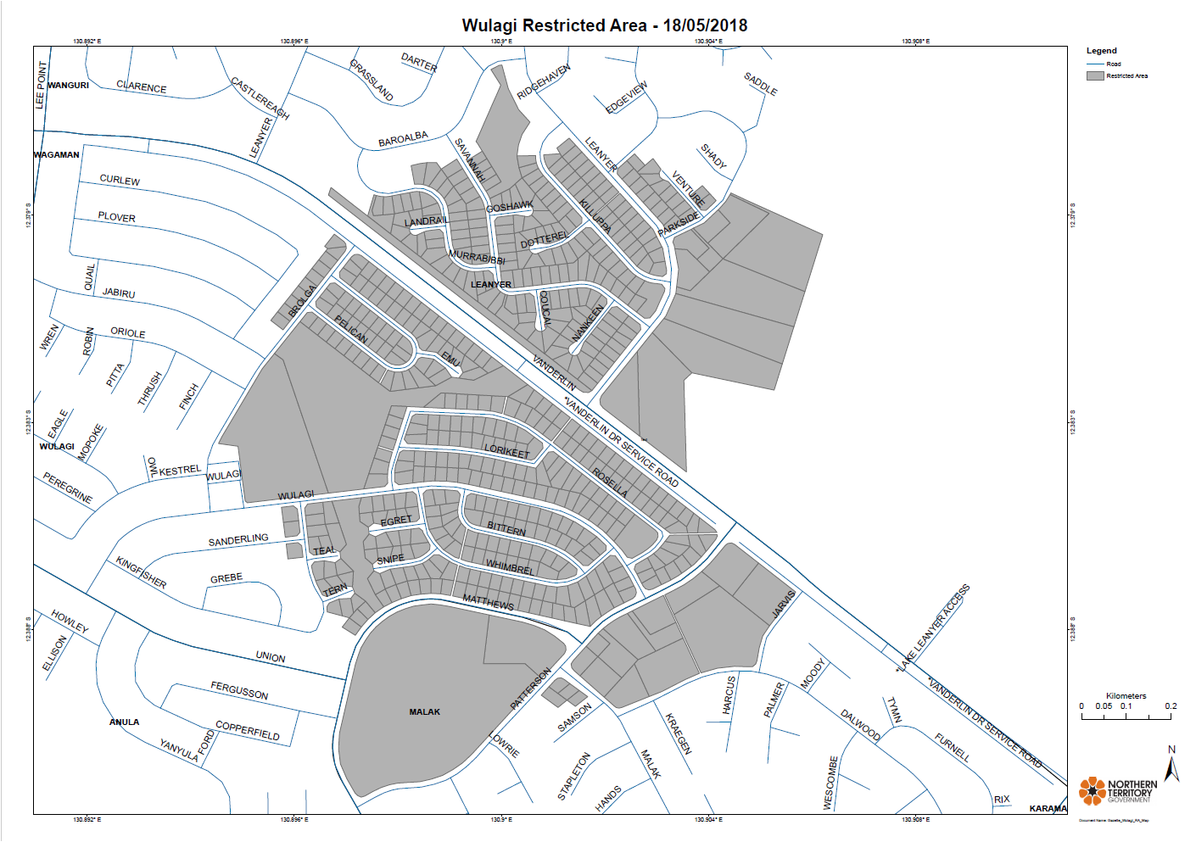
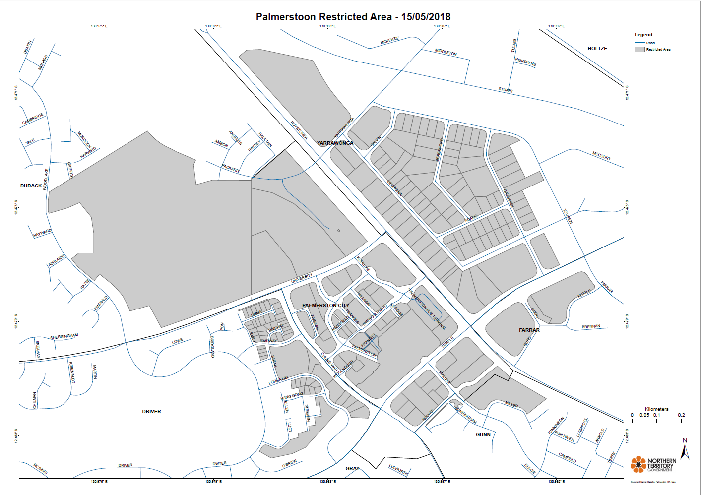
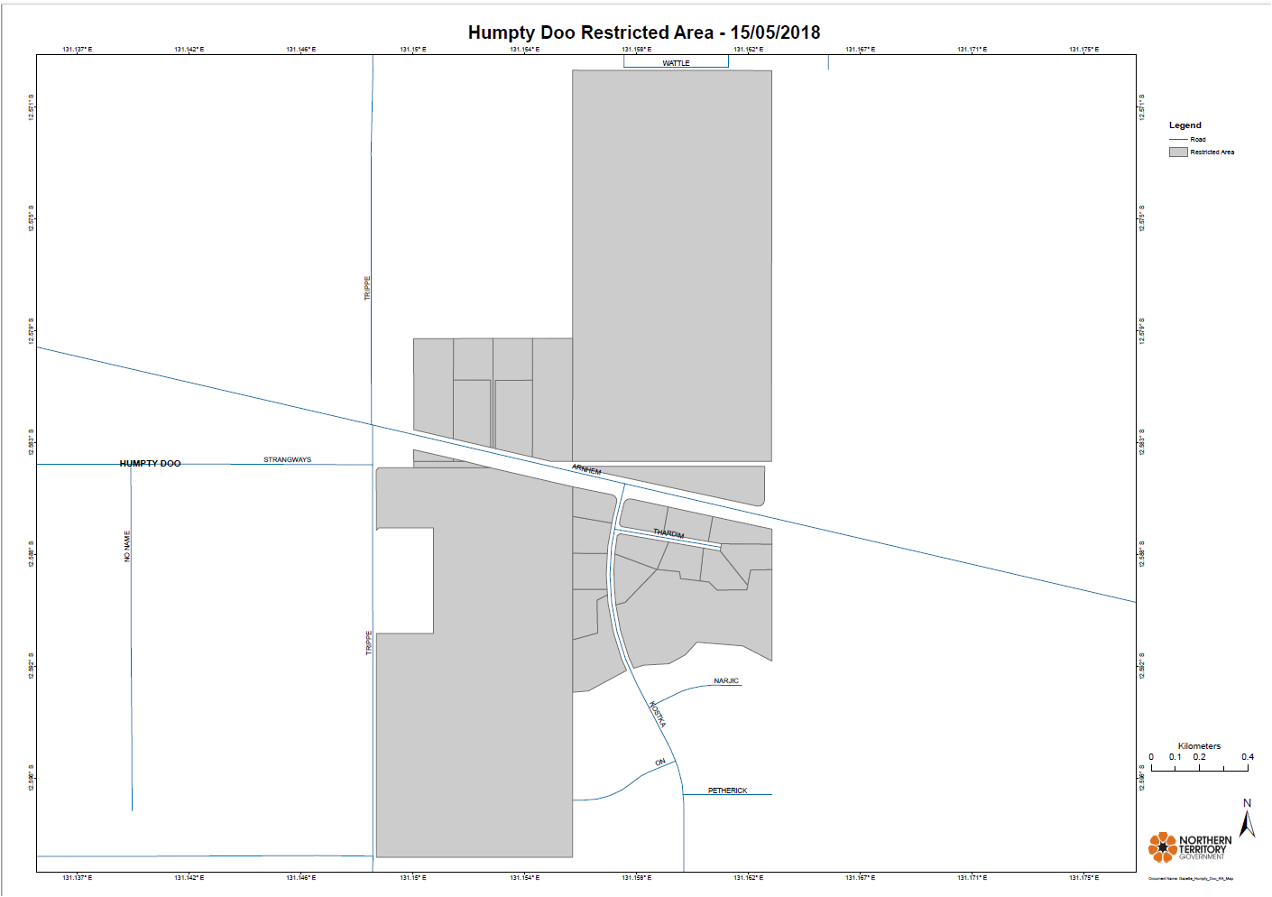
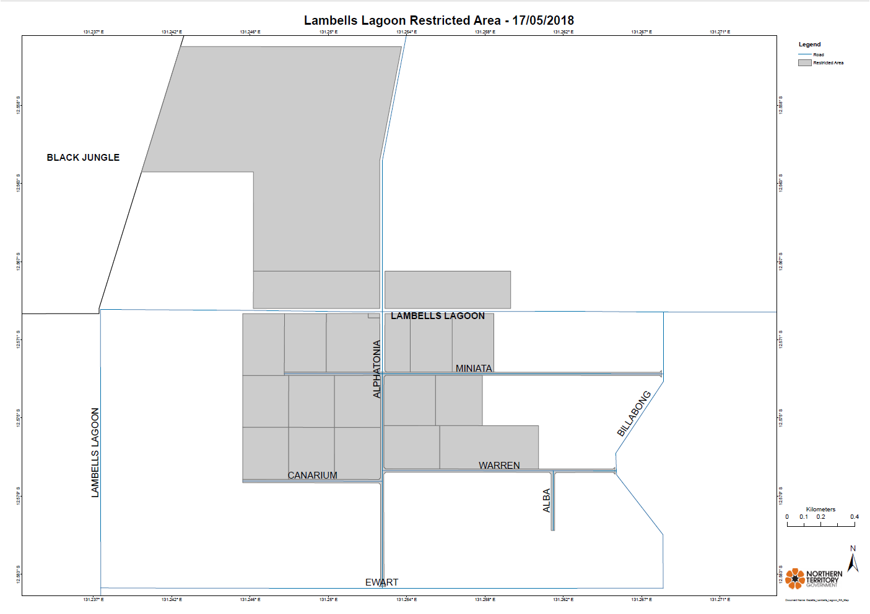
Schedule 2
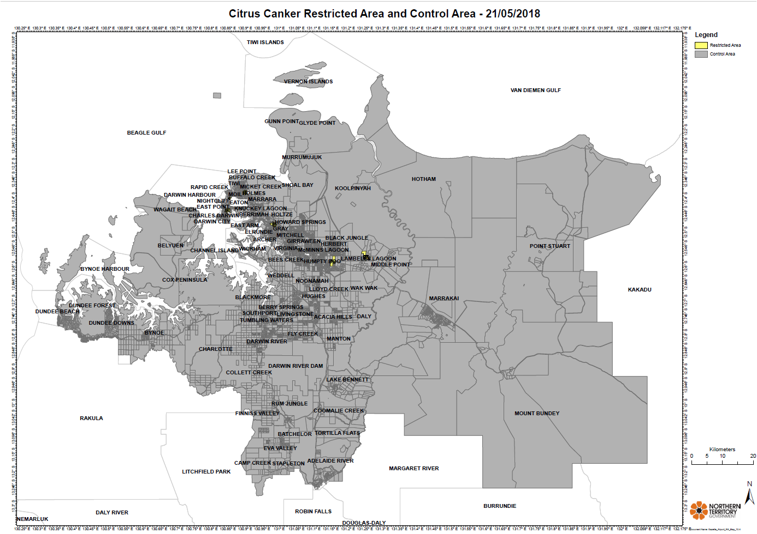

Northern Territory of Australia

Plant Health Act
Prohibition of Export from the Territory of
Specified Plant and Material
I, Sarah Kathryn Corcoran, Chief Inspector of Plant Health, under section 17(2) of the Plant Health Act and with reference to section 17(1)(b) of the Act, for the control of the declared pest Citrus Canker Xanthomonas citri subsp. citri (the declared pest), prohibit the export from the Territory of a declared host plant or plant-related material for the declared pest, for a period of 12 months on and from the date of publication of this notice, other than in accordance with a written permit given by the Chief Inspector.
Dated 14 May 2018
S. K. Corcoran
Chief Inspector of Plant Health

